RESOLUT
Commercial Pricing Strategy
Version 4.2

Commercial Philosophy
Resolut is not sold as software.
It is participation in a Continuous Trust Infrastructure.
Every participant whether an individual, organisation or enterprise receives immediate value by joining the network. As their responsibilities increase, the platform expands with them.
Customers do not pay for users, documents or transactions.
They pay for the level of responsibility they assume within the network.

The Continuous Trust Infrastructure is built upon two identity layers: trusted individuals and trusted organisations.
Resolut Solo establishes trusted personal identities.
Resolut Pro establishes trusted organisational identities.
Together they create continuously verified relationships that enable compliance, assurance and governance to operate across entire enterprise ecosystems.

Participation creates relationships. Relationships create intelligence. Intelligence creates trust. Trust creates value.
This philosophy underpins every commercial decision.



Commercial Architecture
Resolut is built upon a common infrastructure with products designed for different participants within the network.
Product | Purpose | Primary Customer | Commercial Model
Resolut Core | The System of Record | Shared Infrastructure | Included
Resolut Solo Connected | Trusted Personal Identity | Individuals invited to the network | Free
Resolut Solo Professional | Personal Compliance Management | Independent professionals | Subscription
Resolut Pro Connected | Trusted Organisation Identity | Organisations invited to the network | Free
Resolut Pro Compliance | Compliance Management | Single legal entity | Subscription
Resolut Pro Enterprise | Compliance Intelligence | Multi-entity organisations | Subscription
Resolut Pro Supply Chain | Supply Chain Intelligence | Enterprise network operators | Subscription
Resolut SBOM | Software Supply Chain Intelligence | Software vendors & enterprises | Enterprise Module

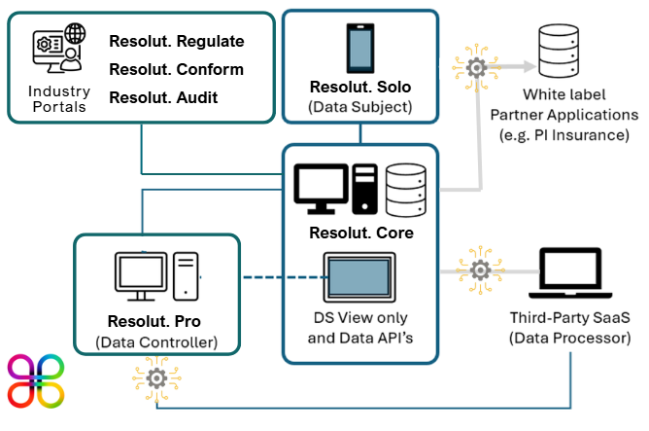
Commercial Journey
The commercial model mirrors increasing responsibility within the Continuous Trust Infrastructure.
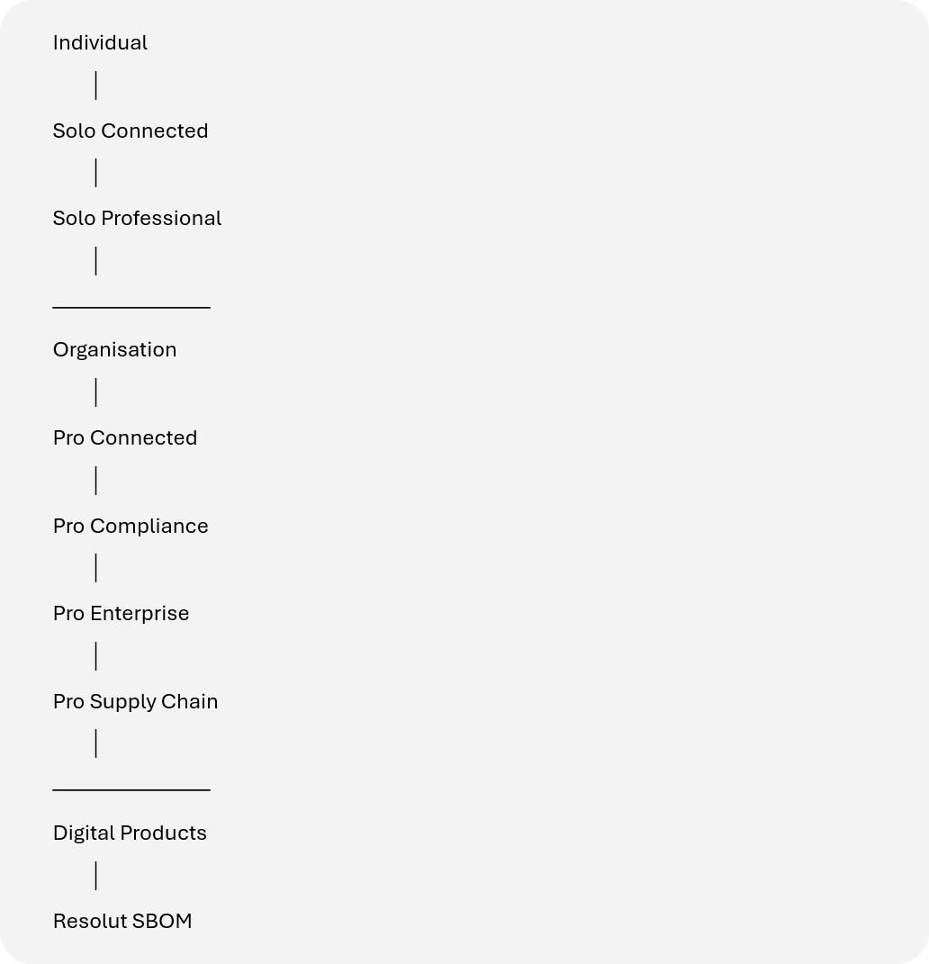

Every stage builds upon the previous one. Nothing is replaced. Everything expands.

Pricing Principles

Resolut follows five commercial principles.

- Everyone should be able to participate.
Entry into the network should be frictionless.

- Responsibility determines value.
Pricing reflects responsibility - not software consumption.

- Networks create enterprise value.
Every participant strengthens the intelligence of the wider platform.

- Simplicity wins.
Customers should immediately understand which product matches their role.

- AI should accelerate adoption.
Artificial Intelligence is included as part of the platform experience rather than sold as an optional feature.

Resolut Core
The System of Record

Resolut Core provides the shared infrastructure supporting every participant within the Continuous Trust Infrastructure.

It continuously maintains trusted relationships and verified compliance status across people, organisations, software, products and supply chains.

Core is not licensed separately.

It is the foundation upon which every Resolut product operates.

Resolut Solo Connected
Free (Sponsored)

Purpose
Provides a trusted personal identity and compliance platform for individuals participating within the Continuous Trust Infrastructure.

Typical users include employees, contractors, agency workers, consultants and regulated professionals whose subscription has been sponsored by an employer, client or other participating organisation.

Resolut Solo Connected provides the complete Solo experience. The individual receives full functionality while the sponsoring organisation funds participation as part of its wider compliance ecosystem.

Includes
- Personal Trust Profile
- Digital Identity
- Credential Wallet
- Secure Evidence Repository
- Compliance Management
- Professional Registrations
- Licence Management
- CPD Tracking
- Insurance Management
- Trusted Credential Sharing
- Personal Audit Readiness
- AI Compliance Assistant
- Career & Opportunity Marketplace
- Mobile Application

Commercial Objective
Remove barriers to adoption.
Enable every individual to participate in trusted compliance relationships.

Resolut Solo Professional
US$120 per year

Purpose
Designed for professionals who choose to manage their own compliance independently.

Typical users include self-employed professionals, consultants, contractors and regulated individuals who are not sponsored by an employer or client.
Resolut Solo Professional provides exactly the same functionality as Solo Connected.

The only difference is the commercial model. Instead of participation being funded by a sponsoring organisation, the individual subscribes directly and retains complete ownership of their professional compliance identity.

Includes
Exactly the same functionality as Resolut Solo Connected.

Commercial Principle
One subscription.
Unlimited employers.
Unlimited clients.
One trusted professional identity.
Whether an individual is sponsored by an organisation or subscribes independently, their professional identity, compliance history and trusted relationships remain continuous throughout their career.

Resolut Pro Connected
Free

Purpose
Allows organisations to participate within customer supply chains without operating their own compliance programme.
Activated following invitation from an existing subscriber.

Includes
- Organisation Profile
- Compliance Status
- Basic Evidence Repository
- Trust Sharing
- Relationship Invitations
- Basic AI Guidance
- Supply Chain Participation

Commercial Objective
Grow the organisational network.
Encourage upgrade through operational value.

Resolut Pro Compliance
From US$3,000 per legal entity annually

Purpose
Everything required to operate compliance for a single registered organisation.

Includes
- Compliance Management
- Policy Management
- Evidence Management
- Obligations Register
- Internal Audit Management
- Training Records
- Asset Registers
- AI Compliance Assistant
- Workflow Automation
- Regulatory Intelligence
- Compliance Dashboards
- Continuous Audit Readiness
- API Integrations

Commercial Principle
- One legal entity.
- Unlimited users.
- Unlimited internal collaboration.
- The organisation manages itself.

Resolut Pro Enterprise
From US$30,000 annually

Purpose
Designed for organisations responsible for multiple legal entities.
Examples include:
- Holding Companies
- Enterprise Groups
- Franchisors
- International Businesses
- Public Sector Organisations

Includes
Everything within Pro Compliance plus:
- Multiple Organisations
- Executive Dashboards
- Cross-company Reporting
- Group Governance
- Shared Regulatory Frameworks
- Central Policy Management
- Enterprise AI
- SSO
- Advanced Integrations
- Executive Analytics

Commercial Principle
Central intelligence across multiple organisations.

Resolut Pro Supply Chain
From US$75,000 annually

Purpose
Manage compliance and operational risk across supplier ecosystems.

Includes
Everything within Enterprise plus:
- Supplier Onboarding
- Third-party Compliance
- Nth-party Visibility
- Dependency Mapping
- Continuous Monitoring
- Relationship Intelligence
- Risk Propagation
- Network Dashboards
- AI Supply Chain Analytics

Every supplier invited onto the platform receives Pro Connected free of charge.
This creates a naturally expanding network while reducing onboarding friction.

Resolut SBOM
Software Supply Chain Intelligence
Designed for organisations developing, procuring or operating software.

Capabilities include:
- Software Bill of Materials
- Dependency Intelligence
- Component Inventory
- Vulnerability Monitoring
- AI-assisted Risk Assessment
- Software Relationship Mapping
- Regulatory Reporting
- Continuous Software Assurance

Enterprise pricing by quotation.

Resolut AI

Artificial Intelligence is embedded throughout every Resolut product.

Rather than restricting usage through daily limits, each subscription includes a generous allocation of Resolut AI Credits, reflecting the expected usage of that customer segment.

Customers requiring additional AI capacity can purchase credit bundles at any time, ensuring uninterrupted access while providing transparent cost recovery as AI models continue to evolve.

Subscription | Included AI Credits (Monthly)
Solo Connected | 500
Solo Professional | 500
Pro Compliance | 5,000
Pro Enterprise | 50,000
Pro Supply Chain | 250,000

Additional AI Credit Bundles

Bundle | Price
5,000 Credits | USD $25
25,000 Credits | USD $100
100,000 Credits | USD $350

As AI processing costs reduce over time, Resolut expects to increase included credit allocations without changing subscription pricing.

Founding Partner Programme

The Founding Partner Programme recognises organisations that help shape the future of the platform.

Benefits
- 50% discount during Year One
- 25% discount during Year Two
- Standard pricing from Year Three
- Lifetime Founding Partner Recognition
- Product Roadmap Influence
- Quarterly Executive Workshops
- Early Product Access
- Advisory Council Participation
- Joint Case Studies
- Co-marketing Opportunities

This programme rewards early commitment without creating permanent pricing disparities.

Strategic Delivery Partners

Strategic partners—including global consultancies, accreditation bodies and specialist service providers—extend Resolut's reach through advisory, implementation and managed services.

Commercial models may include:
- Referral agreements
- Implementation partnerships
- Managed compliance services
- Joint go-to-market programmes
- Industry-specific solutions

Revenue-sharing arrangements are agreed individually.

Network Growth Model

The commercial model creates a self-reinforcing growth engine.

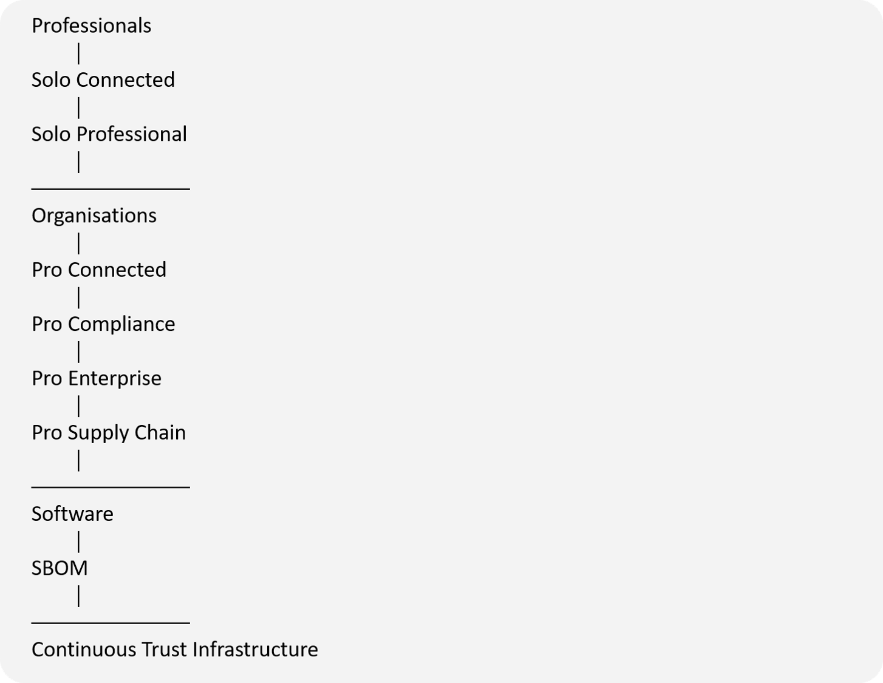

Every participant increases the intelligence and value of the network.

Pricing Summary
Product | Customer | Annual Pricing
Resolut Solo Connected | Sponsored Individuals | Free
Resolut Solo Professional | Independent Individuals | USD $ 120
Resolut Pro Connected | Sponsored Organisations | Free
Resolut Pro Compliance | Single Legal Entity | From USD $ 3,000
Resolut Pro Enterprise | Multi-Entity Organisations | From USD $30,000
Resolut Pro Supply Chain | Enterprise Supply Chains | From USD $75,000
Resolut SBOM | Software Supply Chain | Enterprise Pricing
Notes:

