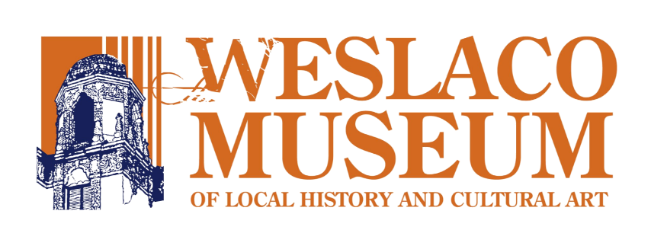

Please use this form to nominate an individual for membership on the Board of Directors of the Weslaco Museum.

To be eligible for election to the WM Board of Directors, an individual:
• must be committed to being an advocate for the museum.
• must be willing and able to attend monthly evening meetings
• must be willing and able to commit 5-15 hours each month to Board activities.

Contact Information
Name of Nominee: _______________________________________________________
Address: ___________________________________________________________
___________________________________________________________
Phone: ___________________ e-mail: ________________________________________

The WM seeks to add several new members to its Board of Directors. The WM Board of Directors is actively engaged in strategic planning and guiding the operations of the museum. Board members attend monthly evening meetings every second Monday of the month at 5:30pm and commit 5-15 hours per month to Board activities. The WM Board of Directors would benefit from new members with experience and skills in any of a variety of different areas, including (but not limited to) the following:

marketing communications public relations fund development
grant writing special event planning information technology website development accounting financial planning tax preparation historical preservation

Candidates will either be invited to a board meeting or interviewed over the phone. New
board members will be selected by a vote of the current WM Board of Directors.

