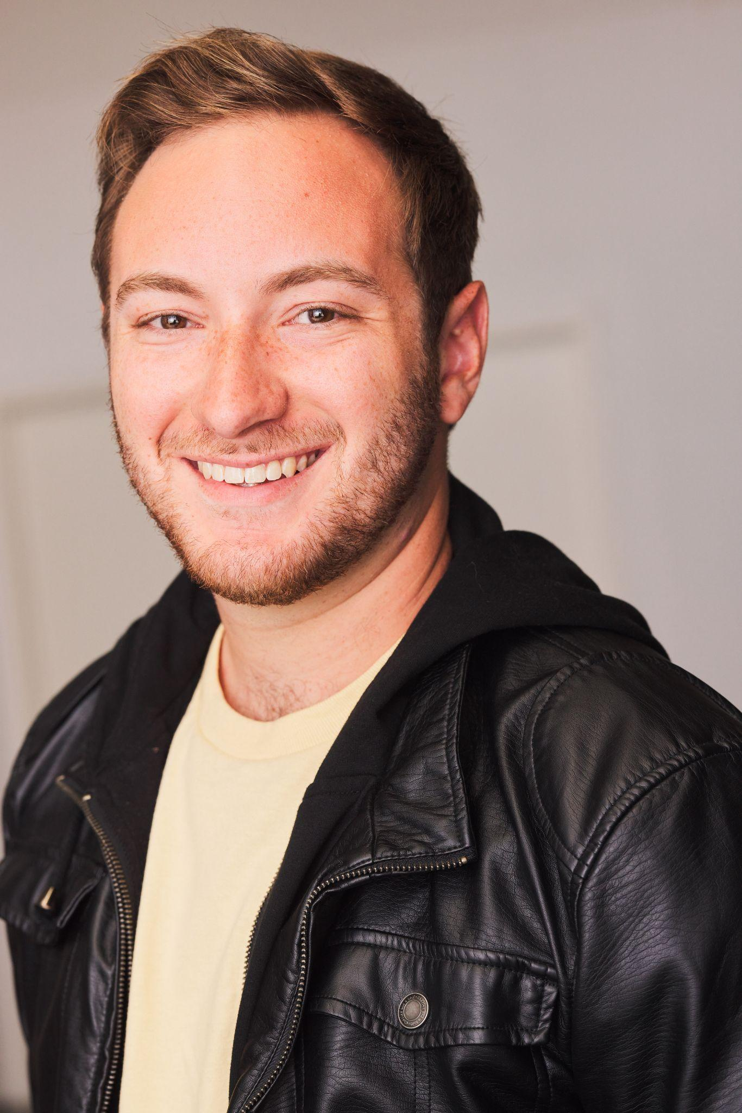

**Sam Davidson**

**Height:** 5’8’’ | **Hair:** Light Brown | **Eyes:** Brown | **Voice:** (F2-A5)

[Warriorofthehope@gmail.com](mailto:Warriorofthehope@gmail.com) | 818-515-8740 | [Samdavidsonactor.com](http://samdavidsonactor.com)

______________________________________________________________________________

**Educational Theatre**

Head over Heels Dametas Jerry Herman Theatre

Urinetown Officer Barrel Jerry Herman Theatre

Seussical Mr. Mayor Jerry Herman Theatre

Now Here This Soloist UCLA’s MTSI Program

A New Brain Ensemble Jerry Herman Theatre

Three Penny Opera Matthias Jerry Herman Theatre

_____________________________________________________________________________________

**Education and Training**

**BFA in Musical Theatre Performance -University of Miami-**

| **Dance:** | Christine Mazepa, Samantha Pazos, Natsuo Tomita, *Wild Card Dance Company,* *Los Angeles Ballet Academy*. (Hip hop, jazz, ballet, contemp) |
| --- | --- |
| **Acting:** | NDavid Williams, Richard Tatum, Michael Dean Morgan, Jenifer Bashline, Burton Tedesco, Kevin Kennison, Maha Mccain, April Shawhan, Michael Mcclain, Diane Feldman. |
| **Singing:** | NDavid Williams, Edgar Miguel Abréu, Ross Chitwood, Michael Mcclain,  Diane Feldman. |
| **Speech:** | Richard Tatum, Michael Dean Morgan, Jennifer Burke. |

**Special Skills**

**Stage Combat:** *Dueling Arts International* lvl 1 unarmed, broadsword, single rapier certified

**Impressions:** Stitch, Dr Doofinshmirtz, Mario, Beetlejuice (can do more and share voice reel on request)

**Accents:** Californian, Brooklyn, Cockney, RP, Irish, Russian, Southern

**Instruments:** Guitar (15 years), Piano (2 years)

**Experience with children:** Teaching music and jewish song leading for ages 3 to 16 (8 years)

**Languages:** English, Hebrew (Conversational)