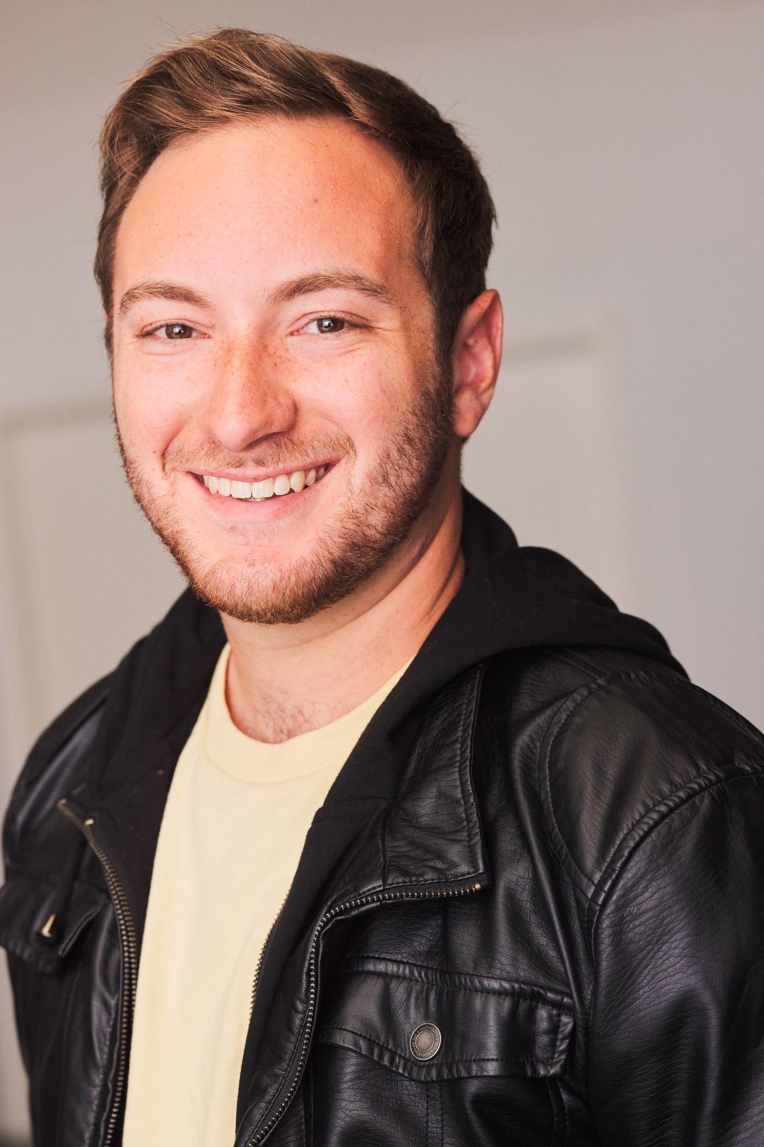
Sam Davidson

Height: 5’8’’ | Hair: Light Brown | Eyes: Brown | Voice: (F2-A5)

Warriorofthehope@gmail.com | 818-515-8740 | Samdavidsonactor.com
______________________________________________________________________________Theatre

Polar Express Swing Rail Event Productions
Head over Heels Dametas Jerry Herman Theatre
Urinetown Officer Barrel Jerry Herman Theatre
Seussical Mr. Mayor Jerry Herman Theatre
Now Here This Soloist UCLA’s MTSI Program
A New Brain Ensemble Jerry Herman Theatre
Three Penny Opera Matthias Jerry Herman Theatre
______________________________________________________________________________
Education and Training
BFA in Musical Theatre Performance -University of Miami-
Dance: Kyle Pleasant, Christine Mazepa, Samantha Pazos, Natsuo Tomita, Wild Card Dance Company,
Los Angeles Ballet Academy. (Hip hop, jazz, ballet, contemp)
Acting: NDavid Williams, Richard Tatum, Michael Dean Morgan, Jenifer Bashline, Burton Tedesco,
Kevin Kennison, Maha Mccain, April Shawhan, Michael Mcclain, Diane Feldman.
Singing: John Berst, NDavid Williams, Edgar Miguel Abréu, Ross Chitwood, Michael Mcclain,
Diane Feldman.
Speech: Richard Tatum, Michael Dean Morgan, Jennifer Burke.
____________________________________________________________________________
Special Skills

Stage Combat: Dueling Arts International lvl 1 unarmed, broadsword, single rapier certified

Impressions: Stitch, Dr Doofinshmirtz, Mario, Beetlejuice (can do more and share voice reel on request)

Accents: Californian, Brooklyn, Cockney, RP, Irish, Russian, Southern

Instruments: Guitar (15 years), Piano (2 years)

Experience with children: Teaching music and jewish song leading for ages 3 to 16 (8 years)

Languages: English, Hebrew (Conversational)

Shop Work: Carpentry, Sound Design, Sound Board Operation, Scenic Painting

