Course 2

Lesson 2 How to Turn On the Computer & Access the Internet
- Turn on the power button on the CPU.
- Turn on the power button on the monitor.
- If you by wish to print turn on the power button on the printer.
- Look for the Google symbol on your desktop computer or cellphone.

- Double click on the Google symbol with your mouse.
- At the top of your screen in the Google search engine bar where it will ask type in your search or web address. Then type in a word or the web address you are searching for.
- hen click on the enter key to go to the website
- Double click on the Google symbol with your mouse. 6. At the top of your screen in the Google search engine bar where it will ask type in your search or web address. Then type in a word or the web address you are searching for. 7. Then click on the enter key to go to the website.

- Repeat the same steps to visit other websites.
- Once you are done click on the X at the top of the page to close all of the browser.
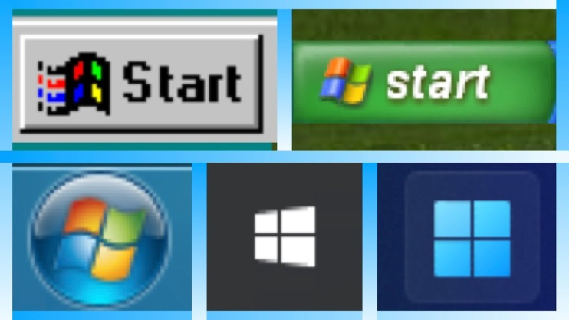
- Click on the start button on your computer.
- Scroll down to the word shut down . Then highlight the shutdown key and shutdown co
- Repeat the same steps to visit other websites.
- Once you are done click on the X at the top of the page to close all of the browser.

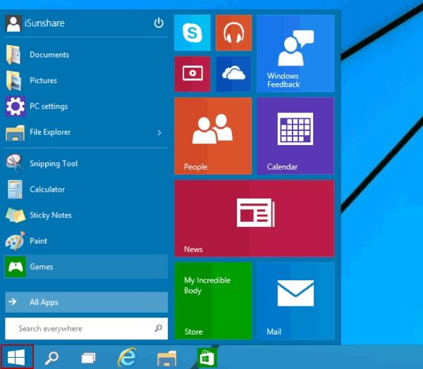

- Repeat the same steps to visit other websites.
- Once you are done click on the X at the top of the page to close all of the browser.
- Click on the start button on your computer.
- Scroll down to the word shut down . Then highlight the shutdown key and shutdown your computer.
- Then push the power button on your monitor and turn off your monitor.
.

