Help Shut Down Slave Houses

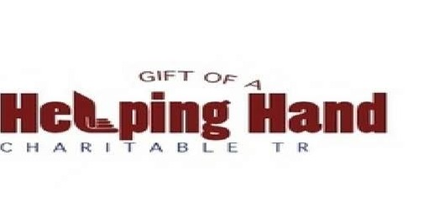
Help shut down these slave houses permanently and globally. These slave houses are a haven for drug trafficking, human trafficking, prostitution, molestation of children, rape of young girls and women, kidnapping, gang activities and other illegal crimes. If you are suspicious of slave homes and illegal activities in your communities please contact the local authorities. Feel free to contact Cathy Rather Russell at helpinghands20021964@gmail.com or authorcathypratherrussell@gmail.com if you would like to make a donation to help support this cause.

