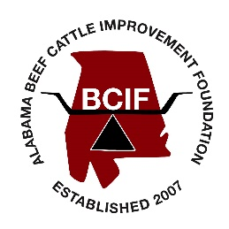

**Application for Alabama Beef Cattle Improvement Foundation Undergraduate Scholarships**

**First Name: Middle Initial: Last Name:**

**Current Mailing Address:**

**Current Phone #: Email:**

**Home (or Permanent) Mailing Address:**

**Home (or Permanent) Phone #:**

**Degree Sought: Department:**

**\*\*(Please include your major and any minor studies)\*\***

**Academic Advisor:**

**Please Indicate Your Academic Classification:**

**Freshman Sophomore Junior Senior**

**Expected Semester and Year of Graduation:**

**Current GPA: Number of Hours for the Current Semester:**

**\*\*Please also provide with this application an OFFICIAL copy of your transcript.\*\***

**List all financial assistance, scholarships, and/or other fellowships that you are receiving or have been approved for the current or upcoming academic year.**

**Career Goals:**

**Livestock Background:**

**Extracurricular Activities/Leadership/Internships/Employment in Agricultural Industries:**