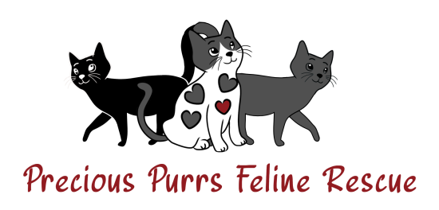

Precious Purrs Feline Rescue

Phone (951)446-9791

E-mail: [preciouspurrsfr@gmail.com](mailto:preciouspurrsfr@gmail.com)

Name of Cat/Kitten(s):

***Tell Us About Yourself:***

Name:

Primary Phone Number:

Alternate Contact:

Home Address:

City, State, Zip code:

Is this a house, apartment, condo etc?

Do you rent or own?

If own, are you the owner?? Who is?

If renting, who is the lease holder?

If renting, does your landlord allow pets? Please provide name and phone number for landlord:

Are you at least 18 years of age??

Page 2

***Adoption Questions:***

Is the cat/kitten(s) being adopted for you or for someone else?

How long have you been thinking of adopting and why is now the right time?

Who will be responsible for the cat/kitten’s daily care?

Is everyone in the home on board with adopting?

Tell us about animals you have cared for in the past?

Are you prepared to care for this cat/kitten for their entire lifespan of 15 to 20 years?

Yes-

No-

Will the cat(s) be indoor or outdoor? Please share your thoughts.

Page 3

Please share with us your thoughts on declawing cats?

Do you have any other pets currently??

If yes, what kind of pets and how many, ages?

Are your pets vaccinated, spayed/neutered?

Have you ever adopted from a rescue or animal control agency before? If yes, name of the rescue or animal control agency.

Have you ever had to re-home a pet?? If yes, why?

What factors could cause you to give up a pet?

What will you do if you have to give up the cat/kitten?

Do you have a vet? Please list name and phone number:

Do you give us permission to contact your vet?

Do you take your pets for routine wellness checkups/ vaccine boosters?

If yes, how often, if no, why?

What would you consider too much to spend on a cat for a medical situation?

Personal Reference:

Name:

Phone Number:

Relation:

What makes you a great adopter?

***About your household:***

Please list and provide the name and age for all members of your household, including yourself.

What is a typical day like in your household?

Page 5

Does anyone in your household have allergies or asthma?

Does anyone in your household smoke?

Do you work outside the home?

What is your profession?

Would you be amenable to a home check?(could be virtual or in person)

Do you anticipate any major life changes in the next 6 months? (Moving, new baby, job change etc..)

Thank you so much for taking the time to fill out the application.

We do this to help ensure that we place our cats in loving, responsible, committed homes, we have a screening process before you can adopt a pet from Precious Purrs Feline Rescue, that includes an application, a phone interview, small adoption fee, and adoption papers. We reserve the right to turn down potential adopters as we deem necessary.  
Animals are for life. When you adopt an animal, it is a commitment you make to the animal, for the lifetime of that animal. By adopting a cat from Precious Purrs Feline Rescue, you’re making a commitment to provide love, care, and medical treatment for the life of the animal, which can be up to 20 years or more. Adopting a cat is a serious commitment that is incredibly rewarding. 11/14/23