Cardiovascular Testing

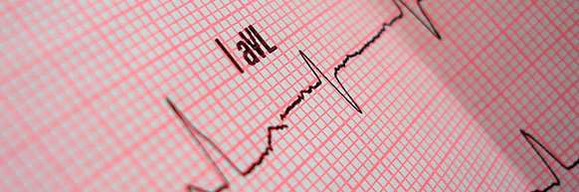

Electrocardiogram

An electrocardiogram, also known as an EKG or ECG, is a noninvasive diagnostic test that detects electrical activity in the heart. It is usually part of a routine physical exam and is commonly performed after patients have experienced heart attack symptoms including chest pain, shortness of breath and heart palpitations. An EKG produces a record of waves that relate to the electrical impulses that occur during each beat of a patient's heart.

This test is performed by attaching electrical wires, called electrodes, to the arms, legs and chest. The EKG will begin recording your heart's electrical activity, showing how quickly and regularly your heart beats, as well as any structural abnormalities in the chambers and thickness of the heart. It is important for patients to remain still during this test, as muscle movement may interfere with results. Abnormal results from an EKG may indicate signs of a heart condition, which should be further investigated.

Cardiovascular Testing

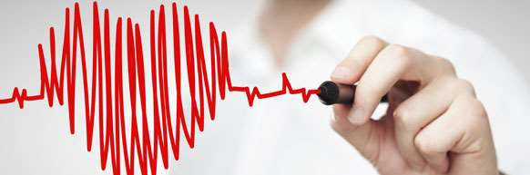

Echocardiography

Echocardiography uses an echocardiogram (ultrasound of the heart) to assess the functioning and health of the the heart by creating images out of sound waves. In addition to detecting many other heart problems, echocardiograms can diagnose specific heart conditions; determine if heart abnormalities exist; and evaluate the effectiveness of procedures that have been performed on the heart.

The most common type of echocardiogram is transthoracic (TTE), which is painless and noninvasive. A transducer that emits high-frequency sound waves is placed on the patient's chest; when the sound waves bounce back to the transducer, they are interpreted by a computer and the results are shown on a monitor.

Cardiovascular Testing

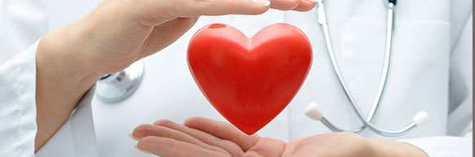

Arrhythmia Monitoring

Heart arrhythmias occur when the electrical impulses that coordinate your heartbeats don't function properly, resulting in your heart beating irregularly, too quickly or too slowly. To diagnose a heart arrhythmia, your doctor will review your symptoms and perform cardiac tests that specifically monitor arrhythmias. These tests include:

- Electrocardiogram
- Holter Monitor: a small, wearable device that keeps track of your heart rhythm for 24 hours while you go about your daily activities.
- Event Monitor: a portable device that you attach to your body as you experience arrhythmia symptoms.
- Zio XT Patch: a small, wearable patch that continuously records your heart rhythm for up to 14 days.

Cardiovascular Testing

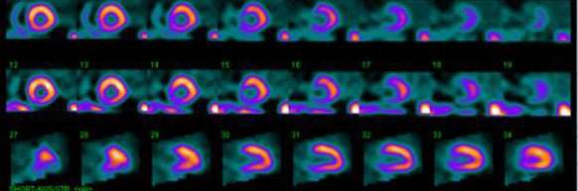

Nuclear Perfusion Imaging

Nuclear perfusion imaging, also known as a nuclear stress test, is a diagnostic test performed to determine if the heart is receiving adequate blood supply under both stress and rest conditions. The test is done with the injection of a small amount of radioactive material into the bloodstream, which will circulate throughout the body and help to evaluate the blood flow and function of the heart. This procedure is performed to determine the risk of a heart attack and to show if there is a limited blood flow to the heart and determine the best treatment plan for serious heart conditions.

During the stress test, a radioactive isotope (either thallium or sestamibi) is injected into the oodstream once during the exercise portion of the test and again when the patient is at rest. Images of the heart will be taken shortly after each injection to show any areas of the heart that are not receiving enough blood. Both sets of images will be interpreted by a board­ certified nuclear cardiologist before providing the patient with the results.
Cardiovascular Testing

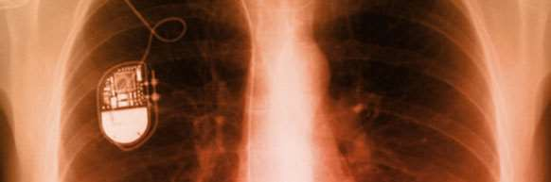

Pacemaker Interrogations

If you have a pacemaker implanted, you will need to have it monitored at regular intervals. Your doctor will use a computer to ensure that your pacemaker is functioning properly and that there is adequate battery life.

Cardiovascular Testing

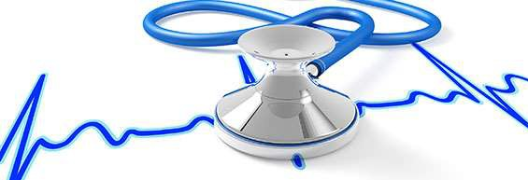

Stress Echocardiogram

A stress echocardiogram is a diagnostic test used to evaluate the strength of the heart mus as it pumps blood throughout the body. Using ultrasound imaging, the stress echocardiogra detects and records any decrease in blood flow to the heart caused by narrowing of the coronary arteries. The test, which takes place in a medical center or in the doctor's office, is administered in two parts: resting and with exercise. In both cases, the patient's blood pressure and heart rate are measured so that heart functioning at rest and during exercise can be compared. The ultrasound images enable the doctor to see whether any sections of the heart muscle are malfunctioning due to a poor supply of blood or oxygen.

Reasons For A Stress Echocardiogram

The test is administered to patients whose heart health is in question or to evaluate ongoing cardiac treatment. Patients are candidates for a stress echocardiogram if they have been having chest pains or angina or have recently had a heart attack. They may also have the t as a requirement prior to heart surgery or before beginning an exercise program. The stres echocardiogram measures:

- How well the heart muscle and valves are working
- How well the heart handles exercise (stress)
- Whether the patient is likely to have coronary artery disease
- Whether the patient's heart function has improved after treatment
- Whether chambers of the heart are enlarged

Results of the stress echocardiogram are helpful to the cardiologist in determining whether there is a problem with heart muscle strength and what that problem might be. They also he determine an appropriate new course of treatment or evaluate a previous one.

Preparing For A Stress Echocardiogram

Before undergoing a stress echocardiogram, patients should ask their doctors whether it is necessary to temporarily stop taking certain medications prior to the test. Patients should refrain from eating or drinking for at least 2 hours before the test and wear comfortable, lam fitting clothing to the procedure.

The Stress Echocardiogram Procedure

Before the test begins, the patient will have electrodes placed at various locations on the chest, arms and legs to record electrical activity in the heart, and will be wearing a blood pressure cuff. The resting portion of the procedure is administered while the patient lies on t side with the left arm extended. The doctor moves an ultrasound transducer over the patien chest. A special gel has been applied to enable the transducer to move smoothly and to transmit sound waves directly to the heart.

During the second portion of the test, the patient exercises by walking on a treadmill. At approximately 3 minute intervals, the patient will be asked to speed up activity or to walk up an incline. Depending on the patient's age and fitness level, the test can take from 5 to 15 minutes. Normally, the test is stopped when the patient's heart is beating at a targeted rate, when fatigue, chest pain, or blood pressure changes necessitate cessation. The test results provide the doctor with critical evidence as to whether the heart has more difficulty functioni under stress.

Preparing For Your Appointment
Once you have scheduled an appointment, you can fill out the patient forms at home, or you can come in 15-20 minutes before your appointment to fill out the paperwork in our office.
The necessary forms for your visit include the registration form, patient consent form, electronic prescribing and demographic form, and your corresponding doctor's history form.

Here is a list of items that you should bring with you:

- Insurance card(s)
- Photo identification, such as a driver's license
- Referral form (for HMO insurance, if required)
- List of current medications you are taking including prescriptions, over-the-counter medications and any herbs (do not hesitate to just bring in the bottles if you are unsure)
- Current pharmacy information
- Relevant information about your medical and surgical history

Having these items ready will help us ensure a smooth office visit.

Mandatory Electronic Prescription Medication Compliance
As of March 27, 2016, NYS Public Health Law requires your prescriber to electronically prescribe (e-prescribe) all your prescription medications directly to your pharmacy.
Prescriptions will no longer be handwritten or called in to your pharmacy, except in limited circumstances.

When requesting prescription refills, please make sure that our office has up-to-date pharmacy information so that we may electronically send your prescriptions to the correct pharmacy. If you use more than one pharmacy, please indicate which pharmacy you would like us to use when requesting your refills.

Please click here for more information from the NYS Department of Health and for answers to frequently asked questions.

To request prescription refills, please call (212) 752-2000 option 5.

Patient Forms
Please download the appropriate forms (depending on the doctor you are scheduled with) and complete prior to your appointment. Please be sure to bring the completed paperwork with you.

Our Services

For more information on Our Services, click on the links below

Cardiovascular Testing
- Clinical Cardiology Services
  - Electrocardiogram
  - Echocardiography
  - Stress Echocardiogram
  - Exercise Stress Test
  - Nuclear Perfusion Imaging
  - Arrhythmia Monitoring
  - Pacemaker Interrogations
  - Abdominal Aortic Ultrasound

