**Bixby Grove HOA**

PayHOA Overview

March 2023

# System Overview

PayHOA streamlines account management for both homeowners and board members.

## Registration

Homeowners can easily register in seconds.

1. Visit PayHOA.com and select Join your HOA.
2. Click activation email.

### Payments

Never miss a payment or hassle with checks or money orders. You can enable auto pay and let the system do the work for you.

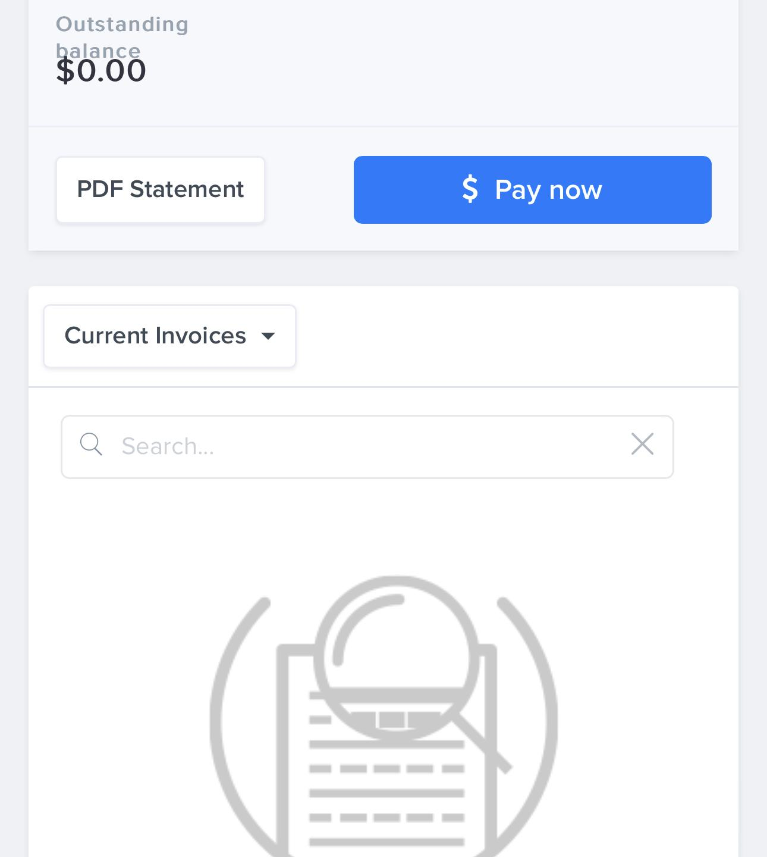

Payment Features

* AutoPay
* 24/7 access
* Real time processing
* Electronic Receipts
* Account History
* Payment Plans
* Low Processing Fees

Benefits

* Reduce returned check fees.
* Eliminates waiting for a receipt.
* Reduce manual entry, eliminating typos/mistakes
* Eliminates waiting for a check to clear.
* Allows owners to pay with credit card.
* Owners can break down annual fees into smaller, more manageable amounts.
* Board can perform in-house collections, reducing legal fees.
* Seamless transition to successors.

## Communication Features

* Documents 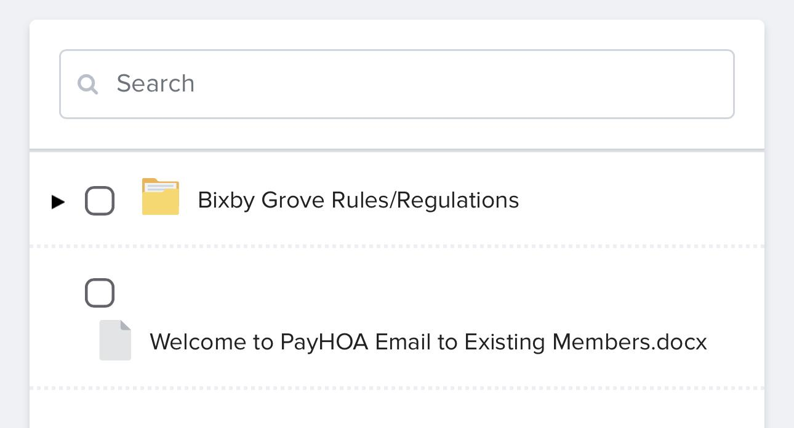
* Calendar 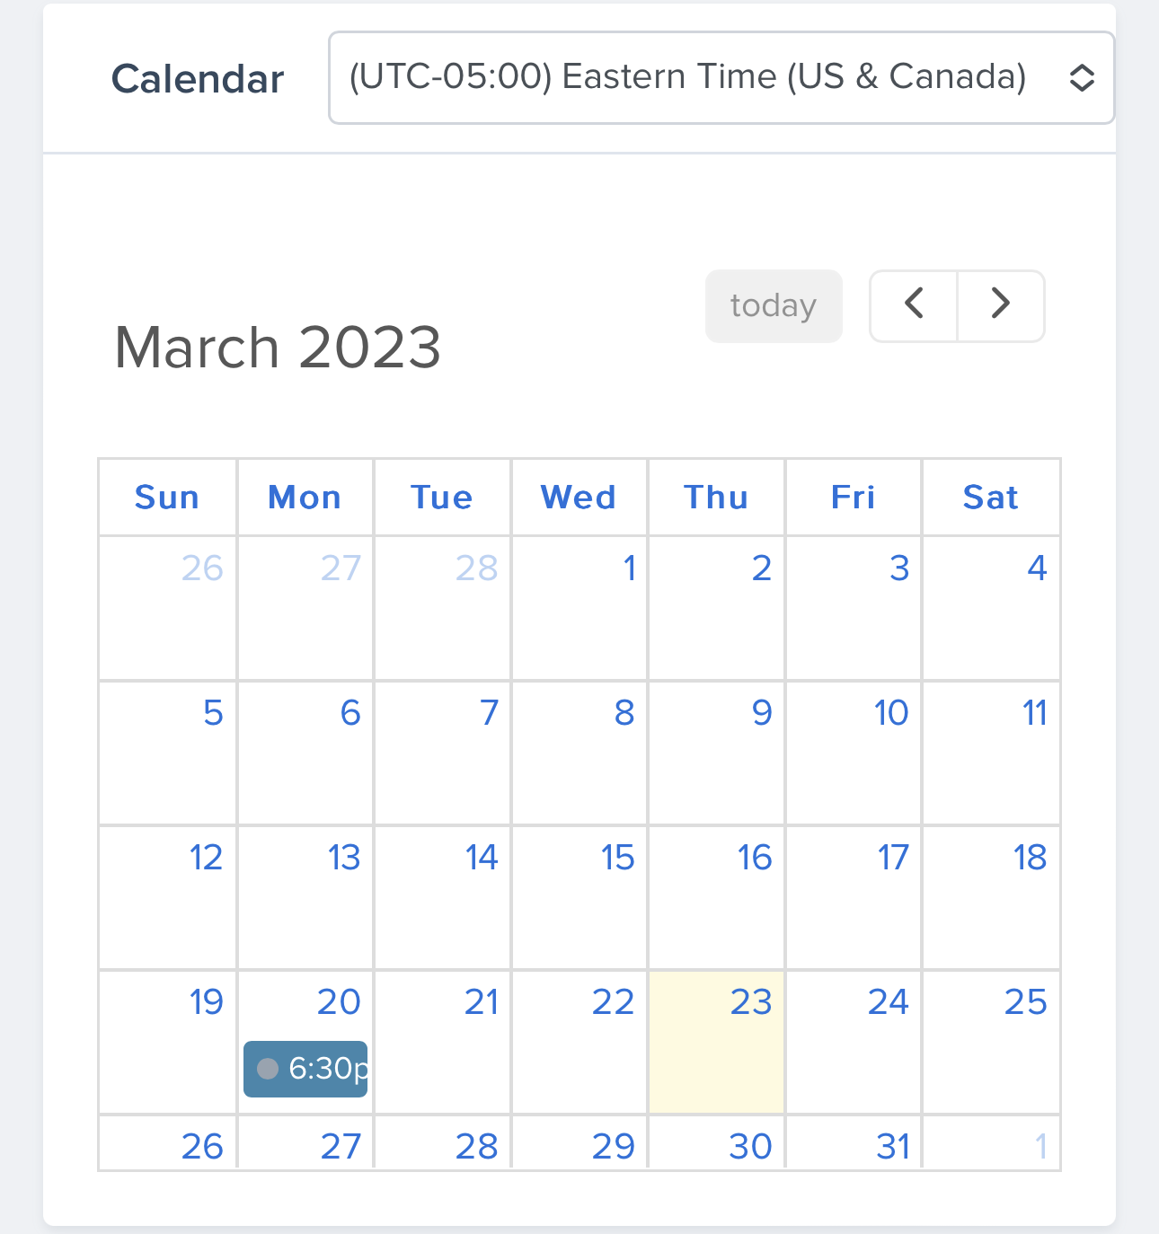
* Message Boards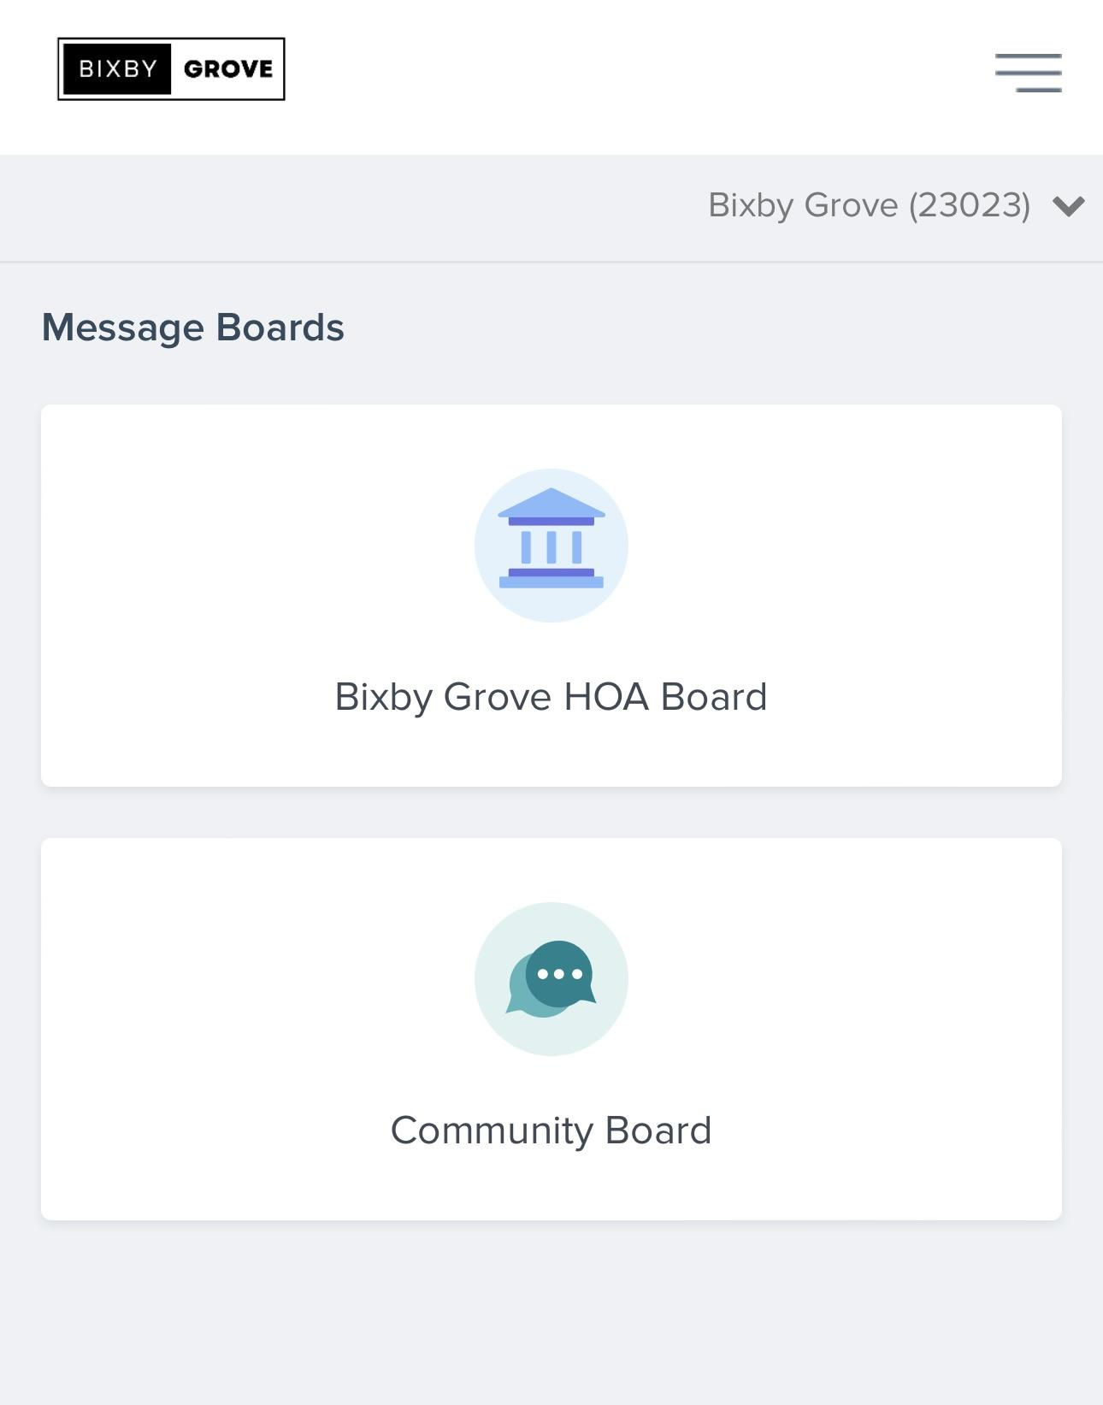
* SMS Text
* Email
* Paper Mail
* Surveys

Communication Benefits

* Easily find information in one place
* Chat with neighbors
* Share ideas
* Ability to send text blast for urgent needs (lost pet, snow removal)
* Clean email (never get a reply to all again)
* Tracking feature to determine if mail is undeliverable
* Print/mail service (we’ll never ask you to help fold and stuff 300 envelopes)
* Owners can update contact information
* Survey can gauge community preferences or facilitate voting

# Request Features

* Exterior Improvements
* Compliance Concerns
* General Requests
* Variance Requests

Request Benefits

* Owners can track status/progress 24/7
* Record of applications/approvals in one location.

Violations

* Violations can quickly be processed to speed the resolution process.
* Track repeat offenses, allowing board to take more aggressive action