**DISABILITY DISCRIMINATION AWARENESS QUESTIONNAIRE (DDAQ)**

**SUMMARY PILOT GROUP FINDINGS (n=100) (08.04.25)**

Disability discrimination is common in the NHS. (Tyerman, 2023). Neither the disability requirements of the UK Equality Act (EqA, 2010) nor the UN Convention on the Rights of Persons with Disabilities (UNCRPD, 2006) are covered effectively in professional training. In response, resources were developed to raise awareness, promote good practice and reduce discrimination. This includes a Disability Discrimination Awareness Questionnaire (DDAQ); 5 Disability Discrimination Practice Checklists (DDPCs); background, suggested action and reference material, hosted on website: <https://equitynotjustequality.co.uk/>

The natural starting point is the DDAQ (Tyerman et al. 2023). This focuses on the objectives of the UNCRPD (2006) and Equality Act (EqA, 2010) rather than legal liability. Items are taken from the Equality & Human Rights Commission (EHRC) statutory codes on ‘services, public functions and associations’ (EHRC, 2011b) and ‘employment’ (EHRC, 2011a) and technical guidance on ‘further and higher education’ (EHRC, 2014). Items cover the definition of disability (7 items) and forms of discrimination: direct (3), indirect (4), arising from disability (2), failure to make reasonable adjustments (10), harassment/ victimisation (2) and other unlawful behaviour (2). Results for the first 100 pilot healthcare respondents in the UK are reported below.

**Respondents**

Of all respondents, 88% were health professionals, most of whom work with people with disability on a routine basis. This was mostly OTs (**26%),** Psychologists (19%), Medical staff (19%), Physiotherapists (9%) and Speech & Language Therapists (6%). The other responders include other therapists, nurses, administrative staff and assistants. The respondents are mainly experienced staff: 24% > 20 yrs.; 63% > 10 yrs. and 76% > 5 yrs. Of 88 asked, 37% reported a prior reason to seek information on disability discrimination.

**Total DDAQ score**

The distribution of DDAQ scores, plotted below, has a flat / wide peak (scores 11-22). 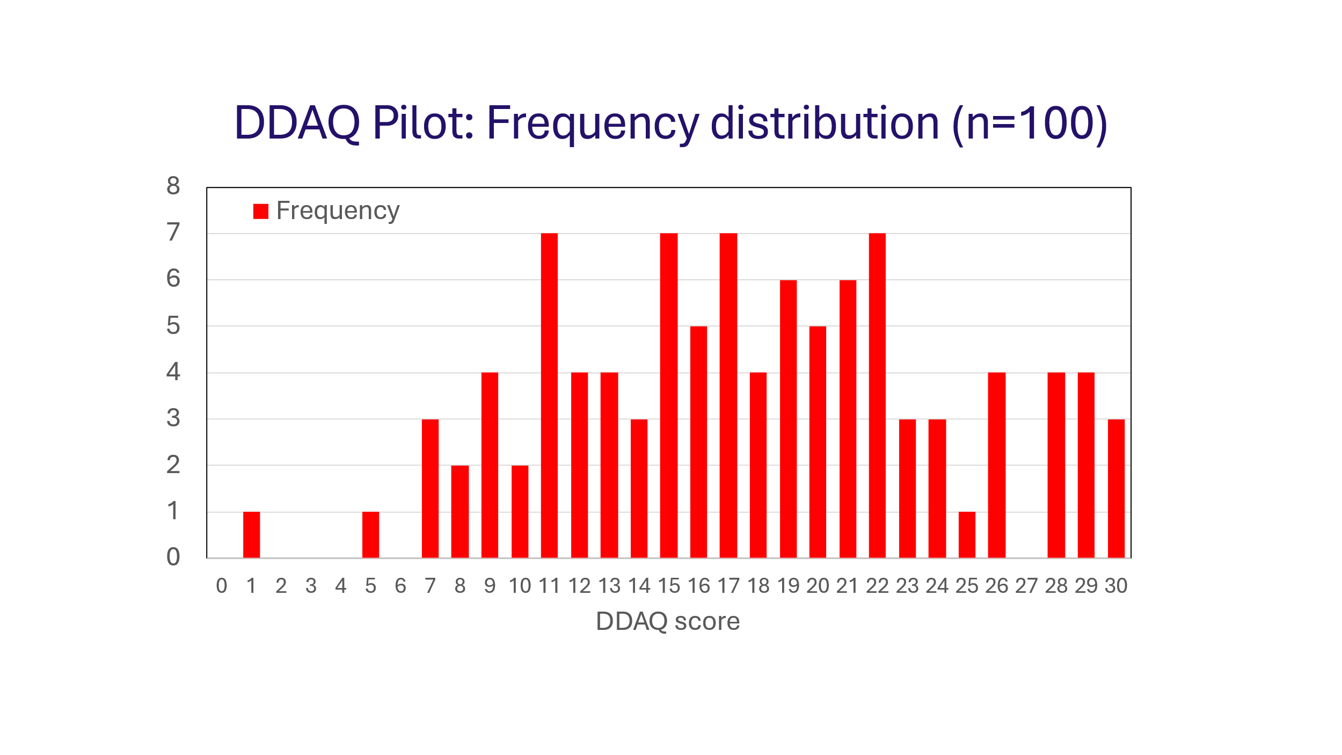

***The mean total DDAQ score was 17.76 (median 17.5, range 1-30), equivalent to just 59% awareness*.** In order to prevent disability discrimination you would expect health professionals to know all except perhaps two DDAQ items (Nos. 12 & 16), both related to the legal justification for not making adjustments. If you allow one other gap in awareness, the target score on the DDAQ is provisionally set at 27-30 (i.e. a score of 90% or higher).

***The target score of 27-30 was achieved by just 11% of respondents, with 38% scoring 50% or less and 13% scoring 33% or less***.

**Awareness on individual DDAQ items**

Awareness on individual DDAQ items ranged from just 23% to 97%, ***with 10/30 items known by less than 50% of*** ***healthcare staff.***  Whilst there were many ‘partly aware’ responses (range 3-51%), these would likely not prevent discrimination. Whilst at least one item was known by less than 50% in each section except for Direct Discrimination, it is of major concern that 3/7 items on the definition of disability and 3/10 on the duty to make reasonable adjustments were known by less than 50% of respondents, as detailed below.

|  |  |  |
| --- | --- | --- |
| **Table 1. Summary of key items of concern with less than 50% awareness** | | |
| 4 | Exceptions to standard disability definition for people with cancer, HIV and MS | 23% |
| 5. | A medically diagnosed cause of impairment is not required | 25% |
| 6 | Need to set aside treatment and adjustments in judging if disability covered by EqA | 46% |
| 13 | Indirect discrimination unlawful, even if disadvantage not intentional or even realised | 49% |
| 21 | Need for risk assessment if denying work/service adjustments on grounds of H&S | 39% |
| 23 | If co-operation of others needed, obstructive/unhelpful behaviour to be dealt with | 37% |
| 25 | Reasonable step not taken if adjustment does not reduce disadvantage | 46% |
| 28 | Disability related victimisation – definition and the nature of ‘protected acts’ | 31% |

**Awareness self-ratings (n=100)**

As illustrated in the figure below, mean ratings of prior awareness after DDAQ completion was 5.78. As a result of the DDAQ training, mean ratings rose significantly by 1.96 to 7.74 (t = 12.05, p<0.0001). ***This represents a 34% increase in overall awareness.***

This encouraging increase is also likely reduced slightly through a partial ceiling effect as both the two ratings of pre-DDAQ awareness at 10/10 and the 7 scoring 9/10 did not have a need or scope to increase in line with the mean rise of 2.16 points for the other 91 respondents. ***The mean increase of 2.16 (5.44>7.6) for 91 staff with a need to improve awareness (i.e. score 8 or below) represents a 40% increase*** *(up from 34% for all 100).*

The increase in awareness for staff with the lowest ratings is marked: those with a rating of 5 or below reduced from 42% to 9% and those rating 4 or below from 25% to just 1%. ***The mean rises of 3.07 and 3.36 represent increases of 80% and 109% respectively.***

Mean ratings of overall awareness for retrospective pre-DDAQ and post DDAQ training are plotted below for all 100 respondents, for the 91 excluding 9 with a likely ceiling effect and for the 42% and 25% rating their prior awareness at 5/10 or below and 4/10 or below.

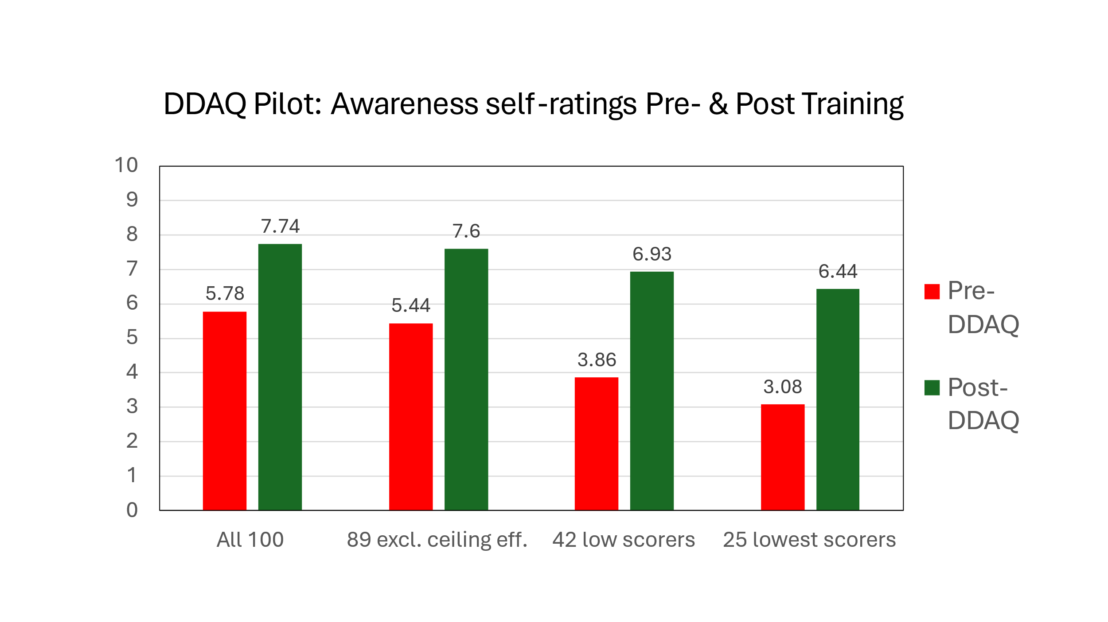

**Summary and conclusions**

The first 100 DDAQ responses from mainly well experienced health professionals, most of whom work routinely with people with disability, confirm a striking lack of awareness of the specific disability rights and discrimination. The overall DDAQ target score was achieved by just 11% of staff, with 38% scoring 50% or less. Of the 30 individual items, 10 were known by under 50% of staff including 3/7 items on the EqA definition of disability and 3/10 items on the duty to make reasonable adjustments. As such, NHS staff and Trusts are at risk of inadvertent acts of discrimination in clinical practice and service delivery. This is in the context of the UNCRPD’s additional responsibilities for healthcare staff, over and above the core requirements of the Equality Act and Public Sector Equality Duty.

Completing the 15-20 min. DDAQ training resulted in a 34% increase in self-ratings of awareness for all respondents, 40% if the 9 highest scorers with no need and little scope to improve are excluded. For those with previous self-ratings at or below 50% and 40% rose by 80% and 109% respectively. The extent of the rise in awareness indicates a lack of effective training on the disability requirements of the UNCRPD and Equality Act.

Results from this pilot suggest that the DDAQ training significantly improves awareness of disability discrimination. The DDAQ and other resources are available to NHS staff now at no charge. There is a need for the DDAQ to be completed by a large representative group to check for any differences across professions, experience and work settings and to consider targeted training. This would need commitment from one or more NHS Trusts.

Whilst the DDAQ was developed initially with the NHS in mind, it seems likely that it has much wider potential public and private sector application. This warrants exploration. Any interested individuals, teams, services or organisations are invited to make contact.

In conclusion, there is an urgent need to review training on disability rights and the specific responsibilities of health professionals under the UNCRPD and the Equality Act. Given the difficulty in engaging NHS staff in post in the DDAQ training, this could potentially be achieved by including the DDAQ in Trust induction programmes or on internal promotion to a service or staff management role. We would then be in a much stronger position to respond to the call for urgent action to advance health equity for persons with disabilities from the WHO (2022) and the UK Equality and Human Rights Commission (EHRC, 2017).

**Author/contact details**:

Dr. Andy Tyerman, BA., MSc, PhD, CPsychol, FBPsS, BEM,

Honorary Consultant Clinical Neuropsychologist

[a.d.tyerman@gmail.com](mailto:a.d.tyerman@gmail.com) 07889-494740

**FYI: A fuller report *‘DDAQ HC100 08.04.25’* is available as one of the downloads at the bottom of the following web page:** [**https://equitynotjustequality.co.uk/ddaq**](https://equitynotjustequality.co.uk/ddaq)

**References**

EHRC (2011a). Equality Act 2010 Employment Statutory Code of Practice. Equality and Human Rights Commission. <https://www.equalityhumanrights.com/sites/default/files/employercode.pdf>

EHRC (2011b). Equality Act 2010: Services, public functions and associations. Statutory Code of Practice. Equality & Human Rights Commission. <https://www.equalityhumanrights.com/sites/default/files/servicescode_0.pdf>

EHRC (2014a). Equality Act 2010: Technical Guidance on Further & Higher Education. <https://www.equalityhumanrights.com/sites/default/files/equalityact2010-technicalguidance-feandhe-2015.pdf>

Tyerman A (2023). The WHO call for urgent action to advance health equity, set in the context of the UN Convention on the Rights of Persons with Disabilities and the Equality Act. Clinical Psychology Forum, 368: 33-42. Leicester: British Psychological Society. Download ‘CPF_368_ Andy Tyerman (pdf)’ at the bottom of web page: <https://equitynotjustequality.co.uk/context>

Tyerman A., Tyerman P., Tyerman, E., & Tyerman, C. (2023). The Disability Discrimination Awareness Questionnaire (DDAQ). On-line resource available at: <https://www.equitynotjustequality.co.uk/ddaq>

UNCRPD (2006). United Nations Convention on the Rights of Persons with Disabilities. UN General Assembly Reports on Social Development. <https://social.desa.un.org/issues/disability/crpd/convention-on-the-rights-of-persons-with-disabilities-crpd>

WHO (2022). Global report on health equity for persons with disabilities. World Health Organization. <https://www.who.int/teams/noncommunicable-diseases/sensory-functions-disability-and-rehabilitation/global-report-on-health-equity-for-persons-with-disabilities>