Fundraising Opportunities for Branches
Please do your own due diligence to ensure that these programs are right for your branch
and that they can be done safely at this time.

Terra Greenhouses | https://www.terragreenhouses.com/fundraiser/  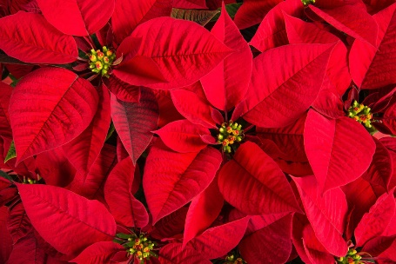  Terra Greenhouses are in Burlington, Hamilton, Milton, Waterdown, and Vaughan. | TERRA grows over 60,000 Poinsettias each year. We pride ourselves on superior quality plants that simply cannot be found elsewhere. A plant sure to brighten any room during the Holiday season can become a great fundraising venture for your group.  TERRA’s great poinsettia Fundraising is an established program that has brought great success to several causes. From schools to churches, sports teams and clubs, all have brought great gains to their cause.
Factory Shoes | https://www.factoryshoe.ca/_store/fundraise.php | Earn $5 for every pair of shoes purchased.
Share your fundraising initiatives in your holiday greetings! | 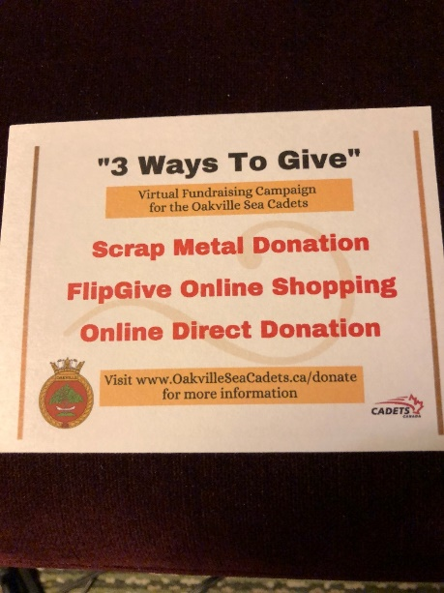 | This was enclosed in the holiday cards sent out by the Oakville Branch.  A similar message could be shared on your website and social media platforms, too.  Thank you, Oakville Branch, for sharing this great idea!
Terra Cotta Foods Ltd. - Cookie Dough Drop ™ Fundraising | www.terracottacookies.com/fundraising | The products are sold for $13 per box (40 cookies), and you make $5 profit on every sale.
Rain barrel Fundraising | https://rainbarrel.ca/programdescription/ | Summary: Customers order online from a dedicated webpage. The barrels are sold for less than half of what you would pay for a new product at a retail store. Profits are $10 or more per barrel depending on the selling price. Branch members are needed to staff the 2–3-hour distribution day at your location. Additional profits can be made on some accessories like downspout diverters, rain barrel stands and hoses.
Canadian Safety Supply | https://www.canadiansafetysupplies.com/Fundraising-with-First-Aid-Kits-s/157.htm | From the website:  First Aid items are easy to sell:  · Practical useful items make great purchases and gifts  · No upfront payment, no contract  · Quality made in Canada products; no minimum orders  · Free Shipping for orders of $1000 or more  · Great profits (40% or more)  Products can carry your logo if a minimum order is placed.
Equator Coffee Roasters | https://equator.ca/  Program Letter https://acrobat.adobe.com/link/review?uri=urn:aaid:scds:US:0c337cf3-312b-30ee-8643-1183be0fc0b4  Individual Order Form https://acrobat.adobe.com/link/review?uri=urn:aaid:scds:US:3d12088c-02ba-381d-9a2b-1bc45396c75c  Summary Order Form https://acrobat.adobe.com/link/review?uri=urn:aaid:scds:US:4bbf5938-113e-39d0-8ae3-3ed091afdff7 | Summary: Equator Coffee is organic coffee offering 8 different blends either as whole bean or ground coffee. They also offer products such as cane sugar, cocoa powder, semi-sweet chocolate chips, hot chocolate, chocolate bars, and tea. The minimum order is $100.00 with the potential of making approximately 50% markup on each product. The Program Letter will give you further information and instructions if you are interested.

