**Erlton North Windsor Civic Association Update**

**December 2020**

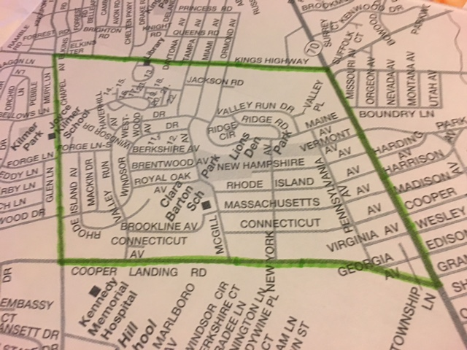

**A Message from the ENWCA**

It has been a really tough year for all of us and we would like to thank everyone who participated in our Birthday Parades, our Light It Blue campaign, our Dinner for Jefferson from Chick’s, our Movie Night in the Park, our Window Scavenger hunts and Chalk Art Challenges. The “Boo” basket, instead of our regular Halloween Kick-Off gathering seems to have been a hit. We sincerely hope that our efforts helped make 2020 just a bit more bearable and we will continue to be as creative as we can, until we can all get back to normal again. We wish all of our residents a Happy and Healthy Holiday Season and let’s hope 2021 is a much better year for all of us.

**Thanks from the ENWCA**

The ENWCA sends a big shout out to Abe Karetny for another very successful Neighborhood Yard Sale despite the rain in the early morning. Thanks also go to Pam Carpenter for organizing our Clean Communities event once again. The ENWCA thanks both of you for your continued commitment to our neighborhood.

**Annual General Meeting**

Our Annual General Meeting of the ENWCA will be held via Zoom this year due to COVID restrictions. It is scheduled for January 27th at 7pm. This meeting is open to all residents of Erlton North and Windsor Park. Our Annual elections will be held to elect board members for 2021. We encourage residents to attend. We welcome your input and ideas. If you wish to receive the link for the meeting, please email [trvldawn@aol.com](mailto:trvldawn@aol.com).

**Feral Cats in Erlton North Park**

The ENWCA is working with the Township, Voorhees Animal Shelter and Independent Animal Control on the continuing problem with the feral cats in Erlton North Park with some success. This situation is causing real medical issues for some of our residents with serious cat allergies. They are also setting off people’s security alarms in the middle of the night and using resident’s flower gardens as litter boxes creating an awful odor. The Township has advised us to ask all residents to please stop feeding the cats as it only exacerbates the problem. If you are experiencing problems with the cats, please contact us at [trvldawn@aol.com](mailto:trvldawn@aol.com). Let’s all work together to find a better alternative for the cats and reduce the problem for our neighbors. .

**Holiday Decorating Contest**

The neighborhood is starting to look very festive so it is time to start our Annual Holiday Decorating Contest. Please take a moment and drive around the neighborhood and vote for your favorite house in the following categories:

Best Decorated

Most Decorated

(a home cannot win in both categories so make sure you vote for one in each)

Kids’ Choice Award-this is for the kids to pick and our winners always love getting this one. Please remember to include your child’s name as they will be entered in the drawing for a $25 gift card.

Please send all of your votes to [trvldawn@aol.com](mailto:trvldawn@aol.com) by December 20th.

**Traffic Issues**

The ENWCA has been working with the Council of Cherry Hill Civic Associations to advocate for more traffic enforcement in the neighborhood. This is an ongoing problem on many of the streets that are used by “cut through” traffic. We are asking the township to monitor the situation so please, be cognizant of your speed at all times to avoid being ticketed by CHPD.

**Business Card Ads**

Do you have a business or know of a business that would like to buy an ad in our quarterly newsletter or on our website? This will help us raise funds to do more for the neighborhood. .

**ENWCA Membership Drive**

In order to be as productive and effective as we envision, we need your support. Our annual dues are $20 per household. Please join us if you haven’t already. There are real benefits to joining with us.

1. ENWCA has joined with the [Global 1 Federal Credit Union](http://global1fcu.com/), located on Maple Avenue in Pennsauken. ENWCA members, in good standing, are able to join the credit union for their own personal business. There are many benefits to being a member of a credit union, such as: various savings accounts, CD’s, IRA’s, Vacation Club accounts, Direct Deposit, Auto, home and personal loans, Visa Credit and Debit cards and MasterCard Credit cards. We are very pleased to be able to offer this service to our members.
2. We will continue to advocate for our neighbors and work hard to find solutions for the problems and look for social opportunities to bring our neighborhood together.
3. As we receive them from the Cherry Hill Police, we will email Police reports for our neighborhood, to our members. It is in all of our interests to know what is happening around us.

If you have not yet paid your dues for 2020, please go to our website at enwca.org where you can join using Paypal or if you would prefer, please mail a $20 check to ENWCA, c/o 207 Rhode Island Avenue, Cherry Hill, NJ 08002.

NAME:______________________________________________________

ADDRESS___________________________________________________

Email:___________________________Phone:______________________

Please include email to receive quarterly newsletters.

**2020 ENWCA Executive Board Members**

Dawn Higgins-President

Abe Karetny-Vice President

Casey Marshall-Treasurer

Genie Pentimalli-Secretary

Pam Carpenter

Frank Plunkett

Sheila Cummings

Paul Asman

Keep informed between our quarterly newsletters by going to the website at enwca.org or visit us on FB.