***Erlton North Windsor Civic Association***

***December 2022***

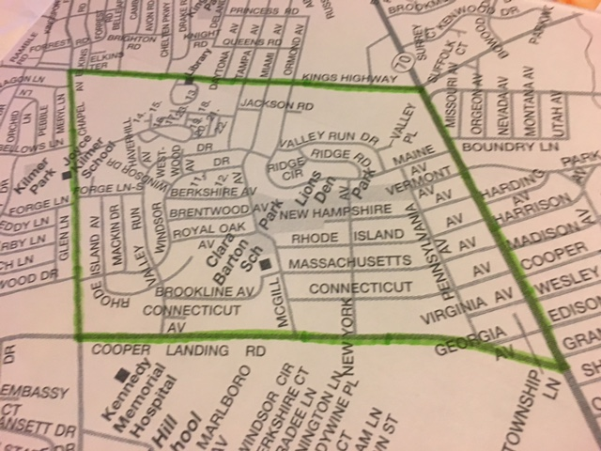

**Message from the ENWCA**

Thankfully, as 2022 began, we were all just starting to relax a bit after the COVID crisis. We were once again able to hold events for our residents. It was so wonderful to return to “normal” and to see so many of our neighbors over the course of the year. We would like to thank every family that has supported us in the past year and we hope 2023 is an even better year. Best wishes to all of you for a happy, healthy and joyful holiday season.

**Annual General Meeting**

We will be holding our Annual General Meeting at the Cherry Hill Library in the Multi-Cultural Room (on the lower level) on January 30th at 7pm. We invite all residents to attend and give us their input and ideas. Elections will be held at this time for the ENWCA Board. If you would like to consider running for a position please contact us at [trvldawn@aol.com](mailto:trvldawn@aol.com) prior to the General Meeting.

**Cherry Hill RISE Program**

Recently, the ENWCA attended a meeting with the Township about the 11.3 million dollars that we received from the feds for COVID recovery. Unlike most municipalities, Cherry Hill has decided to use these funds to help Cherry Hill residents whose businesses were badly impacted by the shut down by awarding grants to those who qualify. It is a great program for Cherry Hill small businesses. Here is the link:

[http://www.chnj.gov/rise](https://www.chnj.gov/rise?fbclid=IwAR3Uj3c7gfPwVd8QRmKHFKwCHZhaBiuMk4aGbGYZPBW23WD0_EtjbMXgzPg)

The deadline date to apply is January 31,2023 and the Township is conducting informational meetings (dates on website). Applications are being accepted now.

**Holiday Decorating Contest**

Once again our neighborhood is so festive and beautiful with all of the holiday lights. Please take a few minutes and drive around the neighborhood and pick your favorites. Please send us your votes for the Best Decorated House in the neighborhood. Also, have your kids (under 18) pick their favorite. Their votes (please include address) will be entered into a drawing for a Visa gift card. Votes should be emailed to [trvldawn@aol.com](mailto:trvldawn@aol.com) by 12/21.

**Annual Yard Sale**

Many thanks go to our Vice President, Abe Karetny for all of his hard work on our annual yard sale. It was a great success as always. Remember to save all of your “stuff” for next year. The Yard Sale is usually held in September.

**Halloween Kick-off**

We had wonderful attendance at our Halloween Kick-off this year. The costumes on the kids and even some adults, were great. The ENWCA has been doing this for many years and many of us have adult children with very fond memories of receiving a full size candy bar at Lions’ Den Park. We love carrying on the tradition and this year we added a drawing for the kids. Lucas Houseman received a Snack Box full of goodies and Will Crowell was the happy recipient of a Visa gift card.

**Clean Communities Event**

Another shout out to Pam Carpenter for her leadership, every year, for the Clean Communities event when we ask residents to join us as we clean up our parks and this year we even included Barton. This is a great opportunity for our young students to earn Community Service hours and it helps keep our park looking good. Thanks to those of you that showed up and worked with us.

**Tree Planting**

In November, the ENWCA planted 36 trees in Erlton North Park. The trees were donated by residents and are several different varieties and sizes. This now brings the total of trees planted by the ENWCA to 56. Our heartfelt thanks go out to John Higgins, Greg and Lynne Bruno and Paul and Julian Asman for doing all their hard work.

**Feral Cats in Erlton North Park**

The ENWCA continues to work with the Township to resolve the feral cat issue in our park in a very humane way. At the request of Animal Control, we once again, ask our residents not to feed the cats as it is causing nuisance issues and very real health issues for many of our neighbors. We also caution all cat owners to refrain from allowing your household cats to run outside so they are not inadvertently trapped by Animal Control. If you are experiencing an issue with feral cats, please call Independent Animal Control at 855-422-7226 or [iacsnj@gmail.com](mailto:iacsnj@gmail.com). There is no charge to Cherry Hill residents for this service. We sincerely appreciate your cooperation.

**Volunteers Needed**

We currently have two openings on our Executive Board. We are also looking for someone who would be willing to Chair our Block Party committee. Most of our meetings are virtual to make it easy for everyone and we meet bi-monthly so this does not involve a huge time commitment. Please consider joining us on the board. We would love to hear new ideas and suggestions.

Also, we still need volunteers to help distribute fliers during out membership drive (usually in March/April) and for our yard sale in September. High school students who are willing to help will get credit for their Community Service at West. Contact [trvldawn@aol.com](mailto:trvldawn@aol.com) if you are willing to give us a hand.

**ENWCA Membership**

In order to be as productive and effective as we envision, we need your support. Our annual dues are $20 per household. Please join us if you haven’t already and encourage your neighbors to join too. There are real benefits to joining with us.

1. We continue to advocate for our neighbors and work hard to find solutions for any neighborhood problems and look for social opportunities to bring our residents together.
2. As we receive them from the Cherry Hill Police, we will email Police reports for our neighborhood, to our members. It is in our interest to know what is happening around us.
3. We participate in the Council of Cherry Hill Civic Associations to advocate for all Cherry Hill residents when the need arises.

To pay your dues for 2023 via Paypal go to enwca.org. If you would prefer to pay by check please mail to ENWCA, c/o 107 West Miami Avenue, Cherry Hill, NJ 08002 utilizing the form below.

Please include email to receive quarterly newsletters.

NAME:______________________________________________________

ADDRESS___________________________________________________

Email: __________________________

Phone:______________________