**Erlton North Windsor Civic Association**

**December 2021**

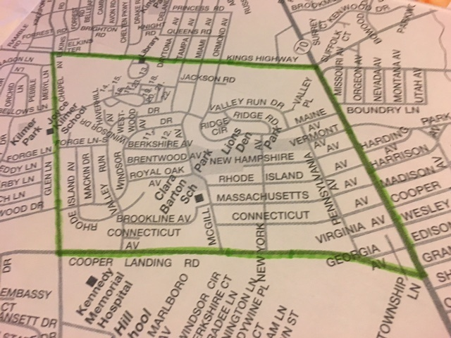

**Message from the ENWCA**

It has been a tough couple of years as we all worked hard to keep everyone safe from COVID-19. We have missed spending time with our residents and are hopeful that we can have our usual events in 2022. Plans are being made for a Bowling Fundraiser and our Annual Block Party. We were able to do our Clean Communities, Yard Sale and Halloween Kick-off in 2021 and hope to return with bigger and better events in 2022 but much depends on the support that we receive from the neighborhood. You will find a membership form at the end of this newsletter so please, sign up, pay your dues and tell all of your neighbors so we can have the best year ever.

**Annual Meeting for All Residents**

The ENWCA will hold our Annual Meeting on January 12th at 7:00pm. For everyone’s safety, it will be held on Zoom again this year. Elections will be held for our Executive Board. We are also looking for volunteers for several committees in 2022. We invite all residents of our neighborhood to join us on the 12th to discuss ideas and concerns. This is your opportunity to make your voice heard. Please email [trvldawn@aol.com](mailto:trvldawn@aol.com) to receive the link for the meeting.

**Annual Yard Sale**

We were able to hold our Annual Yard Sale in September and many thanks to ENWCA Vice-President, Abe Karetny for all of the hard work that he puts in to this event every year. We are hopeful that the Girl Scouts and Barton PTA can join with us, once again in 2022, to make it even better than ever.

**Clean Communities Event**

Fortunately, we were able to resume our Clean Communities event in October. Many thanks to ENWCA Board member Pam Carpenter who does all of the work to get this event off the ground. This year we had the best attendance ever so many thanks to all who showed up to clean up our park. This event is held in October every year so make plans to attend in 2022.

**Halloween Kick-off**

We were happy to be able to hold our traditional Halloween Kick-off at Lions’ Den for Halloween. Our thanks go out to Genie Pentamalli for her hard work to make this event a real success every year. It was great to see all of the kids in costume.

**Holiday Decorating Contest and Raffle for the Kids**

It’s that time of year again, please send in your votes for your favorite house to [trvldawn@aol.com](mailto:trvldawn@aol.com) by Sunday, December 19th. If you have a child under the age of 18, send their names in to the same email address to qualify for our Kids' Holiday drawing. Winner receives a Visa gift card.

**Feral Cats in Erlton North Park**

The ENWCA is working with the Township, Voorhees Animal Shelter and Independent Animal Control on the continuing problem with the feral cats in Erlton North Park with some success. This situation is causing real medical issues for some of our residents with serious cat allergies. They are also setting off people’s security alarms in the middle of the night and using resident’s flower gardens as litter boxes creating an awful odor. The Township has advised us to ask all residents to please stop feeding the cats as it only exacerbates the problem. If you are experiencing problems with the cats, please contact us at [trvldawn@aol.com](mailto:trvldawn@aol.com). Let’s all work together to find a better alternative for the cats and reduce the problem for our neighbors.

**ENWCA Membership**

In order to be as productive and effective as we envision, we need your support. Our annual dues are $20 per household. Please join us if you haven’t already and encourage your neighbors to join too. There are real benefits to joining with us.

1. ENWCA has joined with the [Global 1 Federal Credit Union](http://global1fcu.com/), located on Maple Avenue in Pennsauken. ENWCA members, in good standing, are able to join the credit union for their own personal business. There are many benefits to being a member of a credit union, such as: various savings accounts, CD’s, IRA’s, Vacation Club accounts, Direct Deposit, Auto, home and personal loans, Visa Credit and Debit cards and MasterCard Credit cards. We are very pleased to be able to offer this service to our members.
2. We will continue to advocate for our neighbors and work hard to find solutions for the problems and look for social opportunities to bring our neighborhood together.
3. As we receive them from the Cherry Hill Police, we will email Police reports for our neighborhood, to our members. It is in all of our interests to know what is happening around us.

To pay your dues for 2022 via Paypal, go to enwca.org or if you would prefer, please mail a $20. check to ENWCA, c/o 107 West Miami Avenue, Cherry Hill, NJ 08002.

Please include email to receive quarterly newsletters.

NAME:______________________________________________________

ADDRESS___________________________________________________

Email:___________________________Phone:______________________