Erlton North Windsor Civic Association
March 2022 Newsletter

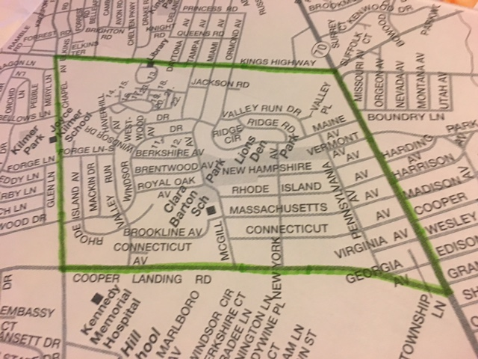

ENWCA Board Members for 2022
The ENWCA ‘s Annual General Meeting was on January 12th and elections were held, our 2022 Board is as follows:
Dawn Higgins President
Abe Karetny Vice President
Treasurer Casey Marshall
Secretary Genie Pentamalli
Membership Chair Frank Plunkett
Clean Communities Chair Pam Carpenter
We currently have openings on the Board and we are looking for volunteers. We meet bi-monthly (usually via Zoom). If you have any interest in helping to make our neighborhood an even better place to live, please email trvldawn@aol.com to arrange an interview.
Planned Events for 2022
The ENWCA will be holding the following events in the coming year. Make sure to mark your calendars.
Annual Block Party (held at Lions’ Den Park) May 14th 1:00pm to 4:00pm
Annual Softball Game TBA (usually in June)
Yard Sale September 17th
Clean Communities Event TBA (always in October)
Halloween Kick-off October 31st 4:00 pm
Holiday Decorating Contest
We are currently looking for volunteers to assist with our Block Party. This is the biggest event we hold for our residents and it requires a real effort so if you can spare some time, please contact trvldawn@aol.com. We would love to hear some new ideas and suggestions.
2021 Holiday Decorating Contest
Once again, our residents did not disappoint with their Holiday Decorating. Thanks to all of you who took the time to tour the neighborhood and submit your votes. The results are as follows:
1st place 202 New Hampshire
2nd place 233 Maine
3rd place 114 Maine
Honorable mention:
202 Massachusetts 161 Valley Run
1 Westwood 2 Westwood
333 Windsor 314 Berkshire
Winners received a VISA gift card for their efforts. The winner of our Kids’ Holiday Drawing this year was Emily Marshall.

Feral Cats in Erlton North Park
The ENWCA continues to work with the Township to resolve the feral cat issue in our park in a very humane way. Once the weather gets warmer, we will once again start to work with Animal Control and the Voorhees Animal shelter. At the request of Animal Control, we once again, ask our residents not to feed the cats as it is causing not only nuisance issues but very real health issues for many of our neighbors. We also caution all cat owners to refrain from allowing your pets to run outside so they are not inadvertently trapped by Animal Control. Any questions, email trvldawn@aol.com.

Distribution Team
We are in dire need of volunteers to help distribute fliers during out membership drive (usually in March/April) and for our yard sale in September. High school students who are willing to help will get credit for their Community Service at West. Contact trvldawn@aol.com if you are willing to give us a hand.

ENWCA Membership
In order to be as productive and effective as we envision, we need your support. Our annual dues are $20 per household. Please join us if you haven’t already and encourage your neighbors to join too. There are real benefits to joining with us.
- ENWCA has joined with the First Harvest Credit Union, located on Maple Avenue in Pennsauken. ENWCA members, in good standing, are able to join the credit union for their own personal business. There are many benefits to being a member of a credit union, such as: various savings accounts, CD’s, IRA’s, Vacation Club accounts, Direct Deposit, Auto, home and personal loans, Visa Credit and Debit cards and MasterCard Credit cards. We are very pleased to be able to offer this service to our members.
- We will continue to advocate for our neighbors and work hard to find solutions for the problems and look for social opportunities to bring our neighborhood together.
- As we receive them from the Cherry Hill Police, we will email Police reports for our neighborhood, to our members. It is in of our interest to know what is happening around us.
To pay your dues for 2022 via Paypal, go to enwca.org or if you would prefer, please mail a $20.check to ENWCA, c/o 107 West Miami Avenue, Cherry Hill, NJ 08002.

Please include email to receive quarterly newsletters.

NAME:______________________________________________________

ADDRESS___________________________________________________

Email: __________________________

Phone:______________________

