Erlton North Windsor Civic Association March 2020 Newsletter
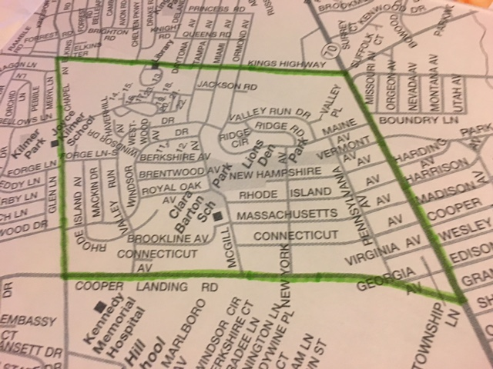

Message from the ENWCA
During these trying times, please be a good neighbor and check on your elderly neighbors. We all have to keep a “social distance” from others but that does not mean that we have to stop caring about each other. So please, reach out via phone and if they are in need of help, do what you can to assist them. If you can’t, for whatever reason, let us know at trvldawn@aol.com and we will do what we can.
Stay informed at https://www.cherryhill-nj.com/. The Township is working hard to protect all of us and any information that you need can be found here.
Also, we know that it is a challenge for many parents to have their children home every day so we have been posting lots of fun things to do on our Facebook page. The Sidewalk Art Challenge asks the kids to create works of art on their sidewalks and driveways, for all of us to enjoy. Many of us have seen them and they are just great, keep them coming until this is all over. Also, we are going to start posting new variations of the Window Scavenger Hunt (where we all put something in our window for the kids to see) every Monday on the Facebook page, Please check it out and let’s have some fun!
Annual Meeting
The ENWCA held their annual meeting on January 31st. At that time, the following people were elected to the ENWCA board for the next year.
Greg Bruno Dawn Higgins Abe Karetny
Pam Carpenter Paul Asman Casey Marshall
Genie Pentamalli Sheila Cummings
At the first reorganization meeting on February 25th, Greg Bruno was named President, Dawn Higgins as Vice President, Genie Pentamalli as Secretary and Abe Karetny as Treasurer.
2019 Year in Review
Continued to work with the Township on the following:
-Regrading project to eliminate standing water in Erlton North Park. The Township has completed the design phase and is expected to start work this spring.
-Working with the Township to eliminate “Tree of Heaven” trees in the neighborhood. These trees are the favorite of the Lantern Flies which have become such a problem in Pennsylvania.
-Working on the issue of Feral cats which are causing very serious health and nuisance issues for many of our residents.
Events Held in 2019
-1st Annual Meet and Greet Block Party-Erlton North vs. Erlton South Softball game -Manned the Water Station for the CHPL’s Book It Run--3rd Annual Neighborhood Yard Sale--Halloween Kick-off at Lions’ Den--Clean Communities Event
Also the ENWCA continues to participate with the Council of Cherry Hill Civic Associations along with 12 other groups to work on mutual concerns in the Township.
Our Heartfelt Thanks
On March 10th, the ENWCA was notified that Greg Bruno, our President, for the past 3 years, was stepping down. Greg has worked tirelessly to make our neighborhood an even better place to live. Under his leadership, we have accomplished so much and we are very grateful for all of his time and effort. We wish Greg well as he moves on to play a volunteer role on the Cherry Hill Zoning Board of Adjustment. We are confident that he will continue to make a real difference in our community. His last act as President was to name Dawn Higgins as the interim President.
ENWCA Board Member receives Camden County Freedom Medal
Congratulations to ENWCA board member, Abe Karetny on receiving this prestigious honor from The Camden County Freeholders. This medal created in 2001, honors civic leaders who demonstrate the ideals and actions that reflect the principles of Dr. Martin Luther King. Abe received the honor for creating and administering the very popular What’s Up in Cherry Hill (Official) Facebook page which has roughly 14,000 followers. If you haven’t joined yet, do so. It is the place to find out what is happening in the community. It is also a great resource for local businesses to advertise.
Holiday Decorating Contest
Best Decorated-333 Windsor Drive
Honorable Mention: 114 Maine and 1 Westwood
Most Decorated-202 New Hampshire
Honorable Mention-2 Westwood and 316 Royal Oak
Kid's Choice-202 Massachusetts
And this year's winner of the Kid's Choice gift card is Tommy Schiable.
Congratulations to all of our winners and many thanks for your hard work making our neighborhood an even lovelier place during the holidays!
Calendar of Events-2020
Given the onset of COVID-19, these dates are tentative. Please watch our website and Facebook page for updates.
Big Event Bowling Party Fundraiser-March 29 has been cancelled and will be rescheduled.
Neighborhood Block Party-May 2 (rain date 5-9)
Neighborhood Baseball Game-Erlton North vs. Erlton South-Tentatively June 14
Neighborhood Yard Sale-September 26
Community Clean Up-October (date to be determined)
Halloween Kick-off Party-October 31
Holiday Decoration Contest-December
International Holiday Party-December 27
2nd Annual Free Meet and Greet Block Party-May 2nd (rain date 5/09)
The ENWCA will hold its Annual Meet and Greet Block Party at Lions’ Den Park. New York Avenue will be closed between Maine and New Hampshire Avenue. There will be music and games for the kids, a kickball game, light refreshments and prizes. Please bring your own lawn chairs or blankets. We would like to have some door prizes, so if you or your business would like to donate, we would appreciate the support. Come out and meet some of your neighbors and have fun with the kids. The kids had a blast last year so let’s make it an even bigger success in 2020. Watch the ENWCA Facebook page for more details.
Scholarships for the 2020 Junior Police Academy
The ENWCA is so pleased to announce that we are going to award two scholarships (1 boy, 1 girl) to the CHPD’s 2020 Junior Police Academy. The academy will run from August 3rd-7th, 2020 for children ages 11 – 14. Included are two sets of the required uniform, a water bottle, a gym bag, and a lunch provided daily by various sponsors in the community. Participants will explore firsthand, various aspects of law enforcement with a curriculum developed by the Department that will emphasize the importance of qualities such as physical fitness, staying drug free, teamwork and respect. Activities throughout the week will include lessons in drill and ceremony, physical training, school safety and bullying, drug awareness, traffic safety, an introduction to specialty units, crime scene processing, fingerprinting and first aid. Participants will also take field trips to tour the Camden County Juvenile Detention Center and Cherry Hill Fire Department Central Command. The week will conclude with a formal graduation ceremony on Friday afternoon.
If you would like to have your child entered to win the scholarship, please email trvldawn@aol.com with their name, gender and age. You must be a member in good standing with the ENWCA to participate in the drawing. Please watch our Facebook page for further information.
Business Card Ads
Do you have a business or know of a business that would like to buy an ad in our quarterly newsletter or on our website? This will help us raise funds to do more for the neighborhood.
Welcome Neighbor Program
If someone new moves into the neighborhood near you (or has recently), please let us know so that the ENWCA can visit and personally welcome them to our great neighborhood. If you would like to come with us when we do so, you are welcome. Please send information on any new neighbors to trvldawn@aol.com.
ENWCA Membership Drive
In order to be as productive and effective as we envision, we need your support. Our annual dues are $20 per household. Please join us if you haven’t already. There are real benefits to joining with us.
- ENWCA has joined with the Global 1 Federal Credit Union, located on Maple Avenue in Pennsauken. ENWCA members, in good standing, are able to join the credit union for their own personal business. There are many benefits to being a member of a credit union, such as: various savings accounts, CD’s, IRA’s, Vacation Club accounts, Direct Deposit, Auto, home and personal loans, Visa Credit and Debit cards and MasterCard Credit cards. We are very pleased to be able to offer this service to our members.
- We will continue to advocate for our neighbors and work hard to find solutions for the problems and look for social opportunities to bring our neighborhood together.
- As we receive them from the Cherry Hill Police, we will email Police reports for our neighborhood, to our members. It is in all of our interests to know what is happening around us.
If you have not yet paid your dues for 2020, please go to our website at enwca.org where you can join using Paypal or if you would prefer, please mail a $20. Check to ENWCA, c/o 107 West Miami Avenue, Cherry Hill, NJ 08002.

NAME:______________________________________________________
ADDRESS___________________________________________________
Email:___________________________Phone:______________________

Please include email to receive quarterly newsletters.

