**Erlton North Windsor Civic Association**

**March 2021**

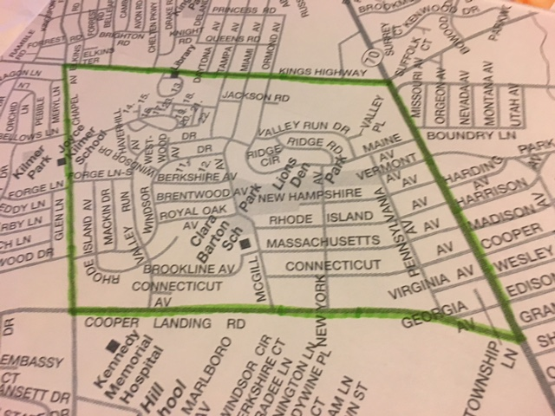

**A Message from the ENWCA**

2020 was a very difficult year for all of us but things are looking up in 2021. Please get your vaccines and continue to follow CDC guidelines so we can all get back to “normal” as soon as possible. We can’t wait to start holding events again and to see our residents in person. Plans are in the works for a Bowling Party fundraiser at the Big Event sometime in late spring and we hope to be able to do our Annual Block Party sometime soon. Our Annual Yard Sale and Clean Communities events will happen in the fall and we are hopeful that the Halloween Kick-off can resume too. Read your newsletters and visit us on Facebook for details as they come available.

**ENWCA Officers for 2021**

The ENWCA held our annual meeting via ZOOM on January 27th. Thanks to all who participated. Elections were held and our Board for 2021 is as follows:

President-Dawn Higgins Vice President-Abe Karetny

Secretary-Genie Pentimalli Treasurer-Casey Marshall

Board Members

Pam Carpenter, Paul Asman, Frank Plunkett and Sheila Cummings

We have also made the decision to hold two General Meetings a year to hear from residents so our next one will be in the fall. Please plan to attend, we are anxious to hear your ideas and concerns, it helps us to be more effective for the neighborhood. Watch the newsletters or our Facebook page for the date.

**Cherry Hill Township Helps Seniors Get Vaccine**

In an effort to help Cherry Hill senior citizens aged 65 and above receive the COVID vaccine, Cherry Hill Township is working with the Camden County Department of Health to help reschedule senior vaccination appointments to an earlier date. While we cannot guarantee an earlier appointment, should additional vaccines and appointments become available, Cherry Hill Township in coordination with Camden County will work to move up vaccination appointments. Please note you must first sign up for an vaccination appointment through the Camden County vaccination website before you can reschedule, and only appointments in April or later are being accepted.

For Cherry Hill Senior Citizen Residents who wish to reschedule their appointment for an earlier date, please follow the directions below:

➡️If your last name begins with the letter A to M, please call the Mayor’s office at (856) 488-7878

➡️If your last name begins with the letter N to Z, please call the Recreation Department at (856) 488-7868

➡️Seniors can also email Vaccine@Chtownship.com to be included

Feel free to leave a voicemail with the necessary information and we will return your call to confirm. Please either call or email, please do not do both.

Please have the following information ready:

• First and Last Name

• Phone Number

• Home Address

• Date of Birth

• Current Appointment Date

Once your information is received by Camden County, a Cherry Hill Township employee will reach out with your new appointment date.

**Traffic Issues**

The ENWCA has been working with the Council of Cherry Hill Civic Associations to advocate for more traffic enforcement in the neighborhood. This is an ongoing problem on many of the streets that are used by “cut through” traffic. We are asking the township to monitor the situation so please, be cognizant of your speed at all times to avoid being ticketed by CHPD.

**Feral Cats in Erlton North Park**

The ENWCA is working with the Township, Voorhees Animal Shelter and Independent Animal Control on the continuing problem with the feral cats in Erlton North Park with some success. This situation is causing real medical issues for some of our residents with serious cat allergies. They are also setting off people’s security alarms in the middle of the night and using resident’s flower gardens as litter boxes creating an awful odor. The Township has advised us to ask all residents to please stop feeding the cats as it only exacerbates the problem. If you are experiencing problems with the cats, please contact us at [trvldawn@aol.com](mailto:trvldawn@aol.com). Let’s all work together to find a better alternative for the cats and reduce the problem for our neighbors.

**ENWCA Membership Drive**

We are conducting our Annual Membership drive so keep an eye out for the flier on your doorstep or use the member ship form below. In order to be as productive and effective as we envision, we need your support. Our annual dues are $20 per household. Please join us if you haven’t already and encourage your neighbors to join too. There are real benefits to joining with us.

1. ENWCA has joined with the [Global 1 Federal Credit Union](http://global1fcu.com/), located on Maple Avenue in Pennsauken. ENWCA members, in good standing, are able to join the credit union for their own personal business. There are many benefits to being a member of a credit union, such as: various savings accounts, CD’s, IRA’s, Vacation Club accounts, Direct Deposit, Auto, home and personal loans, Visa Credit and Debit cards and MasterCard Credit cards. We are very pleased to be able to offer this service to our members.
2. We will continue to advocate for our neighbors and work hard to find solutions for the problems and look for social opportunities to bring our neighborhood together.
3. As we receive them from the Cherry Hill Police, we will email Police reports for our neighborhood, to our members. It is in all of our interests to know what is happening around us.

To pay your dues for 2021 via Paypal, go to enwca.org or if you would prefer, please mail a $20. check to ENWCA, c/o 107 West Miami Avenue, Cherry Hill, NJ 08002.

Please include email to receive quarterly newsletters.

NAME:______________________________________________________

ADDRESS___________________________________________________

Email:___________________________Phone:______________________