

_______________________________ ______________________________

Calvin Williams, President Sharon Blosser, Director

Halifax County Cancer Association (HCCA) is making plans for the 13th Annual Walk for Hope to be held Saturday September 16, 2017. The Walk For Hope is held each year to celebrate cancer survivors, remember those who have lost their battle with cancer and to raise funds to assist current cancer patients.

With the support of local businesses and community leaders, Halifax County Cancer Association provides financial assistance to cancer patients who are residents of Halifax County, VA. In 2016, 231 patients were helped with travel to over 3,100 doctor appointments and treatments in the amount of $38,155.00 as well as assistance with other items such as; medication, bras, wigs, prosthesis, nutritional supplements, medical bills and much more.

The board of directors of Halifax County Cancer Association invites you and your business to be part of the 13th Annual Walk For Hope by:

* Making a tax-deductible donation through sponsorship of The Walk For Hope
* Walking with us in our Walk For Hope on September 17, 2016
* Inviting Halifax County Cancer Association to present information about HCCA at your business to encourage employees to participate in The Walk For Hope

For more information about Halifax County Cancer Association, The 13th Annual Walk For Hope or to schedule a presentation at your business, contact our office at 434-476-2714 or visit our website at [www.hccahope.org](http://www.hccahope.org) or by email at [hcca.hope@gmail.com](mailto:hcca.hope@gmail.com).

Thank you in advance for your support of Halifax County Cancer Association.

Dear Friends,

Walk for Hope

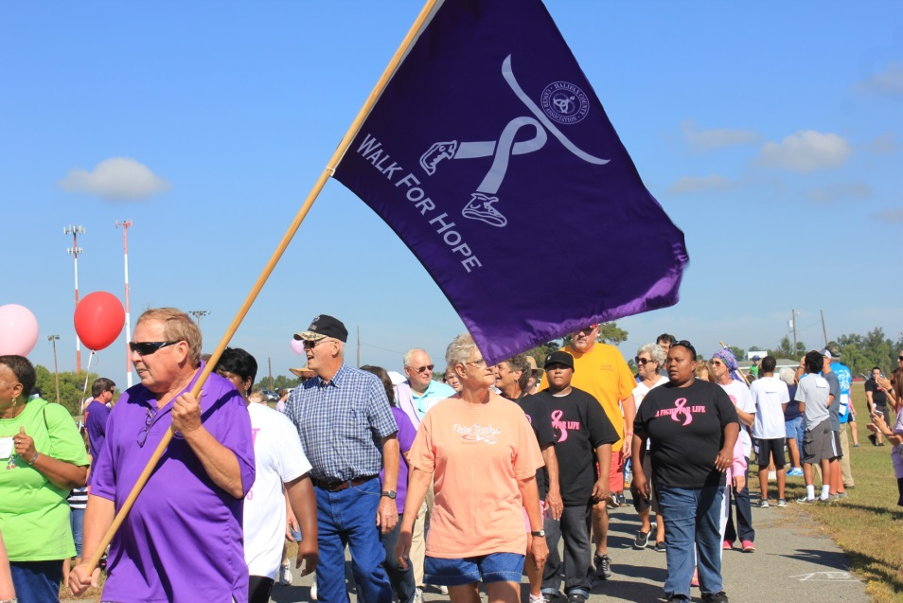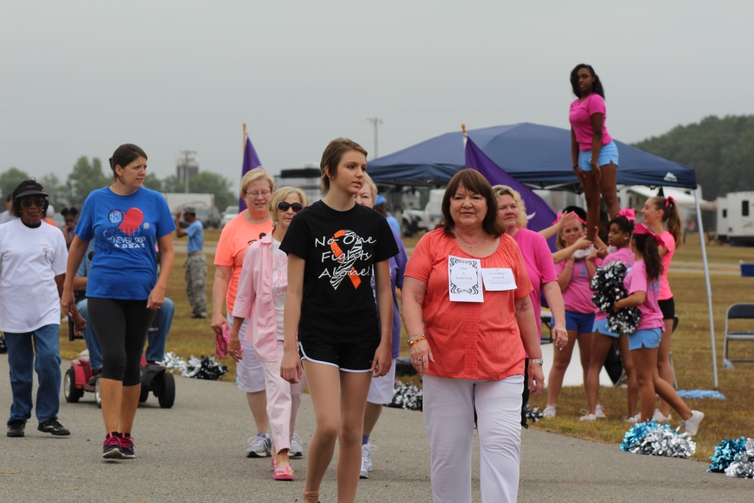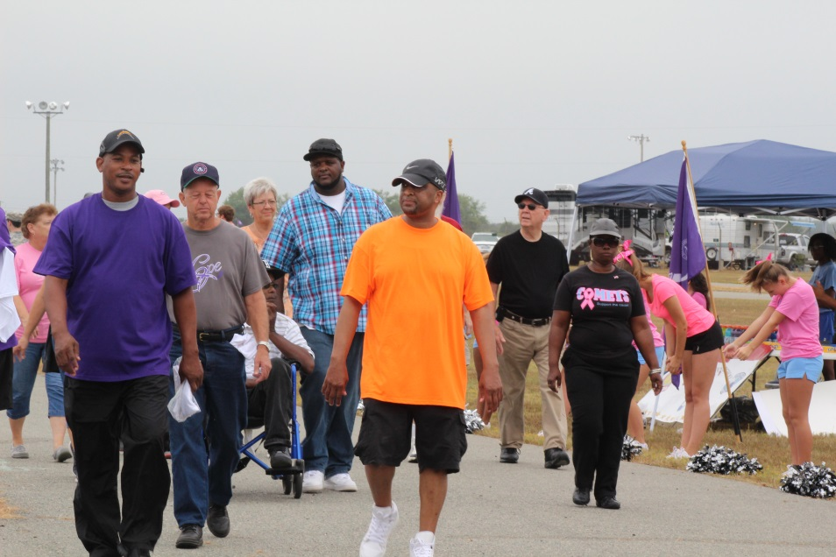

Halifax County Cancer Association PO Box 1891 South Main St, Halifax, Virginia 24558 M-F 9am-1pm 434-476-2714 www.hccahope.org