Sun | Mon | Tues | Wed | Thurs | Fri | Sat
 | Please note:  We will be celebrating Dr. Seuss’s birthday all next week with a special theme each day! |  |  |  |  | 1
2  Read Across America!    Happy Birthday Dr. Seuss! | 3  Spanish: Libros/books  Colors: Green/rainbow  Letter: M  Number: 15 | 4  Fox in a Sock  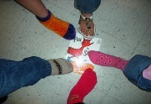Story time  This Photo by Unknown Author is licensed under CC BY-SA-NC | 5  “Wacky Wednesday”  wacky craft | 6  Art/Fine motors  The Lorax  Truffula Trees | 7  “Green eggs and ham”  Dr Seuss rhyming | 8
9  Daylight savings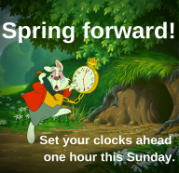 | 10  Gross motors  M is for Musical Monday  M is for March | 11  Fine motors  Magic fizzing shamrocks | 12  Math  Lucky charm necklaces   | 13  STEM  Leprechaun traps | 14  Science  Skittle rainbow  Pajama Day!!! | 15
16  Spanish: Primavera/ Spring  Colors: Green/rainbow  Letter: P  Number: 14 | 17    Will we catch a leprechaun this year?!? | 18  Fine motors  I am lucky because…  St. Patrick’s Day Freeze Dance | 19  Scissor skills    Rainbow twirlers | 20  First day of spring!    This Photo by Unknown Author is licensed under CC BY-ND  Nature hunt | 21  Art  Create with nature | 22  
23  30 | 24  Science  What do we know about bugs?  31 | 25  Math  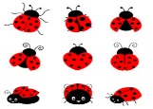  Count lady bug | 26  Motor skills  Discovering bugs | 27  Art  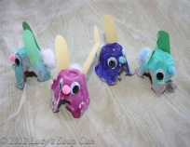  Create your bug | 28  Sensory  Playdough bug search  Show and tell  Pajama Day!!! | 29

