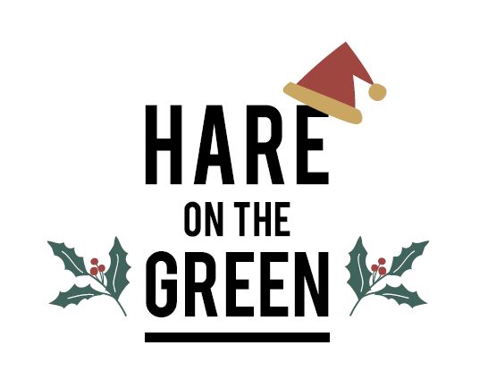
Christmas Pre Order - ADULT
£60 per head
You will be served a 5 course menu including canopes and a cheese board. All drinks at additional cost. Please select your options and send back to us.

Date | 25th December – Christmas Day! | No. Guests
Time |  | Adults
Name |  | Children
Telephone No |  | Highchairs
Email address

STARTERS | No. Servings
Chicken liver parfait served with warm bread
Carrot and Coriander Soup
TOTAL

Fish course | No. Servings
Smoked salmon parcels
Fruit de mer - giant prawns, white fish and white bait (or Chicken Wings)
TOTAL

MAINS | No. Servings
Full Christmas dinner
Beef cheeks with mash potato and almond baked broccoli
Salmon with hassle back potatoes and broccoli
TOTAL

DESSERTS | No. Servings
Christmas pudding with custard or brandy butter
Hot chocolate cake with cherry centre and chocolate sauce
Biscoff cheesecake
Minced Pies
TOTAL

Dietary Requirements & Allergies. Please let us know about any special requirements and names of guests with allergies so we can cater to your needs.

Christmas Pre Order - KIDS
£30 per head
Please select 3 courses for your children
1 from Starter or Fish
1 from Main
1 from Dessert

Please contact us if there is not a suitable choice based on your child’s dietary needs and we can accommodate

STARTERS | No. Servings
Chicken liver parfait served with warm bread
Carrot and Coriander Soup
TOTAL

Fish course | No. Servings
Smoked salmon parcels
Fruit de mer - giant prawns, white fish and white bait (or Chicken Wings)
TOTAL

MAINS | No. Servings
Full Christmas dinner
Beef cheeks with mash potato and almond baked broccoli
Salmon with hassle back potatoes and broccoli
TOTAL

DESSERTS | No. Servings
Christmas pudding with custard or brandy butter
Hot chocolate cake with cherry centre and chocolate sauce
Biscoff cheesecake
Minced Pies
TOTAL

Dietary Requirements & Allergies. Please let us know about any special requirements and names of guests with allergies so we can cater to your needs.

