DEVOTION TO THE HOLY FACE OF JESUS

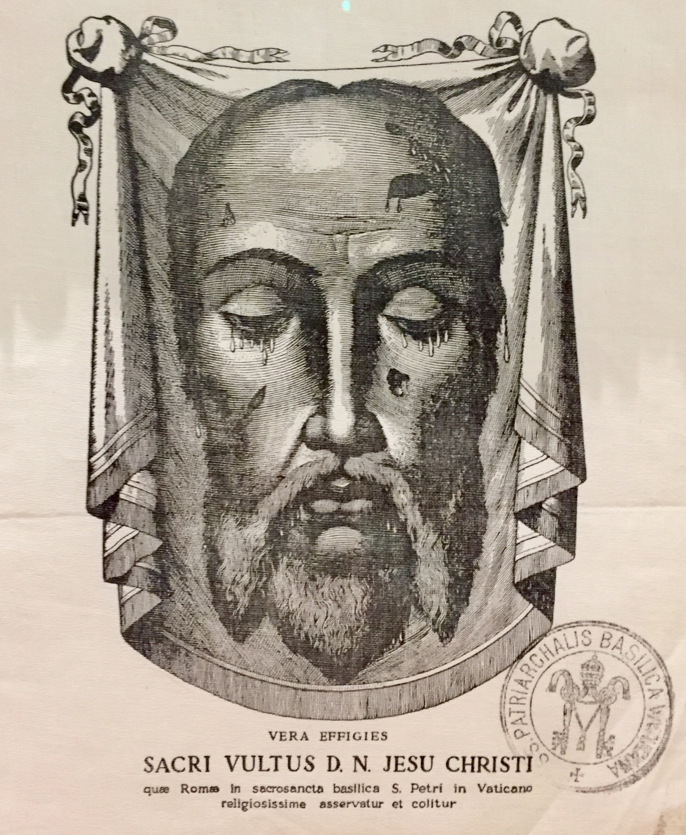
God is calling you to pray for conversion and reparation as one of His
DEFENDERS OF THE HOLY NAME OF GOD

This devotion is approved by the Holy Catholic Church
& elevated to the highest level as an Archconfraternity

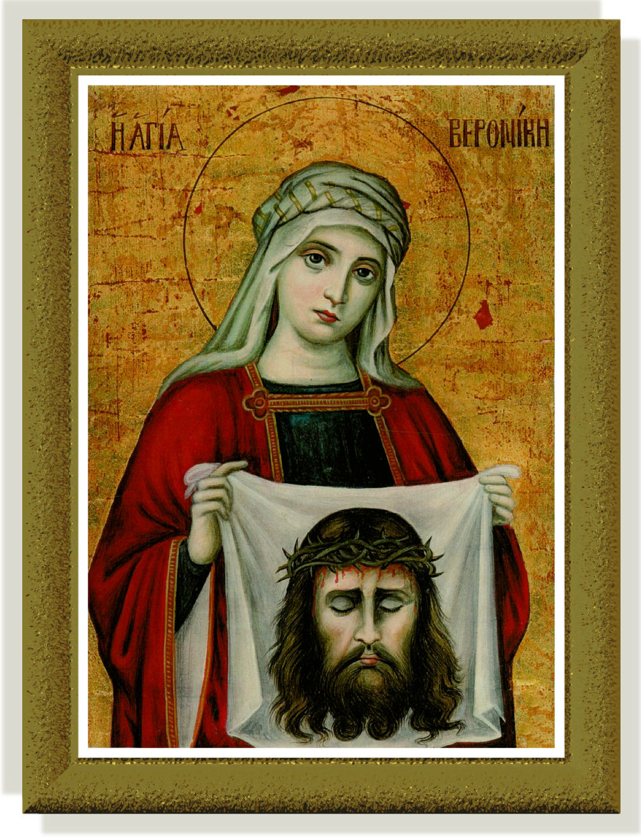

I
desire that my face, which shows my soul’s deepest anguish, my heart’s sorrow and my love, may be more honored. Whosoever contemplates Me, consoles Me.
E
very time that anyone gazes at My Face, I will pour My love into hearts and by means of My Holy Face, the salvation of many souls will be obtained.
—Our Lord to Blessed Maria Pierina de MicheliA
The Eternal Father says,
“I will order My angels to mark the homes where the Holy Face of My Son is located, and My children will be spared from the evils that will come over ungrateful humanity. My children, become real apostles of the Holy Face and spread it all over. The more it is spread the less will be the catastrophe.”
Consolation, Reparation & Conversion
Offer this Daily Act of Praise:
- Dear Lord, through the Sorrowful and Immaculate Heart of Mary, I offer You these prayers in reparation for the sins which offend God in these modern times: the sins of blasphemy, abortion, atheism & the profanation of Sundays and Holy Days of Obligation
- Recite: 1 Our Father, Hail Mary, Glory Be and The Golden Arrow Prayer

Note: If you are in the presence of someone who curses God, console and glorify God
by saying, “Blessed Be the Name of God, Begone Satan.”

If possible, offer Prayers of Reparation on Sundays and Holy Days:
- Golden Arrow Prayer and the daily act of praise
- Litany of the Holy Face
- Chaplet of the Holy Face
- Other prayers of reparation for the sins of blasphemy against the Holy Name of God, the profanation of Sundays and Holy Days of Obligation, abortion, blasphemous laws, apathy and indifference to moral relativism, appropriating the Blessed Sacrament, and those who ignore the teachings of the Catholic faith.
Gaze on the Holy Face of Jesus during prayers as often as possible, and even better if they are recited in the presence of the Blessed Sacrament in Adoration on Tuesdays).

HISTORY
During the 1840s, Our Lord himself communicated a series of messages to Sister Marie of Saint Pierre (1816-1848), a Carmelite Nun in Tours, France. This occurred fifty years after the French Revolution, where the Catholic Church was persecuted and a spirit of atheistic communism was spreading. Jesus told Sister Marie:
“My name is everywhere blasphemed —even children blaspheme it. This is a frightful sin. More than all others, it grievously wounds My Divine Heart. Through blasphemy, the sinner curses me to My Face, attacks me openly, and pronounces his own condemnation and judgment. Blasphemy is a poisoned arrow.”
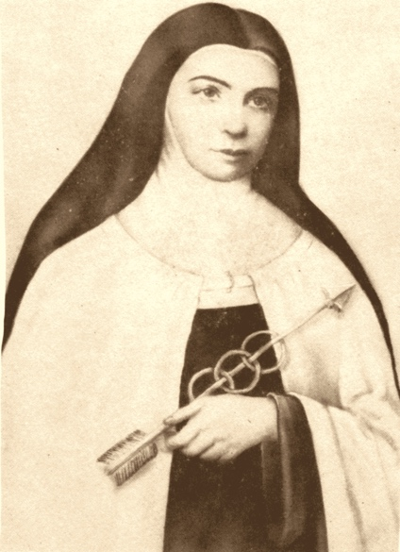
Jesus revealed the entire earth was covered with crimes violating the first Three Commandments of God, and people were profaning Sundays and Holy Days of Obligation. His Father’s wrath demanded reparation and the Lord wished for Sister Marie to establish an army of courageous followers to fight for reparation. Like St. Veronica who at the 6th Station of the Cross had wiped the suffering Face of Jesus with great tenderness and piety, God wanted people to stop sinning and console His blasphemed face:

“When we gaze upon the face of Christ crucified, it unites us with all His sorrows, love and total abandonment. It’s a remedy for our own conversion and the conversion of others. It gives us the grace to change our life and remove the sins that offend God.” www.HisHolyFace.com
Jesus dictated The Golden Arrow Prayer to Sister Marie, instructing her to spread this devotion to “wound God delightfully and repair the malice of sinners.”
This prayer together with prayers composed by Sister Marie (in her autobiography The Golden Arrow) and other holy saints (most notably St. Therese of Lisieux, St. Bernard, St. Gertrude the Great, Pope Leo XIII) were inspired by God and formed The Manual of the Holy Face. Sister Mary was told she would not live to see the spread of this holy devotion, but that it was a weapon to battle blasphemy and crimes in these modern times.
Golden Arrow Prayer
May the Most Holy, Most Sacred, Most Adorable, Most
Incomprehensible and Unutterable Name of God be always praised,
blessed, loved, adored and glorified, in heaven, on earth and in the hells,
by all the creatures of God and by the Sacred Heart of Our Lord Jesus
Christ in the Most Holy Sacrament of the Altar. Amen

Revelations and Work of Reparation
The Lord showed Sister Marie how a daily “Act of Praise” and His association of warriors who offered prayers of reparation on Sundays and Holy Days would result in many conversions and help appease the anger of God that pronounces a sinner’s condemnation and judgment.

“Our Lord showed me this association as an army of brave soldier, uniting themselves to Him as their Commander-in-Chief, to defend the glory of His Father. It is His Will that this militia be called, The Defenders of the Holy Name of God, so this noble title will give evidence to the high calling of those enrolled.”

The Mission: Defenders of the Holy Name of God
The Lord asked Sister Marie to create a well-organized and approved association known as The Defenders of the Holy Name of God. Their mission was to honor the Father’s Name and:
- Make reparation in honor of His Holy Face, for the outrages committed against the Divine Majesty of God by blasphemies, the profanation of Sundays and Holy Days.
- To refrain from work on Sundays and encourage others to do so as well.
- To wear a special scapular with the Holy Face and a cross, on which should be
engraved the words, “Blessed be the Name of God” and on the reverse side, “Begone, Satan!” These two phrases were to be said when someone blasphemed. This will overcome the evil one and render glory to God.
- To obtain conversion and lead others to honor God’s Name and keep His holy days.
- To recite the prayers of reparation, in particular the Golden Arrow prayer.
- To spread devotion to the Holy Face of Jesus.
- To preserve youth and the family from the fatal effects of these scandals, by offering a special devotion of prayer, adoration and love to the most Holy Face of our Lord, outraged and disfigured in the Passion.
- To consecrate yourself to the adorable Trinity, the Holy Name of Jesus, and His sorrowful Face. Place your prayers under the patronage of St. Michael, St. Martin, and St. Louis, protector of France.
- You be devoted for life and death to the worship of the merciful and compassionate Face of our Lord, and to never utter blasphemies or imprecations, to hold conversation, to read nothing written and to take no part in any act which outraged God and our Lord Jesus Christ; and to never perform any servile work on Sundays and holy days without necessity and without permission.

Ecclesiastical Approval of the Archconfraternity
“The Divine Savior warned me (Sister Marie) that I would have much to suffer because this herd of blasphemers was in a special manner under the leadership of the prince of demons, that is Lucifer himself.”.. But the Lord said, “Do not fear him. Saint Michael and the other holy angles will protect you..”

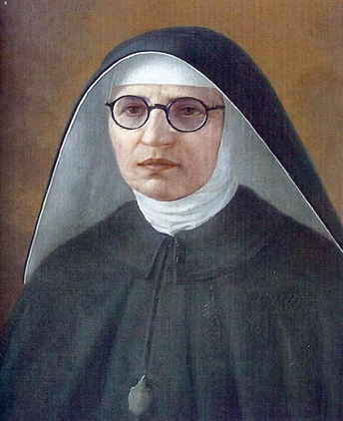
On June 28th, 1847, the Bishop of Tours established the Confraternity of Reparation but following the death of Sister Marie in 1849, the remarkable miracle of the illuminated Face of Jesus on Veronica’s Veil took place in St. Peter’s Basilica in Rome, Italy. Artists copied the image we venerate today.
In 1876, Bishop Charles Colet established the Confraternity of the Holy Face and Pope Leo XIII quickly elevated it to the rank of Archconfraternity in 1885. The parents of St. Therese of Lisieux enrolled their family in it and St. Therese, enraptured by it, added the Holy Face to her religious name.

A century later, Blessed Maria Pierina de Micheli, another religious sister and mystic, was called to have a medal cast to honor this devotion that Our Lady called, the divine remedy for our modern ills”. Jesus asked Sister Maria while venerating the cross one Good Friday to offer her kiss to repair the kiss of Judas.
All those who shall wear a Scapular like this and make, if possible, a visit
to the Blessed Sacrament every Tuesday in reparation for the outrages that
the Holy Face will receive many graces that include strength of Faith, overcoming difficulties, and a peaceful death.” —Mother Marie Pierina de Michelli

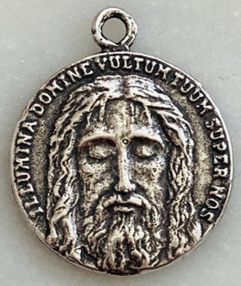
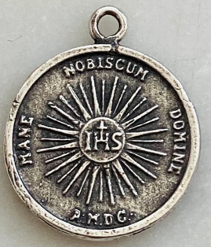
In 1938, while praying before the Blessed Sacrament, Our Lady told Sister Maria to make a scapular of Jesus’ Face and the Holy Eucharist, and in 1940, she was given approval to have a medal of the Holy Face made. Under the directive of Pope Pius XII in 1958, the Feast of the Holy Face of Jesus was instituted on Shrove Tuesday to mark the start of Lent.

Communism & Our Lady of La Salette, Fatima and Akita
The attack on Christ and His Church continued to grow in the 1840s. Qs Karl Marx was preparing his Communist Manifesto, Sister Marie entered the Carmelite Convent in 1843. The blasphemy of a rising atheistic culture manifest in the Communist philosophy caused further sorrow to Our Lord after the destructive forces of the French Revolution.
“The Divine Savior warned me that I would have much to suffer because this herd of blasphemers was in a special manner under the leadership of the prince of demons, that is Lucifer himself.” But the Lord said, “Do not fear him. Saint Michael and the other holy angles will protect you. I give you My cross… and through this weapon, you will become formidable to the demon.”

But Our Lord warned Sister Marie that this scourge could be cast out through the Work of Reparation and that, in the end, it would ultimately fail:
”They will drag Me from my tabernacles, and desecrate My sanctuaries. They dare to lay hands on the priests of the Lord, but all their plotting will be in vain and their schemes will not succeed.”

In 1846, with great hope, Sister Marie asked the Blessed Virgin Mary for help and she responded —appearing to two shepherd children in La Salette-Fallavaux, France, telling Melanie Calvat (14) and Maximin Giraud (11) that people must stop taking the Name of the Lord in vain and profaning Sunday. If not, punishment would ensue and communism would spread throughout the world.
How much longer for Reparation?
Sadly, people did not listen. World War I and II followed, even as Our Lady appeared in Fatima, Portugal in 1917 reiterating the need for prayer, reparation and conversion. In Akita, Japan in 1973, she again warned Sister Agnes Sasagawa, saying a greater punishment on humanity was coming from God the Father if we didn’t listen:
“Fire will fall from the sky and wipe out a great part of humanity, the good as well as the bad, sparing neither priests nor faithful.”

Venerable Leo Dupont “The Holy Man of Tours”

On Good Friday in 1848, six months before the death of Sister Marie, Our Lord revealed His wrath so she offered her life as a victim of Divine Justice to mitigate the coming punishment:

“Racked by burning fever, Sister Marie offered her pain for the conversion of sinners. The throat, tongue, and mouth, instruments of impious blasphemers, were the main cause of Sister Marie’s suffering… but she was consoled knowing she would soon see God’s Adorable Face and sing His praises for all eternity.”

Devotion to the Holy Face grew after Sister Marie’s death thanks to the works of her pious friend, the Venerable Leo Dupont. Known as, “the holy man of Tours” for his work to spread the devotion, he established a home shrine to the Holy Face of Jesus where many miracles occurred.

St. Therese of Lisieux, one of many saints raised with a great devotion to the Holy Face, was influenced by Sister Marie’s biography and embraced the call for prayer and reparation by adding it to her religious name. She knew the rewards promised by heaven.

U
NBELIEVABLE
Promises to the Defenders of the Holy Name of God
“By offering my Face to my Eternal Father, nothing will be refused.”
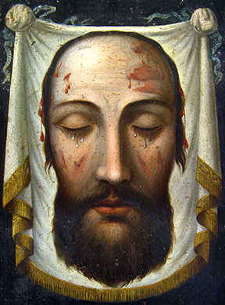
- Contrition so perfect, our sins will be changed into jewels;
- None shall be separated from Jesus after death;
- The purchase of poor sinners, and a plea to God the Father to grant all the petitions presented to Jesus;
- An illumination of Jesus’ light to render fruitful their good works;
- Jesus' divine features will be imprinted in their soul at death and He will renew in them in the image of God; and,
- His brilliant face will fill them with joy and shine in eternal life.

Shrove Tuesday
The Feast Day of the Holy Face of Jesus
Pope Pius XII extended the devotion to the universal Church, and placed the Holy Face Mass on Shrove Tuesday, in 1958.

O Jesus, Who in Thy bitter Passion didst become “the most abject of men, a man of sorrows,” I venerate Thy Sacred Face whereon there once did shine the beauty and sweetness of the Godhead; but now it has become for me as if it were the face of a leper! Nevertheless, under those disfigured features, I recognize Thy infinite Love and I am consumed with the desire to love Thee and make Thee loved by all men. The tears which well abundantly in Thy sacred eyes appear to me as so many precious pearls that I love to gather up, in order to purchase the souls of poor sinners by means of their infinite value. O Jesus, Whose adorable Face ravishes my heart, I implore Thee to fix deep within me Thy Divine Image and to set me on fire with Thy Love, that I may be found worthy to come to the contemplation of Thy glorious Face in Heaven. Amen. —Prayer of St. Therese of Lisieux to the Holy Face of Jesus
PRAYERS OF REPARATION
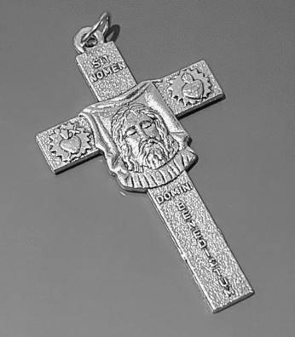
Golden Arrow Prayer
May the Most Holy, Most Sacred, Most Adorable, Most Incomprehensible and Unutterable Name of God be always praised, blessed, loved, adored and glorified, in heaven, on earth and in the hells, by all the creatures of God and by the Sacred Heart of Our Lord Jesus Christ in the Most Holy Sacrament of the Altar. Amen
Prayer to the Holy Name of Jesus
Jesus, Name full of glory, grace, love and strength! You are the refuge of those who repent, our banner of warfare in this life, the medicine of souls, the comfort of those who morn, the delight of those who believe, the light of those who preach the true faith, the wages of those who toil, the healing of the sick.

Offering of the Holy Face to the Eternal Father
Almighty God, Eternal Father, contemplate the Face of Thy Son, our Lord Jesus Christ. We present it to Thee with confidence for the glory of Thy Holy Name, for the exaltation of Thy Holy Church, and for the salvation of the world. Most merciful Advocate, He opens His mouth to plead our cause, listen to His cries, behold His tears, O my God, and Thou wilt be touched with compassion towards the poor sinners who ask of Thee grace and mercy. Amen
Prayer I
I salute Thee, I adore Thee, and I love Thee O Jesus my Savior, outraged anew by blasphemers, and I offer Thee, through the heart of Thy Blessed Mother, the worship of all the Angels and Saints, most humbly beseeching Thee, by virtue of Thy Sacred Face, to repair and renew in me and in all men, Thy image disfigured by sin. Amen (One Our Father, Hail Mary, Glory Be
Prayer II
I salute Thee, I adore Thee, and I love Thee O Adorable Face of Jesus, my Beloved, Nobel Seal of the Divinity; with all the powers of my soul I apply myself to Thee, and most humbly pray Thee to imprint in us all the features of Thy Divine likeness. Amen.
Prayer III
O Adorable Face of my Jesus, so mercifully bowed down upon the tree of the Cross, on the day of Thy Passion for the salvation of men, now again, incline in Thy pity towards us poor sinners; cast upon us a look of compassion, and receive us to the kiss of peace. Amen. Sacred Heart of Jesus, have Mercy on us. Amen.
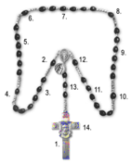
Chaplet of the Holy Face
“Oh Jesus, through the merits of your Holy Face, have pity on us, and on the whole world.” (Repeat 3x)
Sign of the Cross & Opening Prayer:
Dear Lord, through the Sorrowful and Immaculate Heart of Mary, I (we) offer You these prayers in reparation for the sins which offend God the most in these modern times - the sins of blasphemy, atheism, abortion, and the profanation of Sundays and Holy Days of Obligation.
Pray: One Our Father, Hail Mary & Glory Be
- On the Cross, “O God, come to my assistance. O Lord, make haste to help me. Glory Be to the Father, Son and Holy Spirit, as it was in the beginning is now and ever shall be world without end.”
- Big Bead, “In honor of our Lord’s Sense of Touch. My Jesus, Mercy. Glory Be
- Six Small Beads, “Arise, O Lord, and let Thy enemies be scattered, and let all those that hate thee, flee from before Thy Face.”

4. On Big Bead, “In honor of our Lord’s Sense of Hearing, My Jesus, Mercy. Glory Be
5. Six Small Beads,, “Arise, O Lord, and let Thy enemies be scattered…”

6. On Big Bead, “In honor of our Lord’s Sense of Sight. My Jesus, Mercy. Glory Be
7. Six Small Beads, “Arise, O Lord, and let Thy enemies be scattered…”

8. On Big Bead, “In honor of our Lord’s Sense of Smell. My Jesus, Mercy. Glory Be
9. Six Small Beads, “Arise, O Lord, and let Thy enemies be scattered,…”

10. On Big Bead, “In honor of our Lord’s Sense of Taste. My Jesus, Mercy. Glory Be
11. Six Small Beads, “Arise, O Lord, and let Thy enemies be scattered…”

12. On Big Bead, “In honor of Our Lord’s three years of public life: My Jesus Mercy. Glory Be
13. Six Small Beads, “Arise, O Lord, and let Thy enemies be scattered…”

14. On the Holy Face Medal, “God our protector, look upon us, and cast Thine eyes upon the
Face of Thy Christ.”
***
Recite the Glory Be (7x) To honor the 7 Sorrows of the Immaculate Heart of Mary:
1) Prophecy of Simeon 2) Flight Into Egypt 3) Loss of Jesus in the Temple
4) Mary Meets Christ with His Cross 5) The Crucifixion
6) Taking Jesus From the Cross 7) The Burial of Jesus
Litany of the Holy Face
Composed by Sister Marie of St. Peter (Shorter Version)

I salute Thee, I adore Thee and I love Thee, O adorable Face of Jesus, my Beloved noble Seal of the Divinity, outraged anew by blasphemers. I offer Thee, through the heart of Thy Blessed Mother, the worship of all the Angels and Saints, most humbly beseeching Thee to repair and renew in me, and in all men, Thine image disfigured by sin.

O Jesus, whose Adorable Face was adored with profound respect by Mary and Joseph when they saw Thee for the first time, have mercy on us.

O Jesus, whose Adorable Face ravished with joy the Angels, the shepherds, and the magi in the stable of Bethlehem, have mercy on us.

O Jesus, whose Adorable Face, wounded with a dart of love the aged Simeon and the prophetess Anna in the Temple, have mercy on us.

O Jesus, whose Adorable Face, filled with the admiration the Doctors of the law in the Temple at the age of twelve years, have mercy on us.

O Adorable Face, which possesses beauty always ancient and always new, have mercy on us.
O Jesus, whose Adorable Face is the masterpiece of the Holy Ghost, in which the Eternal Father is well pleased, have mercy on us.

O Jesus, whose Adorable Face is the ineffable mirror of the Divine Perfections, have mercy on us.

O Jesus, whose Adorable Face sorrowed and wept at the Tomb of Lazarus, have mercy on us.

O Jesus, whose Adorable Face, was brilliant like the sun and radiant with glory on Mount Tabor, have mercy on us.

O Jesus, whose Adorable Face grew sad at the sight of Jerusalem when Thou didst weep over that ungrateful city, have mercy on us.

O Jesus, whose Adorable Face, was bowed down to the ground in the Garden of Olives, and covered with confusion for our sins, have mercy on us.

O Jesus, whose Adorable Face was covered with the sweat of blood, have mercy on us.

O Jesus, whose Adorable Face was kissed by Judas, have mercy on us.
O Jesus, whose Adorable Face was struck by a vile servant, blindfolded, and profaned by the sacrilegious hands of Thine enemies, have mercy on us.

O Jesus, the divine look of whose Adorable Face wounded the heart of St. Peter with a dart of sorrow and love, have mercy on us.

O Jesus, whose Adorable Face the pious Veronica wiped on the way to Calvary, have mercy on us.

O Jesus, whose Adorable Face was washed and anointed by Mary and the holy women, and wrapped in a shroud, have mercy on us.

O Jesus, whose Adorable Face was all resplendent with glory and beauty on the day of Thy Resurrection, have mercy on us.

O Jesus, whose Adorable Face is hidden in the Eucharist, have mercy on us.

O Jesus, whose Adorable Face will appear at the end of time in the clouds with great power and majesty, have mercy on us.

O Jesus, whose Adorable Face will cause the wicked to tremble, have mercy on us.

O Jesus, whose Adorable Face will fill the just with joy for all eternity, have mercy on us.

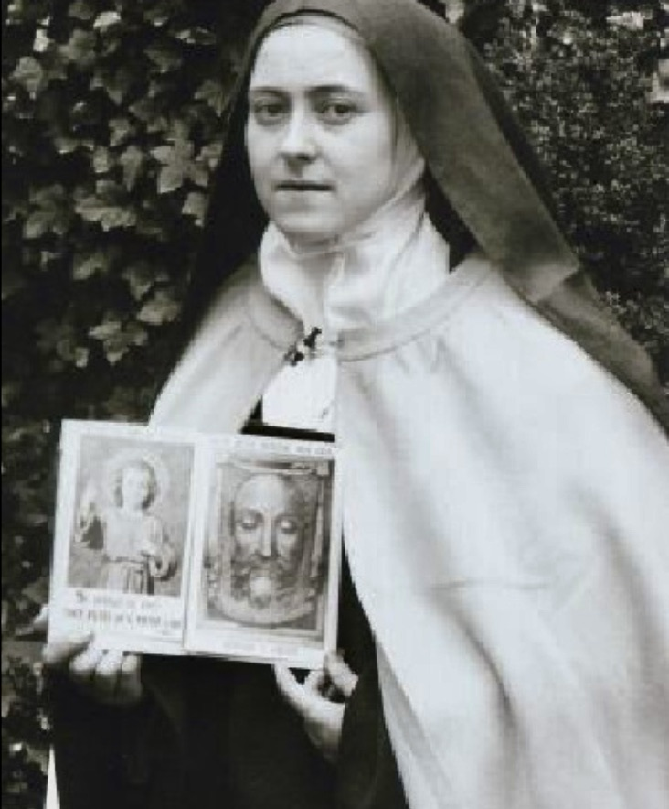
Lamb of God, Who takes away the sins of the world, Spare us O Lord

Lamb of God, Who takes away the sins of the world, Graciously hear us O Lord

Lamb of God, Who takes away the sins of the world, Have mercy on us.

Litany of the Holy Face
Manual of the Archconfraternity of the Holy Face, 1887 (Longer version)

O Adorable Face, which was adored with profound respect by Mary and Joseph when they saw Thee for the first time, have mercy on us.
O Adorable Face, which in the Stable of Bethlehem didst ravish with joy the angels, the shepherds and the Magi, have mercy on us.
O Adorable Face, which in the Temple didst transpierce with a dart of love the saintly old man Simeon and the prophetess Anna, have mercy on us.
O Adorable Face, which was bathed in tears in Thy holy infancy, have mercy on us.
O Adorable Face, which when Thou didst appear in the Temple at twelve years of age, didst fill with admiration the Doctors of the law, have mercy on us.
O Adorable Face, white with purity and ruddy with charity, have mercy on us.
O Adorable Face, more beautiful than the sun, more lovely than the moon, more brilliant than the stars, have mercy on us.
O Adorable Face, fresher than the roses of spring, have mercy on us.
O Adorable Face, more precious than the gold, silver and diamonds, have mercy on us.
O Adorable Face, whose charms are so ravishing, and whose grace is so attractive, have mercy on us.
O Adorable Face, whose ever feature is characterized by nobility, have mercy on us.
O Adorable Face, contemplated by angels, have mercy on us.
O Adorable Face, masterpiece of the Holy Ghost in which the Eternal Father is well pleased, have mercy on us.
O Adorable Face, delight of Mary and of Joseph, have mercy on us.
O Adorable Face, ineffable mirror of the Divine Perfections, have mercy on us.
O Adorable Face, whose beauty is always ancient and always new, have mercy on us.
O Adorable Face, which appeases the wrath of God, have mercy us.
O Adorable Face, which makest the devis tremble, have mercy on us.
O Adorable Face, treasure of graces and of blessings, have mercy on us.
O Adorable Face, exposed in the desert to the inclemencies of the weather, have mercy on us.
O Adorable Face, scorched with the heat of the sun and bathed with sweat in Thy journeys, have mercy on us.
O Adorable Face, whose expression is all divine, have mercy on us.
O Adorable Face, whose modesty and sweetness attracted both the just and sinners, have mercy on us.
O Adorable Face, which gavest a holy kiss to the little children, after having blessed them, have mercy on us.
O Adorable Face, troubled and weeping at the tomb of Lazarus, have mercy on us.
O Adorable Face, brilliant as the sun, and radiant with glory on Mount Tabor, have mercy on us.
O Adorable Face, sorrowful at the sight of Jerusalem and shedding tears on that ungrateful city, have mercy on us.
O Adorable Face, bowed to the earth, in the garden of Olives, and covered with confusion for our sins, have mercy on us.
O Adorable Face, bathed in a bloody sweat, have mercy on us.
O Adorable Face, kissed by the traitor Judas, have mercy on us.
O Adorable Face, whose sanctity and majesty smote the soldiers with fear and cast them to the ground, have mercy on us.
O Adorable Face, struck by a vile servant, shamefully blinded folded, and profaned by the sacrilegious hands of Thine enemies, have mercy on us.
O Adorable Face, defiled with spittle and bruised by innumerable buffets and blows, have mercy on us.
O Adorable Face, whose Divine look wounded the heart of Peter, with a dart of sorrow and love, have mercy on us.
O Adorable Face humbled for us at the tribunals of Jerusalem, have mercy on us.
O Adorable Face, which didst preserve Thy serenity when Pilate pronounced the fatal sentence, have mercy on us.
O Adorable Face, covered with sweat and blood, and falling in the mire under the heavy weight of the Cross, have mercy on us.
O Adorable Face, worthy of all our respect, veneration and worship, have mercy on us.
O Adorable Face, wiped with a veil by a pious woman, on the road to Calvary, have mercy on us.
O Adorable Face, raised on the instrument of most shameful punishment, have mercy on us.
O Adorable Face, whose brow was crowned with thorns, have mercy on us.
O Adorable Face, whose eyes were filled with tears of blood, have mercy on us.
O Adorable Face, whose mouth was poured gall and vinegar, have mercy on us.
O Adorable Face, whose hair and beard were plucked out by the executioners, have mercy on us.
O Adorable Face, which was made like to that of a leper, have mercy on us.
O Adorable Face, whose incomparable beauty was obscured under the dreadful cloud of the sins of the world, have mercy on us.
O Adorable Face, covered with the sad shades of death, have mercy on us.
O Adorable Face, washed and anointed by Mary and the holy women and wrapped in a shroud, have mercy on us.
O Adorable Face, enclosed in the sepulcher, have mercy on us.
O Adorable Face, all resplendent with glory and beauty on the day of the Resurrection, have mercy on us.
O Adorable Face, all dazzling with light at the moment of Thy Ascension, have mercy on us.
O Adorable Face, hidden in the Eucharist, have mercy on us.
O Adorable Face, which wilt appear at the end of time in the clouds with great power and majesty, have mercy on us.
O Adorable Face, which wilt cause sinners to tremble, have mercy on us.
O Adorable Face, which wilt fill the just with joy for all eternity, have mercy on us.

Lamb of God, who takest away the sins of the world, spare us, O Lord.
Lamb of God, who takest away the sins of the world, graciously hear us, O Lord.
Lamb of God, who takest away the sins of the world, have mercy us, O Lord.

Lord Jesus! After having contemplated Thy features, disfigured by grief; after having meditated upon Thy Passion with compunction and love, how can our hearts help being inflamed with a holy hatred of sin, which even now, still outages Thy Adorable Face? But, not allowing ourselves to be content with mere compassion, give us grace to follow Thee so closely on this new Calvary, that the opprobrium destined for Thee may rebound upon us, O Jesus, and that we may at least have some small share in the expiation of sin. Amen.

Additional Prayers for Consideration
Prayer to the Holy Face of Jesus
—By Saint Therese of Lisieux
O Jesus, Who, in Thy cruel Passion became the reproach of men and the Man of Sorrows, I worship thy Divine Face. Once it shone with the beauty and sweetness of the Divinity; but now, for my sake, it is become as the face of a leper. Yet, in that disfigured Countenance, I recognize Thy infinite love, and I am consumed with the desire of making Thee loved by all mankind. The tears that flowed so abundantly from Thy eyes are to me as precious pearls that I delight to gather, that with their worth I may ransom the souls of poor sinners. O Jesus, Whose3 Face is the sole beauty that ravishes my heart, I may not see here below the sweetness of They glance, nor feel the ineffable tenderness of Thy kiss, I bow to Thy Will – but I pray Thee to imprint in me Thy Divine likeness, and I implore Thee to inflame me with Thy love, that it may quickly consume me, and that I may soon reach the vision of Thy glorious Face n Heaven. Amen.
Act of Love to the Holy Face

Adorable Face of my Jesus, my only love, my light and my life, grant that I may see no one except Thee, that I may know no one except Thee, and that I may love Thee alone, that I may live with Thee, of Thee, by Thee.

Prayer to the Eternal Father For Our Country
Eternal Father, we offer Thee the adorable Face of Thy well-beloved Son for the honor and glory of Thy Holy Name and for the salvation of America.

Prayer to the Eternal Father
O Almighty and Eternal God, it is by the Heart of Jesus, Thy Divine Son, my Way, my Truth and my Life, that I draw near to Thee. I come, through this adorable Heart, in union with the holy angels, and with all the saints, to praise, bless, adore and glorify Thy Holy Name, despised and blasphemed by so great a number of sinners. Accompanying, by my desires, the blessed Spirits, ministers of Thy mercy, I circle the world in order to seek for souls bought by the blood of Thy only Son. I offer them all to Thee by the hands of the holy Virgin and of glorious Saint Joseph, under the protection of the angels and of al the saints, begging of Thee, in the Name and through the merits of Jesus our Savior, to convert all blasphemers and all who profane the holy day of Sunday, in order that we may all with one voice, one soul and one heart, praise, bless, love, adore and glorify Thy Holy Name, in the heights, the depths, the breadths, the immensity, the fullness of the honor, the praise and the infinite adorations that the Sacred Heart of Thy well beloved son renders to Thee; that Heart which is the organ and the delight of the most Holy Trinity, and which alone knows and perfectly adores Thy Holy Name in spirit and in truth. Amen.
Twenty-Four Acts of Adoration
—For the Reparation of the Blasphemies Uttered During the Twenty-Four Hours of the Day

Recite the Magnificat at the beginning:
My soul proclaims the greatness of the Lord; My spirit rejoices in God my savior. For he has looked upon his handmaid's lowliness; behold, from now on will all ages call me blessed. The Mighty One has done great things for me, and holy is his name. His mercy is from age to age to those who fear him.

Refrain: Come let us adore the admirable Name of God which is above every name.

- In union with the Sacred Heart of Jesus, Come let us adore the admirable Name of God which is above every name.
- In union with the Holy Heart of Mary: Come let us adore the admirable Name of God which is above every name.
- In union with the glorious Saint Joseph, …
- In union with St. John the Baptist
- In union with the choir of the Seraphim
- In union with the choir of the Cherubim
- In union with the choir of the Thrones
- In union with the choir of the Dominations
- In union with the choir of the Virtues
- In union with the choir of the Powers
- In union with the choir of the Principalities
- In union with the choir of the Archangels
- In union with the choir of the Angels
- In union with the seven Spirits which are before the throne of God and the twenty-four ancients
- In union with the choir of the Patriarchs
- In union with the choir of the Prophets
- In union with the choir of the Apostles and the four Evangelists
- In union with the choir of Martyrs
- In union with the choir of holy Pontiffs
- In union with the choir of holy Confessors
- In union with the choir of holy Virgins
- In union with the choir of holy Women
- In union with all the Heavenly Court
- In union with the whole Church and in the name of all men:
Come let us adore the admirable Name of God which is above every name, and let us prostrate ourselves before Him. Let us weep in the presence of the God who has made us, because He is the Lord our God; we are His people and the sheep of His pasture.

Affectionate Aspirations
Eternal Father, I offer Thee the body and blood of our Lord Jesus Christ, in expiation for our sins and for the needs of the Holy Church.
Amiable Heart of Jesus, our mediator, appease Thy Father, and save sinners.
Powerful heart of Mary, refuge of sinners, stay the arrows of Divine Justice.

Saint Michael, pray for us.
Saint Martin, pray for us.
Saint Louis, pray for us.
O God our Protector, behold us and cast Thine eyes upon the Face of Thy Christ.

Prayer of Reparation to the Holy Face

Lord Jesus, after having contemplated Thy features, disfigured by grief; after having meditated upon Thy Passion with compassion and love, how can our hearts help being inflamed with a holy hatred of sin, which even now, still outrages Thy Adorable Face? But, not allowing ourselves to be content with mere compassion, give us grace to follow Thee so closely on this new Calvary, that the opprobrium destined for Thee may rebound upon us, O Jesus, and that we may at least have some small share in the expiation of sin. Amen
* Recite at the end of prayer meetings and as much as possible:
I have prayed to and entreated Thy Face, O Lord: have pity on me according to Thy promise, save me in Thy mercy; no, I shall never be confounded, because I have called upon Thee. Saint Michael, pray for us. Saint Martin, pray for us. Saint Louis, pray for us.

Prayer Against Communism
“Eternal Father, I offer You the Cross of Our Lord Jesus Christ and all the other instruments of His Holy Passion, that You may put division in the camp of Your enemies, for as Your Beloved son has said, “A kingdom divided against itself shall fall.’”

Miraculous Invocation to St. Therese
O Glorious St. Therese, whom Almighty God has raised up to aid and inspire the human family, I implore your Miraculous Intercession. You are so powerful in obtaining every need of body and spirit from the Heart of God. Holy Mother Church proclaims you “Prodigy of Miracles… the Greatest Saint of Modern Times.” Now I fervently beseech you to answer my petition (mention it here) and to carry out your promises of spending Heaven doing good upon earth…of letting fall from Heaven a Shower of Roses. Little Flower, give me your childlike faith, to see the Face of God in the people and experiences of my life, and to love God with full confidence. St. Therese, my Carmelite Sister, I will fulfill your plea “to be made known everywhere” and I will continue to lead others to Jesus through you. Amen

Prayer of Pope Pius IX (from 1887 Manual)
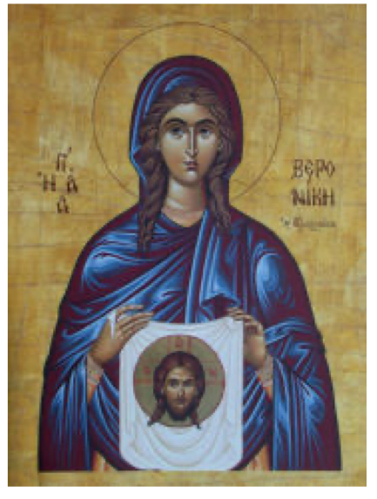
O my Jesus! Cast upon us a look of mercy; turn Thy Face towards each one of us, even as Thou didst turn to Veronica, not that we may see it with the eyes of our body, for we do not deserve to do so, but turn it towards our hearts, that, being sustained by Thee, we may ever draw from that powerful source, the vigor necessary to enable us to wage the combats we have to undergo. Amen

Prayer of Blessed Maria-Pierina

O Blessed Face of my kind Savior, by the tender love and piercing sorrow of Our Lady as she beheld you in your cruel Passion, grant us to share in this intense sorrow and love so as to fulfill the holy will of God to the utmost of our ability. Amen.
Icon of Saint Veronica (Greek Orthodox)
who wiped the Holy Face of Jesus on the Way of the Cross

Litany to Obtain Humility
Lord, have pity on me.
O Jesus, meek and humble of Heart, hear me.
O Jesus, meek and humble of Heart graciously hear me.

From the desire of being esteemed, deliver me Jesus.
From the desire of being loved, deliver me Jesus.
From the desire of being sought after, deliver me Jesus.
From the desire of being praised, deliver me Jesus.
From the desire of being honored, deliver me Jesus.
From the desire of being preferred, deliver me Jesus.
From the desire of being consulted, deliver me Jesus.
From the desire of being approved, deliver me Jesus.
From the desire of being humored, deliver me Jesus.
From the desire of being humbled, deliver me Jesus.
From the desire of being despised, deliver me Jesus.
From the desire of being rebuffed, deliver me Jesus.
From the desire of being calumniated, deliver me Jesus.
From the desire of being forgotten, deliver me Jesus.
From the desire of being mocked, deliver me Jesus.
From the desire of being scoffed at, deliver me Jesus.
From the desire of being insulted, deliver me Jesus.

O Mary, Mother of the humble souls, pray for me.
Saint Joseph, protector of humble souls, pray for me.
Saint Michael, who was the first to tread pride under foot, pray for me.
All the just who are sanctified, above all, by the spirit of humility, pray for me.

Invocation: O Jesus, whose first lesson was this – “Learn of Me, who am meek and humble of Heart,” teach me to become humble of heart like Thee. Amen

St. Michael the Archangel Prayer Chaplet
O God, come to my assistance. O Lord, make haste to help me. Glory be to the Father, etc.
[Say one Our Father & three Hail Marys after each of the following nine salutations in honor of the nine Choirs of Angels]

1. By the intercession of St. Michael and the celestial Choir of Seraphim may the Lord make us worthy to burn with the fire of perfect charity. Amen.
2. By the intercession of St. Michael and the celestial Choir of Cherubim may the Lord grant us the grace to leave the ways of sin and run in the paths of Christian perfection. Amen.
3. By the intercession of St. Michael and the celestial Choir of Thrones may the Lord infuse into our hearts a true and sincere spirit of humility. Amen.
4. By the intercession of St. Michael and the celestial Choir of Dominations may the Lord give us grace to govern our senses and overcome any unruly passions. Amen.
5. By the intercession of St. Michael and the celestial Choir of Virtues may the Lord preserve us from evil and falling into temptation. Amen.
6. By the intercession of St. Michael and the celestial Choir of Powers may the Lord protect our souls against the snares and temptations of the devil. Amen.
7. By the intercession of St. Michael and the celestial Choir of Principalities may God fill our souls with a true spirit of obedience. Amen.
8. By the intercession of St. Michael and the celestial Choir of Archangels may the Lord give us perseverance in faith and in all good works in order that we may attain the glory of Heaven. Amen.
9. By the intercession of St. Michael and the celestial Choir of Angels may the Lord grant us to be protected by them in this mortal life and conducted in the life to come to Heaven. Amen.

Say one Our Father in honor of each of the following leading Angels: St. Michael, St. Gabriel, St. Raphael and our Guardian Angel.
Concluding prayers:

O glorious prince St. Michael, chief and commander of the heavenly hosts, guardian of souls, vanquisher of rebel spirits, servant in the house of the Divine King and our admirable conductor, you who shine with excellence and superhuman virtue deliver us from all evil, who turn to you with confidence and enable us by your gracious protection to serve God more and more faithfully every day.

Pray for us, O glorious St. Michael, Prince of the Church of Jesus Christ, that we may be made worthy of His promises.

Almighty and Everlasting God, Who, by a prodigy of goodness and a merciful desire for the salvation of all men, has appointed the most glorious Archangel St. Michael Prince of Your Church, make us worthy, we ask You, to be delivered from all our enemies, that none of them may harass us at the hour of death, but that we may be conducted by him into Your Presence. This we ask through the merits of Jesus Christ Our Lord.
Amen.
Rosary Recitations for God’s Crown to the Glory of Thy Holy Name

A CROWN OF GLORY TO THE HOLY NAME OF GOD FOR THE REPARATION OF BLASPHEMIES *UNDER THE PROTECTION OF OUR LADY OF THE HOLY NAME OF GOD*
Instead of the Creed, say:
We adore Thee, O Jesus, and we bless Thee, because Thou hast redeemed the world by Thy holy Cross.
Upon the three small beads of the cross, say:
- May the most Holy Name of God be glorified by the most holy soul of the incarnate Word.
- May the most sacred Name of God be glorified by the Sacred Heart of the incarnate Word.
- May the most adorable Name of God be glorified by all the wounds of the incarnate Word.
Prayer on each of the five large beads, say:
We invoke Thee, O sacred Name of the living God, by the mouth of Jesus in the most holy Sacrament, and we offer Thee, O my God, by the blessed hands of the most holy Virgin Mary, all the holy hosts which are upon our altars as a sacrifice of honorable amends and of reparation for all the blasphemies which outrage Thy Holy Name.
Upon each small bead of ten, say:
- Hail, O sacred Name of the living God, through the Heart of Jesus in the most Holy Sacrament.
- I revere Thee, O sacred Name of the living God, through the Heart of Jesus in the most Holy Sacrament.
- I adore Thee, O sacred Name of the living God, …
- I glorify Thee, O sacred Name of the living God, …
- I praise Thee, O sacred Name of the living God, …
- I admire Thee, O sacred Name of the living God, …
- I celebrate Thee, O sacred Name of the living God, …
- I exalt Thee, O sacred Name of the living God, …
- I love Thee, O sacred Name of the living God, …
- I bless Thee, O sacred Name of the living God, …
Closing Prayer is the Prayer said on each of the large beads.
Short Way of the Cross of the Holy Face
(In a Spirit of Reparation and for the Wants of the Church; a great Lenten practice)

O adorable Face of Jesus, hanging so pitifully on the tree of the Cross, at the time of the Pasion for the redemption of the world! Have mercy on us miserable sinners even at this day, look upon us with compassion and grant us the kiss of peace. O my Jesus, mercy!
1st Station – Jesus is Condemned to Death

And He is silent! He who is innocence itsel; He whose words have the power of giving life! His adorable Face loses nothing of Its dignity and sweetness. What a lesson this is for me! O my God, forgive me all those words I have uttered contrary to charity, humility, modesty and piety! And grant that in my trials I may honor Thee by my resignation and patience.

2nd Station – Jesus Carries His Cross

And He receives it with joy and love, and He holds it to His Heart. He presses His Holy Face, His brow and His lips upon it. O how much He loves us! My good Master, forgive me the murmurs and complaints with which I have received the sorrows sent me in They mercy, and teach me to count myself fortunate in having something to suffer for Thee.

3rd Station – Jesus Falls Beneath the Weight of His Cross

And He bruises His Face with the violence of His fall. He rises, His Face covered with mire, dust and blood! Holy Father, I offer Thee the fall of my Savior in expiation of those faults by which I have disedified and scandalized my neighbor. Because of Jesus humiliated and suffering, have mercy on me. In reparation I purpose to strive to prevent evil, and to win hearts to Thee.

4th Station – Jesus Meets His Most Holy Mother

What a moment! What sorrow! What looks I behold, exchanged between this Man-God and His tender mother! What tears bathe their Faces! O Heavenly Father, I offer Thee these tears in expiation of all my self-indulgence and the little resignation I show to Thy holy will. Grant me, as Thou didst Mary, to encounter the look and the Face of Jesus in all my sorrows.

5th Station – Simon, the Cyrenean, Helps Jesus to Carry His Cross

Does a stranger help my Master to carry His Cross?! Whilst I, His child, the object of His tenderness, refuse to do so by endeavoring to escape the contradictions and disappointments with which life is strewn! O how ingrateful am I! Pardon, my God, forget the past, turn Thy Face towards me. Hereafter, I will share Thy sorrows, at least, in accepting mine with a Christian spirit.

6th Station – A Holy Woman Wipes the Face of Jesus

And should I not also, following her example, cause Thee to forget, by my reparation, the outrages Thou receives from so many sinners? Is it not for me to make amends by greater fidelity and love? O this is what I wish to do, my God, to find my glory in Thy humiliations and sorrows!

7th Station – Jesus Falls for the Second Time beneath the Weight of His Cross

O to what a state of abasement and opprobrium do I see Thee reduced, my Savior Jesus! A God prone in the dust! The executioners raise Him with blows! They do not spare even His beautiful Face! And why? To expiate my thoughts of vanity and self-esteem. O with what horror should they fill me, since Jesus has suffered so much to obtain their forgiveness! My God! My God! Have mercy! Let my heart be truly humble.

8th Station – Jesus Comforts the Women of Israel Who Follow Him

O blessed Master! In the midst of His sufferings, He is interested. In those which cause the tears of the good women to flow! He teaches them how to make their tears useful for themselves, and deigns to console them by turning towards them His adorable Face which consoles and blesses them! O my Savior, teach us how to weep for our sins, which are the true cause of Thy sufferings. Grant me more especially a sincere sorrow for my own sins; let my last tear be one of repentance and love.

9th Station – Jesus Falls for the Third Time

He again inflicts upon His Face the same pain and humiliations as before. At the sight of Calvary, He rises, if one may so speak, with renewed courage and renewed love! His Heart bids Him make haste to die for His children. O tender Heart of my God, what a poor return do smallest sacrifice I am frightened and discouraged. Pardon, my Jesus, pardon! I will rise up with Thee, and as an encouragement to follow Thee, I will say to myself in every sorrow: The mercy of God calls me!

10th Station – Jesus is Stripped of His Garments

Strip me, my God, of all that displeases Thee in me; take from me more especially self-love. Wash me in the blood that flows from Thy wounds, and may this innocent blood cause the virtues of purity, sweetness, charity, and a penitential spirit to take root in my heart! May my soul be pleasant to Thy eyes and rejoice Thy Holy Face!

11th Station – Jesus is Bound to the Cross

O my God, I know that it is not sufficient to become detached from myself, but I must practice attachment and unite myself to Thee. Alas! I understand it is only possible in this world by suffering. I submit Lord, without delay and without reserve. Stretch me on the Cross which Thy Providence prepares for everyone in this world, that I may become conformable to Thee! O suffering Face of my Jesus, suspend between heaven and earth, draw me up to Thee and elevate me to Thy height that I may become worthy of Thy eternal glory.

12th Station – Jesus Dies upon the Cross

Holy Father, most powerful and eternal God, I offer Thee the sufferings of my Jesus, His aching Face, His sacred wounds, His adorable blood, His last words and last sigh, in thanksgiving for the benefits which Thou hast heaped upon me, and in expiation of my sins, and more especially to implore of Thee the three following grace:
- For me and mine, a perfect contrition, with a firm will to belong only to Thee.
- For the conversion of poor sinners, and for the holy Church, our Mother. Accord to her the help she expects from Thy bounty, in the terrible ordeal through which she is passing!
- Look not upon our sins, O Lord, but look upon the Face of Thy Christ! Look upon the Heart that has loved us so much, and because of Him, have mercy on us.

13th Station – Jesus is Placed in the Arms of His Mother

O Mary, my tender Mother, it is I who have made thee suffer! Let me then, at least, weep with thee; let me adore the suffering and wounded Face of my dear Redeemer! Requite thyself, beloved mother, it is but just, yet requite thyself like a mother! Ask for me of thy Divine Son such love as may enable me to drink with entire willingness, the few drops reserved for me in the chalice of His Passion, and let me repeat with Magdalene: O how sweet it is to recover one’s innocence through tears of repentance and of love!

14th Station – Jesus is Placed in the Sepulcher

O my Jesus, my Savior, Thou shalt not be there alone! Permit Thy child to be buried with Thee! Again this is not enough; enfold me in the mystery of Thy Face and the wounds of Thy Heart, it is there, I wish to take up my abode, to be seen by Thee alone. “My God! My God! Cause me to live but for Thee!!!”

Closing Prayer of Reparation To the Outraged Divinity of Our Lord Jesus Christ
O Lord Jesus, after contemplating Thy features, disfigured by anguish, and after meditating upon Thy Passion, how can my heart not be consumed with love for Thee, and hatred for those sins which, even at this day, wound Thy adorable Face? Permit me not, O Lord to feel merely compassion alone! Make of me a worthy child of Mary, and accord me the grace, as Thou didst to Thy Divine Mother, to follow Thee so closely on this new Calvary that the insults destined for Thee, O Jesus may fall upon me, a member of Thy Holy Church, and cause me to undertake with courage the duty of expiation and of love, Amen.

Rosary Meditations in Honor of the Holy Face
—From the 1887 Manual of the Archconfraternity, recommended by Pope Leo XIII

Joyful Mysteries
1st Mystery: The Annunciation
I adore Thee, O Jesus, who having the Divine nature, didst deign to take upon Thyself our likeness in order to conform us all to Thy semblance. Imprint more and more deeply in our souls, by a lively faith, the seal of Thy Divine resemblance.
Pardon, mercy, for all unhappy pagans who are enemies of the Gospel, and rebel to the grace of Thy Incarnation.

2nd Mystery: The Visitation
I adore Thee, O Jesus, Divine sun, whose rays, though veiled, reaches him “who is one day to walk before Thy Face.” May the light of Thy Face, which descended upon us at the moment of baptism, enlighten, warm, and continually vivify our souls.
Pardon, mercy, for all ungrateful men who desire to efface from their foreheads the mark of a Christian; for heretics who are not blessed by Thy luminous presence in the bosom of the true Church.

3rd Mystery: The Nativity

I adore Thee, O Jesus little Infant laid in a crib. Thy Face, so full of graces, inspires angelic songs, and ravishes the shepherds and the Magi. All Thy features wear an expression of benignity: O beauty of the Holy Face, O goodness of Jesus, captivate all hearts!
Pardon, mercy for the many indifferent men who misunderstand Thy sweet attractions, who shut their hearts to the excess of Thy charity.

4th Mystery: The Presentation
I adore Thee, O Jesus, presented in the Temple by the hands of Mary. Thou art the victim without spot, alone worthy of all the complaisance of the Father. May we like the holy old man Simeon, after having known and contemplated Thee with the eyes of faith, no longer cling to this world, but turn our eyes and our hearts to Thee alone.
Pardon, mercy, for so many poor madmen, who are captivated and seduced by the figure of this world which passes away.

5th Mystery: Finding of Jesus in the Temple

I adore Thee, O Jesus, found again in the temple in the midst of the Doctors. How beautiful was the ray of Divine light, emanating from Thy August Face upon those who listened to Thee! Make that wisdom, which Thou camest to bring down upon earth, and which Thou hast placed within the reach of all, shine upon us.
Pardon, mercy for the voluntarily blind who obstinately refuse Thy light, and for the victims of an education without God.

Sorrowful Mysteries
1st Mystery: The Agony in the Garden
Hail, Adorable Face of my Saviour, bowed to the earth under the weight of the sins of the world which cover Thee with confusion. Take away from us all human respect, all culpable shame.

Eternal Father I offer Thee the Face of Thy Son, covered with the sweat of agony, obscured by the shades of death; may Thy justice be appeased at the sight of so affecting a spectacle; mayest Thou have mercy on our country in spite of all the crimes that are committed against Thee therein.

2nd Mystery:
Hail, Adorable Face of my Saviour, disfigured by the scourges of the executioners filled with fury against their innocent victim. Repair the injuries inflicted upon my soul by sin, which as a hideous leprosy, disfigures and withers it.
Eternal Father, I offer Thee the bleeding Face of Thy Son in reparation for the innumerable, abominable sins, which imprint their shameful marks even upon the face of men.

3rd Mystery:

Hail, Adorable Face of my Savior, ignominiously blindfolded, covered with spittle, crowned with thorns, wounded with blows. Efface from amongst us every trace of that devastating scourge, the impious and satanic pride of our times.
Eternal Father, I offer Thee the Face of Thy Son which has become unrecognizable. Spare us, and our nation which has committed so many blasphemies, so many profanations, so many audacious revolts against Thee.

4th Mystery:
Hail, Adorable Face of my Savior, miraculously impressed upon the veil of St. Veronica. May my soul bear the impress of the features of Thy humiliation, in order that it may be one day clothed with Thy glory.
Eternal Father, I offer Thee the Face of Thy Son still wiped by so many faithful Veronicas, by so many reparatory souls. For the sake of these souls which are so pleasing to Thee, stay Thy chastisements, and do not hurl Thy avenging thunders upon our unhappy people.

5th Mystery:

Hail Adorable Face of my Savior on the Cross. Before Thee the sun is veiled, the earth is moved and is covered with darkness all the nature mourns. O features of the dying Jesus, features of crucified love, the ineffable expression of which as ravished all the Saints! May you be imprinted deeply in my heart!
Eternal Father, I offer Thee the Face of Thy expiring Son. “Look on the Face of Thy Christ.” May Thou be moved, and may the flood of Thy mercy inundate the whole earth.

Glorious Mysteries
1st Mystery: The Resurrection
Glory to Thee, O Lord, risen Jesus, who didst appear with radiant Face to Thy mother, to the holy women, to the assembled disciples. It is no longer Calvary with its horrors. What beauty, what splendor, what gladness!
By that glory of Thy Face, give back to our souls that beaurty of which sin has deprived them; give back to them their Christian characteristics.

2nd Mystery: The Ascension
Glory to Thee, Lord Jesus, ascending to heaven with Thy Face turned towards the shores of Thy blessed home. Thou wilt hereafter escend once more with the angry Face of the Judge, and in presence of Thy Majesty, every proud head shall prostrate itself before Thee.
O sweet Face of Jesus, going to prepare a place for us, draw our eyes, raise our gaze towards Thee! We desire to belong “to the generation of those who, thirsting, seek the Face of the God of Jacob.”

3rd Mystery: The Descent of the Holy Ghost

Glory to Thee, Lord Jesus, seated at the right hand of the Father. Thou wilt appear continually before the Face of God to plead our cause. A thousand and a thousand thanksgivings for that perpetual intercession.
After having obtained the full effusion of the Holy Ghost upon the apostles, pray to Thy Father to let the same Holy Ghost reign over us, let it brood upon the face of the great waters, upon the nations of the earth agitated, like an ocean, by the tempests of atheism.

4th Mystery: The Assumption
Glory to Thee, Lord Jesus, the new Solomon coming to meet Thy mother. How beautiful Thou art, how gracious, how full of infinite amiability in presence of the Holy Ark introduced by Thee into the heavenly Jerusalem amidst celestial songs!
O smiling Face of Jesus, appear to us at the hour of death, and may the horrible form of the devil disappear at Thy aspect.

5th Mystery: The Crowning of the Virgin Mary

Glory to Thee, Lord Jesus, crowning Thy mother, and making her sit down beside Thee. The eyes of all the Blessed are fixed on Thy Face and on that of Thy mother. Those two Faces shine like two suns, and shed joy throughout the whole of Paradise.
O Jesus, O Mary, grant us the grace so greatly to be desired, the grace of graces, that of contemplating Thee thereafter face to Face in the eternal vision of the elect.

NOVENA IN HONOUR OF THE MOST HOLY FACE OF JESUS
"I firmly wish that my face reflecting the intimate pains of my soul, the suffering and love of my heart, be more honoured! Whoever gazes upon me already consoles me."
—Our Lord Jesus Christ to Sister Pierina
This novena prayer may be said at any time, but especially in the nine days leading up to the Feast of the Holy Face on Shrove Tuesday - i.e. starting two Sundays before the start of Lent. Holy Face Devotion is approved by the Vatican.
DAILY PREPARATORY PRAYER
O Most Holy and Blessed Trinity, through the intercession of Holy Mary, whose soul was pierced through by a sword of sorrow at the sight of the passion of her Divine Son, we ask your help in making a perfect Novena of Reparation with Jesus, united with all His sorrows, love and total abandonment.
We now implore all the Angels and Saints to intercede for us as we pray this Holy Novena to the Most Holy Face of Jesus and for the glory of the most Holy Trinity, Father, Son and Holy Spirit. Amen.
"All those who, attracted by my love, and venerating my countenance, shall receive, by virtue of my humanity, a brilliant and vivid impression of my divinity. This splendor shall enlighten the depths of their souls, so that in eternal glory the celestial court shall marvel at the marked likeness of their features with my divine countenance." Our Lord Jesus Christ to St. Gertrude

DAY 1
- Console the Holy Face of Jesus and Recite Preparatory Prayer
- Psalm 51:3-4
Have mercy on me, O God in your goodness, in your great tenderness wipe away my faults: wash me clean of my guilt, purify me from my sin.
O most Holy Face of Jesus, look with tenderness on us who are sinners. You are a merciful God, full of love and compassion. Keep us pure of heart, so that we may see Thee always. Mary, our Mother, intercede for us; Saint Joseph, pray for us.
Through the merits of your precious blood and your Holy Face, O Jesus, grant us our petition.................. Pardon and mercy.
Prayer to Our Almighty Father
Almighty Father, come into our hearts, and so fill us with your love that forsaking all evil desires, we may embrace you, our only good. Show us, O Lord our God, what you are to us. Say to our souls, I am your salvation, speak so that we may hear. Our hearts are before you; open our ears; let us hasten after your voice. Hide not your Face from us, we beseech you, O Lord. Open our hearts so that you may enter in. Repair the ruined mansions, that you may dwell therein. Hear us, O Heavenly Father, for the sake of your only Son, Our Lord Jesus Christ, who lives and reigns with you and the Holy Spirit, one God, now and forever. Amen. (St. Augustine)
Pray (1) Our Father (3) Hail Marys (1) Glory Be
O Bleeding Face, O Face Divine, be every adoration Thine (3x)
DAY 2
- Console the Holy Face of Jesus and Recite Preparatory Prayer
- Psalm 51:5-6a
My offences truly I know them, my sin is always before me
Against you, you alone, have I sinned; what is evil in your sight I have done.
Most Holy Face of Jesus, we are truly sorry that we have hurt you so much by constantly doing what is wrong; and for all the good works we have failed to do. Immaculate Heart of Mary, Saint Joseph, intercede for us, help us to console the Most Holy Face of Jesus. Pray that we may share in the tremendous love Thou hast for one another, and for the most Holy and Blessed Trinity. Amen.
Through the merits of your precious blood and your Holy Face, O Jesus, grant us our petition.................. Pardon and mercy.
Prayer to the Holy Spirit
Come, Holy Spirit, Sanctifier, all powerful God of love, Thou who didst fill the Virgin Mary with grace, Thou who didst wonderfully transform the hearts of the apostles. Thou who didst endow all Thy martyrs with a miraculous heroism, come and sanctify us, illumine our minds, strengthen our wills, purify our consciences, rectify our judgments, set our hearts on fire and preserve us from the misfortune of resisting Thine inspirations. We consecrate to Thee our understanding, our heart and our will, our whole being for time and for eternity. May our understanding be always submissive to Thy heavenly inspirations and to the teachings of Thy Holy Catholic Church, of which Thou art the infallible guide; may our heart he ever inflamed with love of God and neighbor, may our will be ever conformed to the divine will, and may our whole life be a faithful imitation of the life and virtues of our Lord and Saviour. Jesus Christ, to whom with the Father and Thee be honour and glory forever. Amen.
Pray (1) Our Father (3) Hail Marys (1) Glory Be
O Bleeding Face, O Face Divine, be every adoration Thine (3x)
DAY 3
- Console the Holy Face of Jesus and Recite Preparatory Prayer
- Psalm 51,6b-7
You are just when you pass sentence on me, blameless when you give judgment.
You know I was born guilty, a sinner from the moment of conception.
Prayer of Pope Pius IX
O Jesus! Cast upon us a look of mercy: turn your Face towards each of us as you did to Veronica; not that we may see it with our bodily eyes, for this we do not deserve, but turn it towards our hearts, so that, remembering you, we may ever draw from this fountain of strength the vigour necessary to sustain the combats of life. Amen. Mary, our Mother, and Saint Joseph, pray for us.
Through the merits of your precious blood and your Holy Face, O Jesus, grant us our petition.................. Pardon and mercy.
Prayer of Saint Francis
All highest, glorious God, cast your light into the darkness of our hearts, give us true faith, firm hope, perfect charity and profound humility, so that with wisdom, courage and perception, O Lord, we may do what is truly your holy will. Amen.
To the Angels and Saints
We salute you, through the Holy Face and Sacred Heart of Jesus, O all you Holy Angels and Saints of God. We rejoice in your glory, and we give thanks to our Lord for all the benefits which He has showered upon you; we praise Him, and glorify Him, and for an increase of your joy and honour, we offer Him the most Holy Face and gentle Heart of Jesus. Pray that we may become formed according to the heart of God. Amen.
Pray (1) Our Father (3) Hail Marys (1) Glory Be
O Bleeding Face, O Face Divine, be every adoration Thine (3x)
DAY 4
- Console the Holy Face of Jesus and Recite Preparatory Prayer
- Psalm 51: 8-9
Indeed you love truth in the heart;
then in the secret of my heart teach me Wisdom. O purify me, then I shall be clean;
O wash me. I shall be whiter than snow.
O Lord Jesus, who has said, learn of me for I am meek and gentle of heart, and who did manifest upon Thy Holy Face the sentiments of Thy divine heart, grant that we may love to come frequently and meditate upon Thy divine features. We may read there Thy gentleness and Thy humility, and learn how to form our hearts in the practice of these two virtues which Thou desires to see shine in Thy servants. Mary our Mother and Saint Joseph help us.
Through the merits of your precious blood and your Holy Face, O Jesus, grant us our petition.................. Pardon and mercy.
Prayer in Honor of the Dolours of the Blessed Virgin
O Most Holy and afflicted Virgin, Queen of Martyrs! Who stood beneath the cross, witnessing the agony of your dying Son, look down with a mother's tenderness and pity on us as we kneel before you to venerate your Dolours and place our requests, with filial confidence, in the sanctuary of your wounded heart. Present them on our behalf to Jesus, through the merits of His most sacred Passion and Death, together with your sufferings at the foot of the cross, and through the united efficacy of both, obtain the favour which we humbly ask. To whom shall we go in our wants and miseries if not to you. O Mother of Mercy, who having so deeply drunk of the chalice of your Son, graciously alleviate the sufferings of those who still sigh in this land of exile. Amen.
Prayer to the Souls in Purgatory
My Jesus, by the sorrows you suffered in your agony in the garden, in your scourging and crowning with thorns, in the way to Calvary, in your crucifixion and death, have mercy on the souls in Purgatory, and especially on those that are most forsaken. Deliver them from the dire torments they endure. Call them and admit them to your most sweet embrace in Paradise. Amen.
Pray (1) Our Father (3) Hail Marys (1) Glory Be
O Bleeding Face, O Face Divine, be every adoration Thine (3x)
DAY 5
- Console the Holy Face of Jesus and Recite Preparatory Prayer
- Psalm 51:10-11
Make me hear rejoicing and gladness, that the bones you have crushed may revive. From my sins turn away your Face, and blot out all my guilt.
Holy Face of Jesus, Sacred Countenance of God, how great is your patience with humankind, how infinite your forgiveness. We are sinners, yet you love us. This gives us courage. For the glory of your Holy Face and of the Blessed Trinity, hear and answer us. Mary our Mother, intercede for us, Saint Joseph, pray for us.
Through the merits of your precious blood and your Holy Face, O Jesus, grant us our petition.................. Pardon and mercy.
Prayer to Saint Joseph
Dear Saint Joseph! Adopt us as thy children, take charge of our salvation; watch over us day and night; preserve us from occasions of sin; obtain for us purity of body and soul, and the spirit of prayer, through thy intercession with Jesus, grant us a spirit of sacrifice, of humility and self-denial; obtain for us a burning love for Jesus in the Blessed Sacrament, and a sweet, tender love for Mary, our Mother.
Saint Joseph, be with us in life, be with us in death and obtain for us a favourable judgment from Jesus, our merciful Saviour. Amen.
Pray (1) Our Father (3) Hail Marys (1) Glory Be
O Bleeding Face, O Face Divine, be every adoration Thine (3x)
DAY 6
- Console the Holy Face of Jesus and Recite Preparatory Prayer
- Psalm 51:12-13
A pure heart create for us O God, put a steadfast spirit within us.
Do not cast us away from your presence nor deprive us of your Holy Spirit.
May our hearts be cleansed, O Lord, by the in pouring of the Holy Spirit, and may He render them fruitful by watering them with His heavenly dew. Mary, the most chaste spouse of the Holy Spirit, intercede for us, Saint Joseph pray for us.
Through the merits of your precious blood and your Holy Face, O Jesus, grant us our petition.................. Pardon and mercy.
Prayer to Saint Michael the Archangel
O Victorious Prince, most humble guardian of the Church of God and of faithful souls, who with such charity and zeal took part in so many conflicts and gained such great victories over the enemy, for the conservation and protection of the honour and glory we all owe to God, as well as for the promotion of our salvation; come, we pray Thee, to our assistance. for we are continually besieged with such great perils by our enemies, the flesh, the world and the devil, and as Thou wast a leader for the people of God through the desert, so also be our faithful leader, and companion through the desert of this world, until Thou conduct us safely into the happy land of the living, in that blessed fatherland from which we are all exiles. Amen. (St. Aloysius)
Pray (1) Our Father (3) Hail Marys (1) Glory Be
O Bleeding Face, O Face Divine, be every adoration Thine (3x)
DAY 7
- Console the Holy Face of Jesus and Recite Preparatory Prayer
- Psalm 51:14-15
Give me again the joy of your help, with a spirit of fervor sustain me,
that I may teach transgressors your ways and sinners may return to you.
Lord Jesus! After contemplating Thy features, disfigured by grief, after meditating upon Thy passion with compunction and love, how can our hearts fail to be inflamed with a holy hatred of sin, which even now outrages Thy Adorable Face!
Lord, suffer us not to be content with mere compassion, but give us grace so closely to follow Thee in this Calvary, so that the opprobrium destined for Thee may fall on us, 0 Jesus, that thus we may have a share, small though it may be, in expiation of sin. Amen.
Mary, our Mother, intercede for us. Saint Joseph pray for us.
Through the merits of your precious blood and your Holy Face, O Jesus, grant us our petition.................. Pardon and mercy.
Prayer in Honor of Mary
Hail Mary, Daughter of God the Father! Hail Mary, Mother of God the Son! Hail Mary, Spouse of the Holy Spirit! Hail Mary, Temple of the Most Holy Trinity! Hail Mary, our mistress, our wealth, our mystic rose. Queen of our hearts, our Mother, our life, our sweetness and our dearest hope! We are all Thine, and all we have is Thine. O Virgin blessed above all things, may Thy soul be in us to magnify the Lord; may Thy spirit be in us to rejoice in God. Place Thyself, 0 faithful Virgin, as a seal upon our hearts, that in Thee and through Thee we may be found faithful to God.
Grant, most gracious Virgin, that we may be numbered among those whom Thou art pleased to love, to teach and to guide, to favour and to protect as Thy children. Grant that with the help of Thy love, we may despise all earthly consolation and cling to heavenly things, until through the Holy Spirit, Thy faithful spouse, and through Thee, His faithful spouse, Jesus Christ, Thy Son, be formed within us for the glory of the Father. Amen. —St. Grignon de Montfort
Pray (1) Our Father (3) Hail Marys (1) Glory Be
O Bleeding Face, O Face Divine, be every adoration Thine (3x)
DAY 8
- Console the Holy Face of Jesus and Recite Preparatory Prayer
- Psalm 51:16-17
O rescue me, God my helper,
and my tongue shall ring out your goodness. O Lord, open my lips,
and my mouth shall declare your praise.
Most merciful Face of Jesus, who in this vale of tears was so moved by our misfortunes to call yourself the healer of the sick, and the good Shepherd of the souls gone astray, allow not Satan to draw us away from you, but keep us always under your loving protection, together with all souls who endeavour to console you. Mary, our Mother, intercede for us. Saint Joseph, pray for us.
Through the merits of your precious blood and your Holy Face, O Jesus, grant us our petition.................. Pardon and mercy.
Prayer to Saint Peter
O glorious Saint Peter, who in return for thy lively and generous faith, thy profound and sincere humility and thy burning love, was honoured by Jesus Christ with singular privileges, and in particular, with the leadership of the other apostles and the primacy of the whole church, of which thou was made the foundation stone, do thou obtain for us the grace of a lively faith, that shall not fear to profess itself openly in its entirety and in all of its manifestations, even to the shedding of blood, if occasion should demand it, and to the sacrifice of life itself in preference to surrender.
Obtain for us likewise a sincere loyalty to our Holy Mother the Church. Grant that we may ever remain most closely and sincerely united to the Holy Father, who is the heir of thy faith and of thy authority, the one true visible head of the Catholic Church. Grant, moreover, that we may follow, in all humility and meekness, the Church's teaching and counsels and may be obedient to all her precepts, in order to be able here on earth to enjoy a peace that is sure and undisturbed, and to attain one day in heaven to everlasting happiness. Amen.
Pray (1) Our Father (3) Hail Marys (1) Glory Be
O Bleeding Face, O Face Divine, be every adoration Thine (3x)
DAY 9
- Console the Holy Face of Jesus and Recite Preparatory Prayer
- Psalm 51: 18-21
For in sacrifice you take no delight,
burnt offering from me you would refuse,
my sacrifice a contrite spirit.
A humbled, contrite heart you will not spurn. In your goodness, show favor to Zion, rebuild the walls of Jerusalem.
Then you will be pleased with lawful sacrifice, holocausts offered on your altar.
Sacred Face of our Lord and our God, what words can we do to express our gratitude? How can we speak of our joy? That you have deigned to hear us, that you have chosen to answer us in our hour of need. We say this because we know that our prayers will be granted. We know that you, in your loving kindness, listened to our pleading hearts, and will give, out of your fullness, the answer to our problems.
Mary, our Mother, thank you for your intercession on our behalf. Saint Joseph, thank you for your prayers.
Through the merits of your precious blood and your Holy Face, O Jesus, grant us our petition.................. Pardon and mercy.
Prayer to the Holy Trinity
Most Holy Trinity, Godhead indivisible, Father, Son and Holy Spirit, our first beginning and our last end. Since you have made us after your own image and likeness, grant that all the thoughts of our minds, all the words of our tongues, all the affections of our hearts and all our actions may be always conformed to your most Holy Will, so that after having seen you here on earth in appearances and in a dark manner by the means of faith, we may come at last to contemplate you face to face, in the perfect possession of you forever in paradise. Amen.
Pray (1) Our Father (3) Hail Marys (1) Glory Be
O Bleeding Face, O Face Divine, be every adoration Thine (3x)

Act of Consecration to the Holy Face
O Lord Jesus, we believe most firmly in You, we love You. You are the Eternal Son of God and the Son Incarnate of the Blessed Virgin Mary. You are the Lord and Absolute Ruler of all creation. We acknowledge You, therefore, as the Universal Sovereign of all creatures. You are the Lord and Supreme Ruler of all mankind, and we, in acknowledging this Your dominion, consecrate ourselves to You now and forever.
Loving Jesus, we place our family under the protection of Your Holy Face, and of Your Virgin Mother, Mary most sorrowful. We promise to be faithful to You for the rest of our lives and to observe with fidelity Your Holy Commandments. We will never deny before men, You and Your Divine rights over us and all mankind.
Grant us the grace to never sin again; nevertheless, should we fail, O Divine Saviour, have mercy on us and restore us to Your grace. Radiate Your Divine Countenance upon us and bless us now and forever. Embrace us at the hour of death in Your Kingdom for all eternity, through the intercession of Your Blessed Mother, of all Your Saints who behold You in Heaven, and the just who glorify You on earth. O Jesus, be mindful of us forever and never forsake us; protect our family.
O Mother of Sorrows, by the eternal glory which you enjoy in Heaven, through the merits of your bitter anguish in the Sacred Passion of your Beloved Son, our Lord Jesus Christ, obtain for us the grace that the Precious Blood shed by Jesus for the redemption of our souls, be not shed for us in vain. We love you, O Mary. Embrace us and bless us, O Mother. Protect us in life and in death. Amen.
Glory be to the Father, and to the Son, and to the Holy Spirit. As it was in the beginning, is now, and will be forever.
Note:
- Devotion to the Holy Face centers around the Consecration of the Home, as confirmed by St Pius X
- As revealed by Sister Pierina, Tuesday is a day of reparation to the Holy Face of Jesus, in front of the Blessed Sacrament.
- With the wearing of the medal, (or Holy Face Scapular), one completes the Consecration to the Holy Face and gains the blessings promised.
Consecration to the Holy Face of Jesus
—For members of the Archconfraternity:

I, __________________, in order to give still greater increase to the glory of Jesus, dying for our salvation upon the Cross: in order to correspond to the merciful love with which His Holy Face is animated towards poor sinners, and in order to repair the outrages which the frightful crimes of the present day inflict upon His August Face, the most pure mirror of the Divine Majesty I associate myself, fully and freely, to the faithful received into this pious Archconfraternity; I desire to participate in the indulgences with which it is enriched and in the good works practiced therein, as well for the expiation of my sins as for the solace of souls suffering in Purgatory. Amiable Redeemer, most sweet Jesus, hide in the secret of Thy Face all the members of this association; may they there find shelter from the seductions of the world, and the snares of Satan; grant that, faithfully keeping all the precepts of Thy law and fulfilling the special duties of their state they may be more and more inflamed with Zeal for reparation, and with the flames of Thy Divine love.

Signed: ___________________
Dated: ____________________

Consecration of Ourselves To the Holy Face

O Adorable Face of my Jesus, humbly prostrate in They Divine presence, I desire to consecrate myself wholly to Thee and henceforth to live only for Thee. Why have I not at my disposal, the hearts of all creatures, in order to offer them up as a holocaust to Thee? Alas! O well beloved Face, I have only my own, unworthy as it is of Thy attention and often rebelling against the movement of Thy grace; nevertheless, I give it to Thee, my poor heart, and I consecrate it to Thee, in order that, from this moment and during all the days of my life, it may be inflamed with the holy ardor of Thy Divine love. Purify it, warm it with the blessed rays of Thy eternal light, so that I may henceforth exclaim with the prophet king: “Lord, the light of Thy Face is engraved upon us; Thow hast caused joy to spring forth in my heart.”

I offer Thee then this day, deliberately and with great joy, the sacrifice of all the delights which may be offer me on earth. Accept, O Adorable Face, O though whom I love more than aught else in the world, accept the homage of myself, which I present to Thee at this moment. I thrill with gladness and with love, whilst thus consecrating to Thee the whole of my being. Yes, I offer and consecrate to Thee my heart, my body, my soul, my spirit and my life; my heart, to love only Thee, O beauty ever ancient and ever new; my body , to serve as an instrument of reparation and of all that belongs to Thee, and upon all that will tend to spread devotion to Thee; my life, my whole life, in order that it may be penetrated with Thy sweet memory, and filled with actions worthy of Thy Name, so that I one day may merit that life eternal, in which according to the expression of Thy apostle, I may contemplate Thee, no longer as in an enigma and through a mirror, but face to face, and as Thou art.

Whilst waiting until this supreme grace shall be accorded to me, O Holy Face of Jesus, make me walk here below in the light of Thy benign eyes, that when I shall appear before Thee, Thou mayest name me by my name, Thou mayest kiss me with the kiss of Thy mouth, of the blessed who are occupied without ceasing in contemplating Thee, praising Thee, adoring Thee, and eternally singing Thy mercies. Amen.

Signed: ___________________
Dated: ____________________

