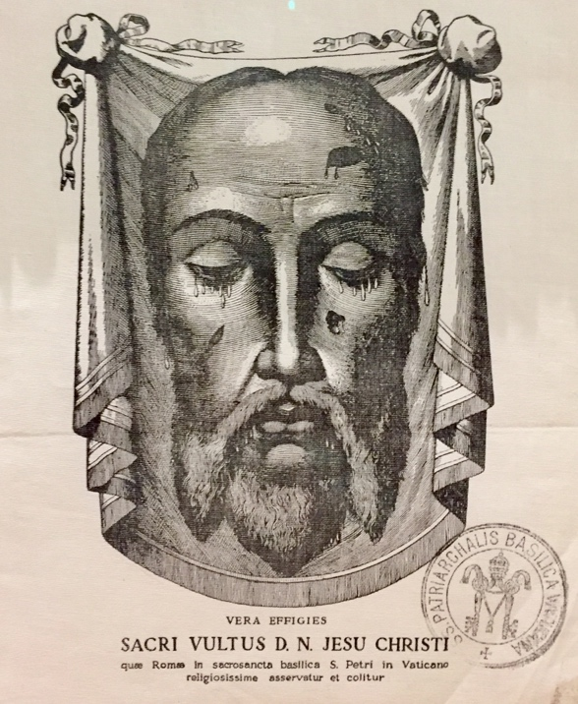
A Brief History of the Holy Face Devotion
“I desire that my face, which shows my soul’s deepest anguish, my heart’s sorrow and my love, may be more honored. Whosoever contemplates Me, consoles Me.”

“Every time that anyone gazes at My Face, I will pour My love into hearts and by means of My Holy Face, the salvation of many souls will be obtained.
—Our Lord to Blessed Maria Pierina de Micheli

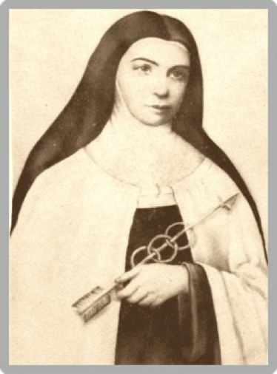
**********

Sister Marie of St. Peter
During the 1840s, Our Lord communicated a series of messages to Sister Marie of Saint Peter (1816-1848), a Carmelite Nun living in Tours, France. These revelations occurred over a six year period and followed the very difficult period of the French Revolution, when the Catholic Church suffered persecutions and many political and spiritual attacks from the ideas of revolutionary men who promoted atheism and communism.
In His messages to Sister Marie (also known as Sister Mary), Jesus shared the many insults He suffered during His passion – how He was slapped, whipped, derided, and spit upon after being kissed by Judas, and the desecration to His Holy Church. He also told Sister Marie the entire earth was covered with crimes that violated the first Three Commandments of God, and that people were profaning Sundays and Holy Days of Obligation.
Sister Marie wrote in her autobiography that the Lord had shown her how these sins violated God’s first three commandments:
- “You shall have no other gods before Me.” Exodus 20:2-3
- “You shall not take the Name of the Lord in vain.” Exodus 20:7
- “Remember the sabbath day, to keep it holy.” Exodus 20:8

Sister Marie was told the Father’s wrath demanded reparation and the Lord wished for her to establish an army of courageous followers to fight for conversion and reparation. Like St. Veronica who wiped the suffering Face of Jesus at the 6th Station of the Cross with great tenderness and piety, God wants people to stop sinning and console Jesus’ blasphemed face:
“My name is everywhere blasphemed —even children blaspheme it. This is a frightful sin. More than all others, it grievously wounds My Divine Heart. Through blasphemy, the sinner curses me to My Face, attacks me openly, and pronounces his own condemnation and judgment. Blasphemy is a poisoned arrow.” (The Golden Arrow)
Our Lord further deepened Sister Marie’s understanding warning of the spirit of atheism and communism that would attack in 1847 with the release of The Communist Manifesto. Jesus asked Sister Marie to “cross swords with the Communists, sworn enemies of the Church.”
Our Lord impressed on Sister Marie the need to establish a public association of prayers through a confraternity so the religious and laity could gaze upon the face of Christ crucified and be united with His sorrows, love and total abandonment. He said this devotion would serve as a remedy for conversion and grace would remove the sin. (www.HisHolyFace.com)
Jesus dictated to Sister Marie the recitation of The Golden Arrow Prayer to delightfully wound and repair the malice of sinners. This and other consoling prayers composed by holy saints (most notably St. Francis of Assisi, St. Therese of Lisieux, St. Bernard, St. Gertrude the Great, and Pope Leo XIII), formed The Manual of the Holy Face; the official prayer guide for the Devotion to the Holy Face.
Sister Marie was told by Jesus these prayers would battle the blasphemies and crimes of our modern times; so evident in today’s world. The time for this devotion is now.

Reparation & Mission of the Defenders of the Holy Name of God
The Lord asked Sister Marie to create an army -the Defenders of the Holy Name through the Holy Face Devotion. “Our Lord showed me this association of brave soldiers, united to Him Him as their Commander-in-Chief, to defend the glory of His Father.” The mission:

- Making reparation in honor of His Holy Face, for the outrages committed against the Divine Majesty of God by blasphemies, the profanation of Sundays and Holy Days.
- Refraining from work on Sundays and encourage others to do so as well.
- Wearing a special scapular with the Holy Face and a cross, with the engraved, “Blessed be the Name of God” and “Begone, Satan!” These two phrases were to be said when someone blasphemed.
- Obtaining conversion and leading others to honor God’s Name and keep His holy days.
- Reciting the prayers of reparation, in particular the Golden Arrow prayer. Spread devotion to the Holy Face of Jesus.
- Preserving youth and the family from the fatal effects of these scandals, by offering a special devotion of prayer, adoration and love to the most Holy Face of our Lord, outraged and disfigured in the Passion.
- Consecrating yourself to the adorable Trinity, the Holy Name of Jesus, and His sorrowful Face. Placing your prayers under the patronage of St. Michael, St. Martin, and St. Louis, protector of France.
- Devoting one’s life to the worship of the merciful and compassionate Face of our Lord, by never uttering blasphemies nor engaging in any act or conversation of any sort which outraged God and our Lord Jesus Christ; and,

Ecclesiastical Approval of the Archconfraternity
“The Divine Savior warned me (Sister Marie) that [she] would have much to suffer because this herd of blasphemers was in a special manner under the leadership of the prince of demons, that is Lucifer himself.” But the Lord also said, “Do not fear him. Saint Michael and the other holy angels will protect you.”
Before her death, a patron of the Carmelite convent named Leo Dupont was given permission to correspond with Sister Marie. He saw her holiness and offered to promote devotion to the Holy Face in his own home where visitors could pray before a replica of the Veil of Veronica. Shortly after Sister Marie died, miracles started occurring in front of Mr. Dupont’s shrine where he kept an oil lamp perpetually lit in front of Jesus’ suffering face.
These events prompted the Bishop of Tours to establish the Confraternity of Reparation on June 28th, 1847, which was soon followed by the remarkable miracle of the illuminated Face of Jesus on Veronica’s Veil in 1849. This happened over Easter in St. Peter’s Basilica in Rome, Italy. Artists copied the image of Veronica’s veil, which is the icon we venerate today.
In 1876, Bishop Charles Colet established the Confraternity of the Holy Face of Jesus, and Pope Leo XIII elevated it to the rank of Archconfraternity in 1885. After her parents enrolled their family into this new devotion, St. Therese of Lisieux was so enraptured by it that she added the Holy Face to her religious name and died holding the image in her hands.

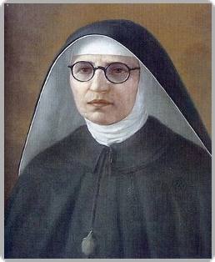
St. Maria Pierina de Micheli
A half-century after Sister Marie’s mission began, a very holy religious sister and mystic named Maria Pierina de Micheli was asked by Our Blessed Mother to promote reparations for our Lord’s suffering Face. Her visions began in 1898 when she was just 7 years of age and saw the baby Jesus in the Holy Eucharist. Again, during Good Friday mass when she was 12, she heard a voice distinctly saying,
“No one gives me a kiss of love on my Face to make amends for the kiss of Judas.”
After kissing our Lord on the cross, a lifetime of heavenly visions and graces followed. Maria joined the Daughters of the Immaculate Conception of Buenos Aires and realized the Holy Face of Jesus was the door to Jesus’ heart. Answering the call to suffer and sacrifice her life for Him, Jesus explained the full devotion to His Holy Face in 1937:
"Perhaps some souls fear that the devotion to my Holy Face may diminish that to my
Sacred Heart. Tell them that, on the contrary, it will complete and increase it.
Contemplating my Face, souls will share my sorrows and will feel the need for love
and reparation. Is this not the true devotion to my Heart?”

Feast of the Holy Face of Jesus (Shrove Tuesday)
Our Lady soon asked Sister Maria to make a scapular of Jesus’ Face and the Holy Eucharist. This scapular was replaced by an church-approval medal of the Holy Face in 1940. Under the directive of Pope Pius XII in 1958, the Feast of the Holy Face of Jesus mass was instituted on Shrove Tuesday, marking the start of Lent.
Jesus asked that the Holy Face be honored especially on Tuesdays, if possible during adoration, and He assured Sister Maria that the promises of the scapular also applied to the medal of the Holy Face.
After World War II, despite many miracles that saved soldiers who wore the medal, the devotion fell away until recently. Sister Pierina was beatified on Sunday, May 30, 2010 at the Basilica of Santa Maria Maggiore in Rome- the first beatification ever held within its walls.
All those who shall wear a scapular like this and make, if possible, a visit to the Blessed Sacrament every Tuesday in reparation for the outrages to the Holy Face, shall receive many graces including strength of faith, overcoming difficulties and a peaceful death. -Mother Marie Perina de Michel

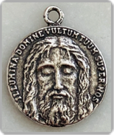
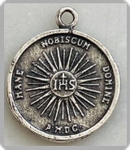
One side is a replica of the Holy Face image from the Shroud of Turin and an inscription based on Psalm 66:2: “Illumina, Domine, vultum tuum super nos”, translated as: “May, O Lord, the light of Thy countenance shine upon us”.

One the other side of the medal, there is an image of a radiant Sacred Host, the monogram of the Holy Name (IHS) and the inscription, “Mane nobiscum, Domine” translated as: “Stay with us, O Lord.”

Embrace the Devotion to the Holy Face of Jesus
By joining a Holy Face prayer group, you can help make reparation through the merits of that Sacred Face by offering it to our heavenly Father. It is a face He cannot refuse, and one that expresses our great love for Christ and the Church. We help to honor the Commandments of God and in return, God has promised all those who honor His Face, many conversions and consolations that include incredible promises at the hour of our death:
“According to the diligence you will manifest in repairing (my image), so will I have the same care in repairing your soul which has been disfigured by sin; I will imprint Theron my image, and will render it as beautiful as when it came forth from the baptismal font.” (Excerpt from The Life of Sister Mary St. Peter)
To learn more about the Devotion to the Holy Face, visit one of the many online sites to find a Holy Face group near you or check out the Guide to Starting a Holy Face group at www.devotiontotheholyface.com. Maybe God is calling you to start a Holy Face devotion at your church or within an existing prayer group. Together, we can build an army for God and Bring hope, faith and greater love to the world.

