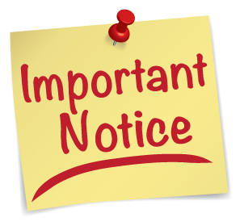

Sept. 1, 2019 is Labor Day. The date for the city council meeting will
be changed to
September 9, 2019.

Thank You.

