Havanese Cuban Cuties
Rebecca Zavala & Aletta Flores
205 - 266 - 6304
HavaneseCubanCuties@gmail.com
2711 Pelham Parkway Pelham, AL 35124
www.HavaneseCubanCuties.com

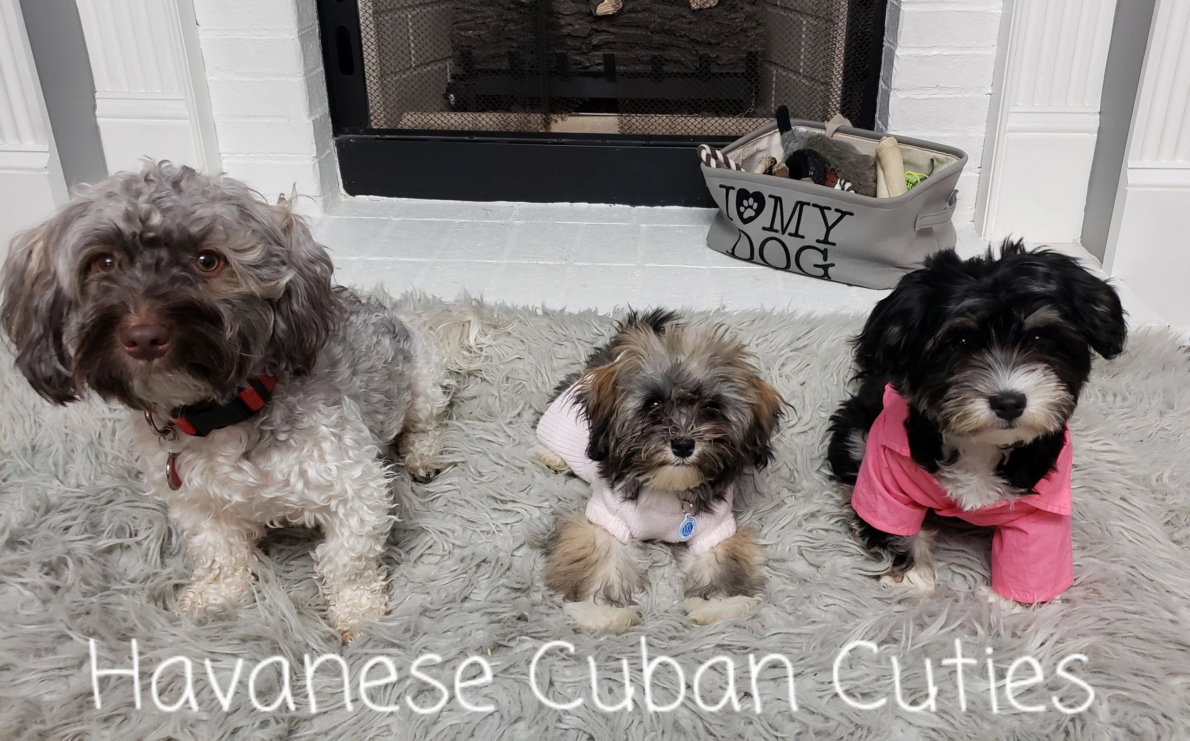

CONTRACT FOR SALE OF DOG

This agreement made the date of ____________________ by and between:
BUYER: _______________________________________________________________________
Address: ______________________________________________________________________
City: ___________________ State: _________ Zip: ____________Cell#: ___________________
Email: ________________________________________________________________________
AND SELLERS: Rebecca Zavala & Aletta Flores as owners of: Havanese Cuban Cuties 2711 Pelham Parkway, Pelham, AL 35124 205-266-6304 Email: HavaneseCubanCuties@gmail.com www.HavaneseCubanCuties.com
Upon PAYMENT of the sum of $________________ (purchase price) paid by Buyer to Seller, receipt of which is hereby acknowledged, Seller grants and sells transfer of ownership of the following Dog to buyer:
BREED: ________________________ SEX: ____________ COLOR: ________________________
DOB: __________________ Litter given name: ________________ Microchip: ______________
SIRE: _________________________________________________________________________
DAM: _________________________________________________________________________

Additional Notes: _______________________________________________________________________________________________________________________________________________________________________________________________________________________________________________________________________________________________________________________
Both parties accept and agree to be bound by the following terms and conditions governing the purchase and sale of This Dog:
DEPOSIT, Payment and Purchase Price, Fees
Buyer has paid a deposit of $________________ (by cash, cashier's check, PayPal or Square with 3.5% fee added, and Zelle) with payment of the balance of $ due upon release of This Dog to Buyer. The mutually agreed upon pickup or delivery date is _________________ , or such other date as the parties may mutually agree in writing beyond the execution of the agreement.
Buyer acknowledges and agrees that the buyer will forfeit the deposit and any rights to the Dog if:
(a) Buyer fails to complete the purchase of This Dog for any reason, or
(b) Buyer fails to pay the balance of the Purchase Price within 48 hours of the agreed upon pickup or delivery date. At which time Seller has the right to offer This Dog up for sale to another family.
In the event that This Dog is not available due to sickness, death, quality or any other circumstance due to the fault of the Seller, statement by veterinarian or acts of nature, Buyers deposit will, at Buyer's option, either be refunded, or transferred to another available puppy within 6-12 months. In the event no other puppies are available, deposit will be refunded.
A boarding fee of $15 TEN DOLLARS per day will be charged for each day This Dog is boarded by Seller past the 14-day date This Dog received its 8-week vet exam, unless Buyer and Seller agree to alternate terms evidenced in writing and dated by both parties. Buyer will be responsible for all normal medical bills such as shot updates, etc. while boarding in seller’s care. Seller will be responsible to keep puppy healthy. Seller will not board sold puppies past the age of 16 weeks.
Transfer of Ownership and AKC Registration
Upon Payment in full of the Purchase Price, Seller shall promptly take all actions required to officially transfer Ownership and AKC limited registration of This Dog to Buyer as agreed.
Seller's Representation and Warranties to Buyer:
(a). Seller is the legal and true owner of the Dog or Seller has the full right and authority to sell This Dog.
(b). This Dog is the breed and true offspring of the sire and dam referenced on page 1 of this agreement.
(c) This Dog is in good health and free of communicable diseases at the time of this sale
(d) Seller gives Buyer TWO 2 business days from the delivery date to have This Dog examined by a licensed veterinarian, at Buyer's sole cost. If This Dog fails the examination, Buyer may return This Dog (at buyers’ expense) with a written statement from the veterinarian, for a full refund or exchange of equal puppy if available. Failure to have the dog examined within 2 TWO business days will nullify this warranty. Should buyer wish to keep the puppy, no replacement will be given, and medical cost and treatments are the sole responsibility of the Buyer. Buyer releases and holds harmless Seller from any liability resulting from any and all health issues and medical cost.
(e) RETURN/REFUND: Seller retains first right of refusal. Should Buyer not want to keep the puppy, seller will take the dog back at any time during the Dog's lifetime for any reason. Seller will not issue a refund upon the return of the dog except for the health guarantee (first year). (See F) If This Dog is young (6 months or less) and is in a healthy condition and sound mind to be resold, buyer may be refunded up to 50% of whatever the new purchase price (set and received by Seller) is minus any and all expenses Seller occurs during this time. This refund shall be issued to buyer only after new sale is complete. Any puppy returned over 6 months of age, no refund will be given. Should Seller receive This Dog back, Buyer will provide the Seller with any and all documentation for This Dog, including medical records and registration papers as well as transfer form for microchip and transfer registration., at Buyers expense.
(f) HEALTH GUARANTEE: Seller guarantees This Dog for 1 year. Should This Dog develop any genetic abnormality (pre- existing conditions excluded), that would significantly shorten the lifespan of This Dog, attested to in writing to Seller by Buyer's veterinarian, and canine specialist, and/or sellers’ choice of a 2nd opinion veterinarian, the seller will provide buyer with a replacement dog upon return of the original Dog. For the first year (first birthday), Seller may pay UP TO FULL purchase price in refund. This is upon proof of medical bills from 2 like opinions from two veterinarians from two separate practices showing statements of a proven life threatening or life altering genetic disorder that will shorten the lifespan or cause lifetime health issues that lessen dog’s quality of life and ability to normal life. One of the opinions must be that of a veterinarian that seller approves or sellers’ vet. Refunds and replacements are of proven genetic issues that are LIFE THREATENING or decrease the quality of having a normal life only. We are not responsible for injuries, tear stains, neglect, seizers from head injuries or toxic items, or hypoglycemia (brought on by stress or lack of eating).
(g) Seller does not guarantee This Dog against any health-related problems or death caused from vaccines, heartworm prevention, or flea/tick treatments (oral or topical). This includes symptoms of kennel cough after puppy has received the vaccine. Seller does NOT give puppy shots any sooner then 3-4 weeks apart. Seller does NOT give Lepto vaccine to any dog under 16 weeks old. Seller does not guarantee loose patella’s or cherry eyes if they were not present at time of sale and found during the initial 2-day vet exam. If This Dog did not have these issues at time of purchase, Seller is not responsible for them later.
Buyers Representations to Seller:
(a) Buyer will maintain This Dog in good health, including keeping up with parasites, internal and external, removing extra puppy teeth, keeping teeth clean, keeping up heartworm prevention and rabies vaccine per law.
(b) This Dog will reside inside the home of the Buyer and his/her family. Dog will not be allowed to roam free outside at will and will not be permanently chained or tethered outside. Dog will be kept free of gross matting and not allowed to sit in his/her feces/urine for long hours.
(c) Buyer will provide the Dog with nutritious high-quality food and keep This Dog’s coat groomed and free of matts and debris. Buyer will provide necessary veterinary care, including routine fecal checks and dental care.
(e) Buyer will NOT sell, release This Dog to a pet shop, puppy mill, retail store, dog dealer, animal testing facility, research facility, or agent for any such facility.
(f) Buyer will NOT breed This Dog to any dog of any breed. This Dog may to be spayed/neutered. Males: We recommend neutering at 9-12 months. Females 3 months after the first heat cycle. Seller may seek recourse in court of up to $15,000 for This Dog being bred as well as repossess This Dog. Seller does not guarantee incontinence due to early spay.
(g) Buyer will return dog to seller if Buyer cannot keep This Dog at any time during dog’s life, unless other satisfactory arrangements are made to place Dog elsewhere. This Dog is not to be surrendered to rescue or to any humane society.
(h) Buyer will seek proper training to ensure the temperament of This Dog is fit for his/her family.
Entire Agreement
This agreement represents the entire agreement between the parties. Seller and Buyer have made no other agreements, promises, representations, or warranties, express or implied, unless specifically stated in this agreement. Seller and Buyer further intend that this agreement be fully binding between parties and agree to be held to the terms of this agreement.
Buyer’s name: _____________________ Address: _____________________________________
Buyer’s Signature: ____________________________________________ Date: ______________
Seller’s name: _______________________________________________ Date: ______________
Seller’s Signature: _______________________________________________________________

