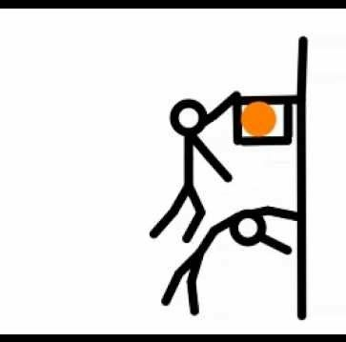 Arizona Amateur’s League
HOOP OR GET HOOPED UP!
Please complete and mail to: hooporgethoopedup@gmail.com
Tiny Tykes Registration Fee: $ 100.00 per session
Training Session includes: 7 weeks – 1 hour of development training per week.

Program Information
- Parents/Legal Guardians assume all risk of injury to their child, and acknowledge that Hoop or get Hooped Up
DOES NOT provide medical insurance and is thereby not responsible for any injury or medical costs. INITIAL HERE _
- Training includes: Developing fundamental skills, Strength, and Confidence. Dribbling, Shooting, Defense, IQ Offense.
- Practices will be once a week (outside/inside, 1-1.5 hours per week). Posted a week before on hooporgethoopedup.com.
- Games scheduled will be determined based on available facilities, and player/team development.
- Indoor game/practice facilities may be provided for additional cost, or based on availability.

Player Code of Conduct
- I will respect myself, coaches all other teammates and players. I WILL NOT LAUGH AT OTHERS!
- I will show good sportsmanship and not engage in bullying, pushing or fighting.
- I will practice every day, and will participate and follow directions at practices and in games.
Parent Code of Conduct
- I will honor respect and good sportsmanship at all times with all teams, players, parents, staff and officials.
- I am responsible for guest behavior that is in my party. NO YELLING! THIS IS A NO BULLYING LEAGUE!
- I will be a fan, parent, or a cheerleader for my child/team. NOT THE COACH OR ASSISTANT COACH!
- I will teach my child respect, honesty, and will encourage my child to practice every day.
- Player multiple absences from practices and or games will result in dismissal from the team.
- Failure after prior warning for violating any these terms can result in a dismal from the program.

Participant Name: Age: DOB / / Boy/Girl
School: Grade: Shirt Size: ____ Short Size: _______
Home Address:
City: State: Zip: Phone #:
Email Address:
Guardian Name:

Hoop or get Hooped Up! Refund Policy Season Start / End Date: __________/___________
No refunds will be granted 10 days after the registration start date. A refund is only granted if the cancellation is within the 10-day registration period. All refund requests will be assessed a $35 cancellation/handling fee and must be sent via email. I_______________________________________ have read and I understand the Refund Policy regarding participation with AAL. By signing below, you have agreed to the Refund Policy, Parent Code of Conduct and the listed participant above to participate in the AAL activities.

Parent Signature ______________________________ Player Signature

