We appreciate the expressed interest in one of our current/ future puppies.

This is not a test; there is no right or wrong answers. Please answer thoughtfully and completely. If there are multiple in the household, please fill out the application together. These questions should help you understand how a puppy or dog my affect your life. Your responses will be used to help make the best possible match of a puppy / dog with your family members, home & lifestyle.

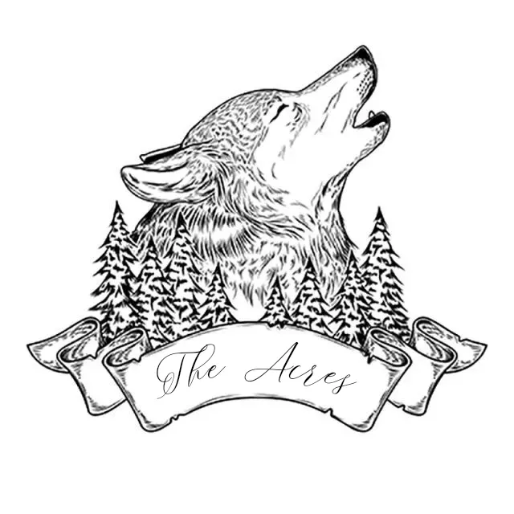

|  |  |
| --- | --- |
| Name: |  |
| Phone Number: |  |
| Email Address: |  |
| Address: |  |
| City, State, Zip. |  |

How did you hear about Husky Acres? Please let us know if it was a previous puppy family.

Please list all family members that live in your home. For Children, please give us an idea of their experience with pets. List Names, Ages, and Experiences.

|  |  |  |
| --- | --- | --- |
| Name: | Age: | Experience: |
|  |  |  |
|  |  |  |
|  |  |  |
|  |  |  |
|  |  |  |
|  |  |  |

Are you Active-Duty Military or in the Reserves? If so, what is the plan if you are deployed?

If you currently own any dogs, please list them. Include their breed, age and if they have been spayed or neutered.

|  |  |  |
| --- | --- | --- |
| Name & Age: | Breed: | Spayed or Neutered: |
|  |  |  |
|  |  |  |
|  |  |  |
|  |  |  |
|  |  |  |

Have you ever had a pet lost and not recovered? If yes, please explain.

Have you ever owned a Siberian Husky, Pomsky or a puppy / dog before? Do you still own the puppy/dog? If mentioned above, please write current animals. If not, what happened to them and where are they now.

Do you have a gender or color preference?

On average how many hours per day will your puppy / dog be left alone?

Where will your new puppy be kept while you are away from home?

|  |  |
| --- | --- |
| Crate |  |
| With a Friend |  |
| Daycare |  |
| Inside Roaming Free |  |
| Outside Roaming Free |  |
| Outside Chained |  |
| Outside Fenced |  |
| Outside Kenneled |  |

What are your living arrangements?

|  |  |
| --- | --- |
| House |  |
| Townhouse |  |
| Own |  |
| Rent |  |
| Condo |  |
| Apartment |  |
| City / Suburb |  |
| Country |  |

**If you live in an apartment, we will ask for proof Siberian Huskies are not on the restricted breed list.

Where will your husky be kept while you are at home?

Do you have a fenced yard? If so, please describe fencing material & height. If you do not have a fenced yard, please describe how you intend to exercise your new puppy/dog?

What would be acceptable reasons for giving up your puppy / dog?

|  |  |
| --- | --- |
| Illness of dog |  |
| Illness of family member or myself |  |
| Moving |  |
| Pregnancy or New Baby |  |
| Allergy |  |
| Destruction of home, toys, crate or yard either as puppy or adult |  |
| Too Active |  |
| Too Shy |  |
| Not compatible with other pets |  |
| Potty Training Accidents |  |
| Submissive Peeing |  |
| Chewing |  |
| Biting |  |
| Fence Jumping |  |
| Growling, Showing Teeth |  |
| Noise concerns such as howling, whining, barking, or talking |  |
| Car Sickness |  |
| Fear of Storms, People, Objects, or Fireworks |  |
| Stealing Food |  |
| Other – please comment in the box below |  |
| None of the Above |  |

|  |
| --- |
| If you choose other, please give us more information. |

Are you buying this puppy / dog as a gift?

Do all family members agree with adding a new puppy or dog to the family?

What activities that you are interested in having you puppy / dog participate in?

|  |  |
| --- | --- |
| Pet / Companion |  |
| Therapy / Service Animal |  |
| Conformation |  |
| Agility |  |
| Breeding |  |

Are you willing to provide regular updates on your puppy / dog growth and development?

Please list the name and contact information of your veterinary you use or plan to use?

Is there is anything else you feel we should know about you while considering the questionnaire?

Thank you for completing our Puppy Application! We will review the application and reach out to you in a timely manner!

* The Acres.