Earraghail Renewable Energy Development Planning Application Factsheet Regarding Community Concerns

Tarbert and Skipness Community Council (TSCC) have now begun to review the Environmental Impact Assessment (EIA) for the proposed development and considering the size and complexity of the document, we are not likely to reach a qualified verdict until we submit at the end of May. However we can say that initial research shows little mitigation by the developer in response to our objections to the Scoping Report.
There is a consensus of concern locally that the site may be unsuitable for a wind-farm, and particularly one incorporating 13 turbines of 180m that include aviation lighting on both hubs and towers, on a site of small hills of approximately 300m altitude. Most existing wind-farms have a maximum tip height of 125m. The larger turbines are out of scale with their surroundings. The proposal directly violates the Argyll and Bute Landscape Wind Energy Capacity Study 2017, which states that large typology turbines (130m or above) should be set well back into the Kintyre peninsula, away from costal fringes; that “the small knotty hills between Tarbert and Skipness would be particularly unsuitable for the large typology”.

Our responses focused on key areas:
- Highly significant landscape impacts owing to a very high range of geographical visibility
- Unreasonable proximity to the largest area of protected SSSI\SAC ancient woodland on the Kintyre peninsula
- Unreasonable proximity to the coastal fringe
- The diversion and transformation of the ancient way-path linking the communities of Tarbert and Skipness and their medieval Castles, that forms the opening section of the Kintyre Way Walking route
- Erosion of experience of other heritage assets including the castle, chapel, historical townships, bronze-age sites and ancient woodland
- Concern regarding the clustering effect and amalgamated impact of wind farm development overall in Kintyre and Knapdale
- Significant cultural impacts relating to the above, reflected in changes to both the built and natural environment
- Direct environmental impacts such as those to rare red-listed protected birds, including golden and sea eagles, black grouse and red-throated divers. These are all acknowledged as using the site and in some cases in growing numbers; the site may be illegal on this basis alone. Also downstream hydrological impacts of changes in the upland land use. Protected habitats and non-development areas surround the site, the buffer zone is not adequate considering the size of the structures
- Potentially significant impacts to local economies expressed in damages to the critical tourism sector

The views from the North Arran scenic areas and Lochranza, as well as from Portavadie, Inchmarnock and Southern Cowal are some of the most significantly altered. The ferry routes connecting them and maritime views generally will be likewise affected. It is located at the only point in Argyll seen from both Ardrishaig and Carradale simultaneously. The word Skipness derives from the Norse for Ship Point. Its commanding views of the surrounding seascape being its strategic ad-vantage. This is why the castle was built here, communicating across the sound to Lochranza by flare signal. It is a singularly visible location to construct a wind-farm when taken in the context of the Kintyre peninsular. The large number of consulted communities in both Argyll and Bute and North Ayrshire is recognition of the unprecedented landscape impact of the proposed development. At all points of the compass and in defiance of the principles of low impact landscape architecture.

The change may be even more striking at night owing to the flashing red aviation lighting. The visual survey attempts to show sights of turbines from Skipness as being limited to the blades and not the hubs and aviation lighting upon them, however closer inspection of the EIA shows this to be a falsehood with hubs and aviation lighting visible from the road entrance to the village, from the beach in the village at low tide, from Kilbranan chapel and Skipness Point, the top of the castle, Port na Chro and the road to Pear house, Altnagalvash and the ancient woodland beyond. These lights are incredibly bright. Look to the south at night and you will see the lights on the turbines at Bhein an Turc (hill of the wild bore) beyond Carradale from 20-30 miles away. What will they look like from 2?

Of course we invite you to make your own opinions. We do however believe it is important for communities to speak as one voice, in so far as it is possible, in ensuring that the necessary deployment of renewable energy technologies is sympathetic to our environment and interests. Many of us have campaigned for years to see renewable energy advanced as an alternative to fossil fuels, however green energy is now big business, it is important that the business interests of energy companies and their financiers do not become the dominant criteria in its development.

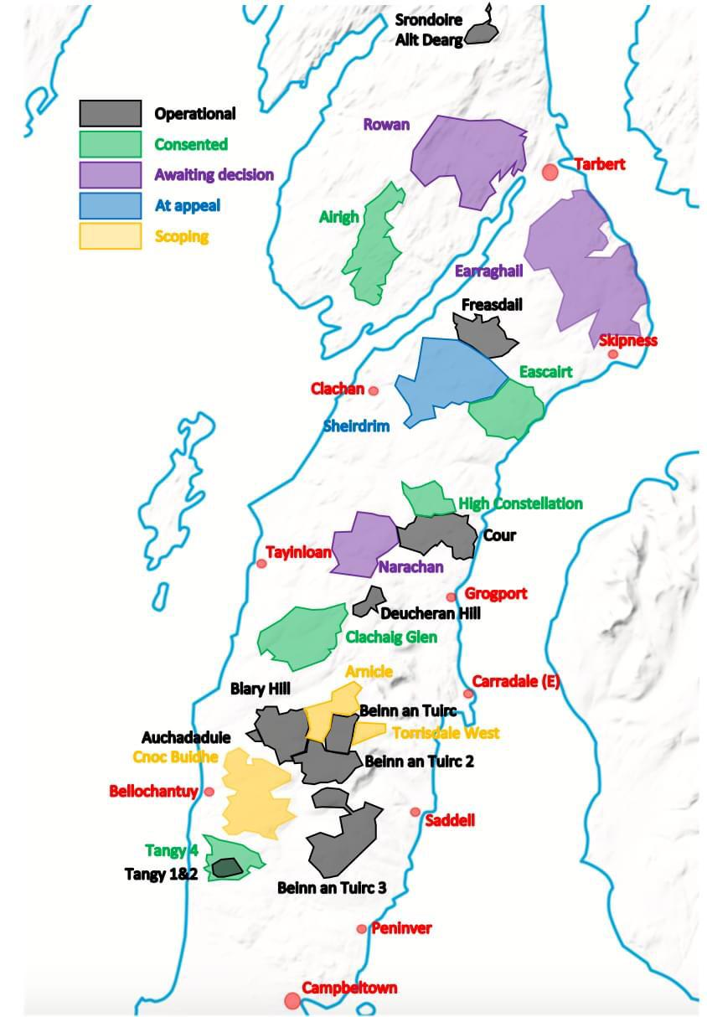

Image showing level of overall wind-farm development in Kintyre and Knapdale

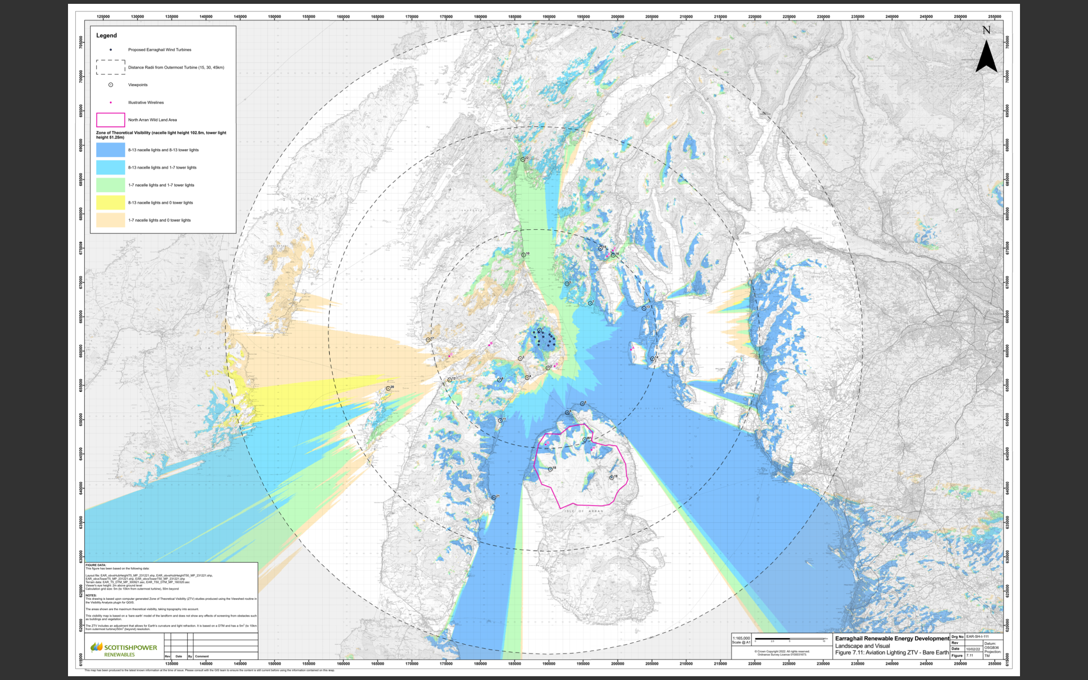

Image showing long-range visibility of aviation lighting

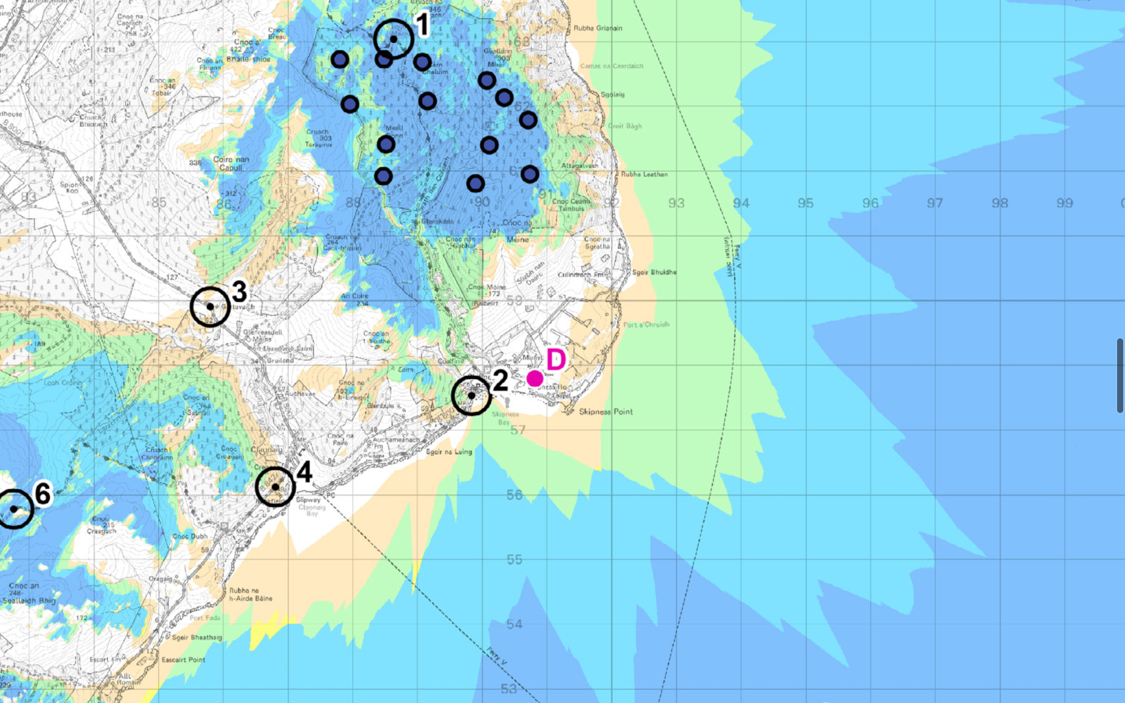

Image showing Impacts of Aviation Lighting on Skipness and Claonig. White shows no visibility, colours show areas of visibility. Darker the colour the more turbines are visible.

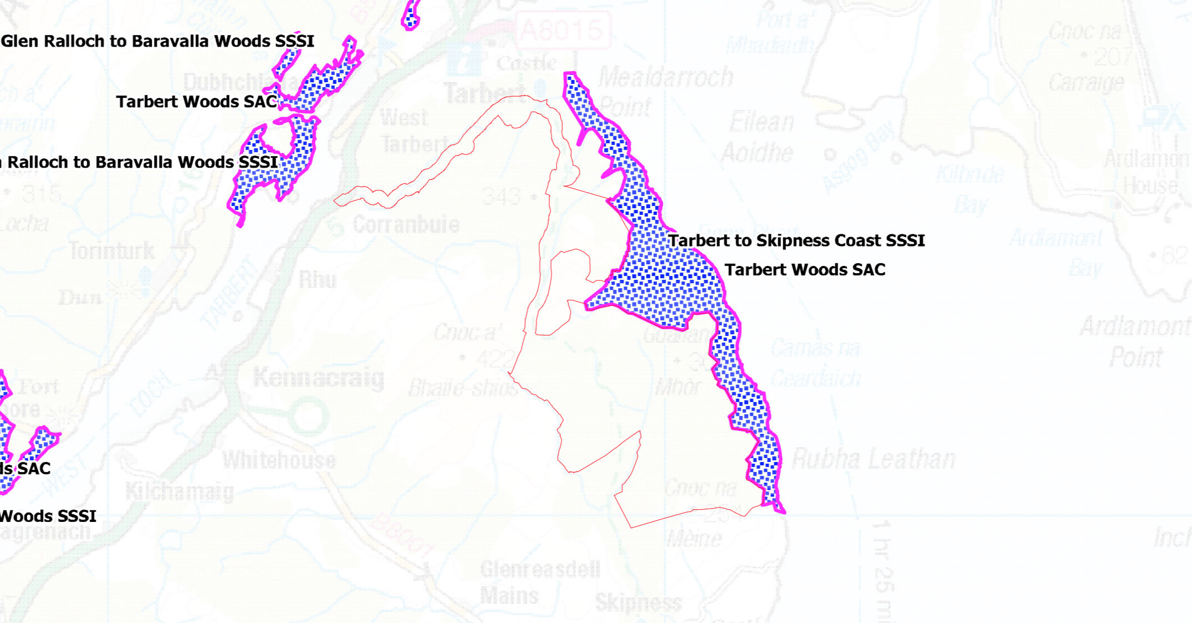

Image showing proximity of development to protected ancient woodland

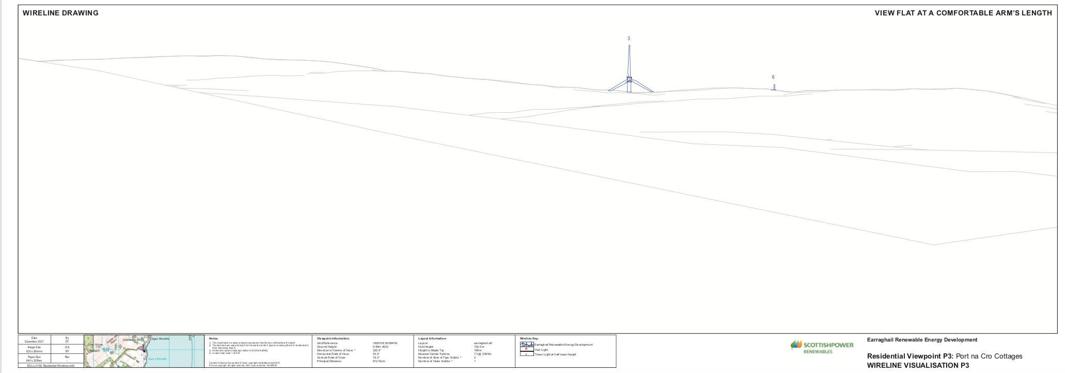

Image showing turbine 3 clearly visible on hillside from Port na Chro beach

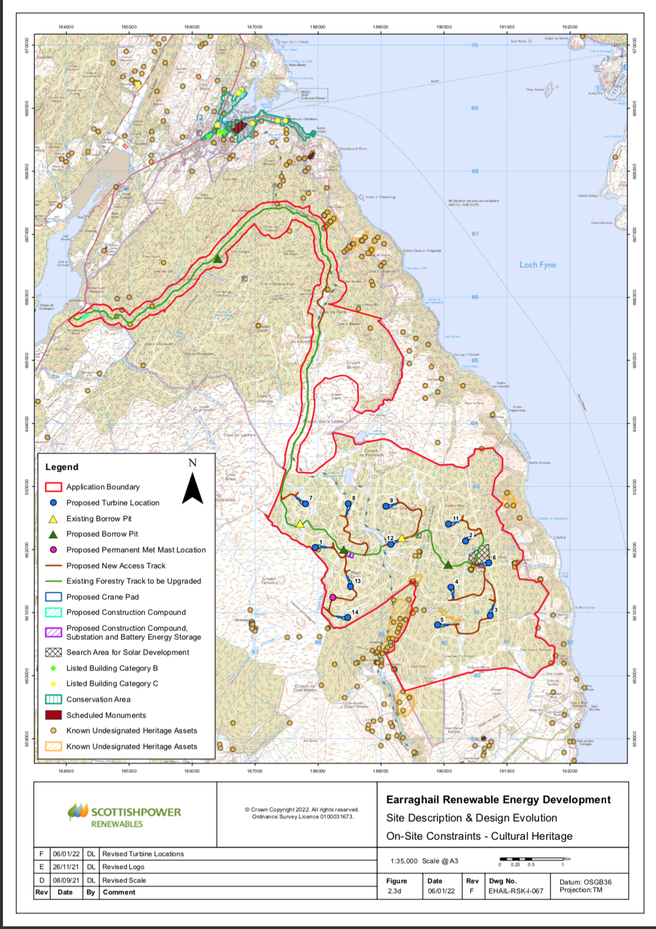

Image showing turbine layout in relation to important cultural heritage sites

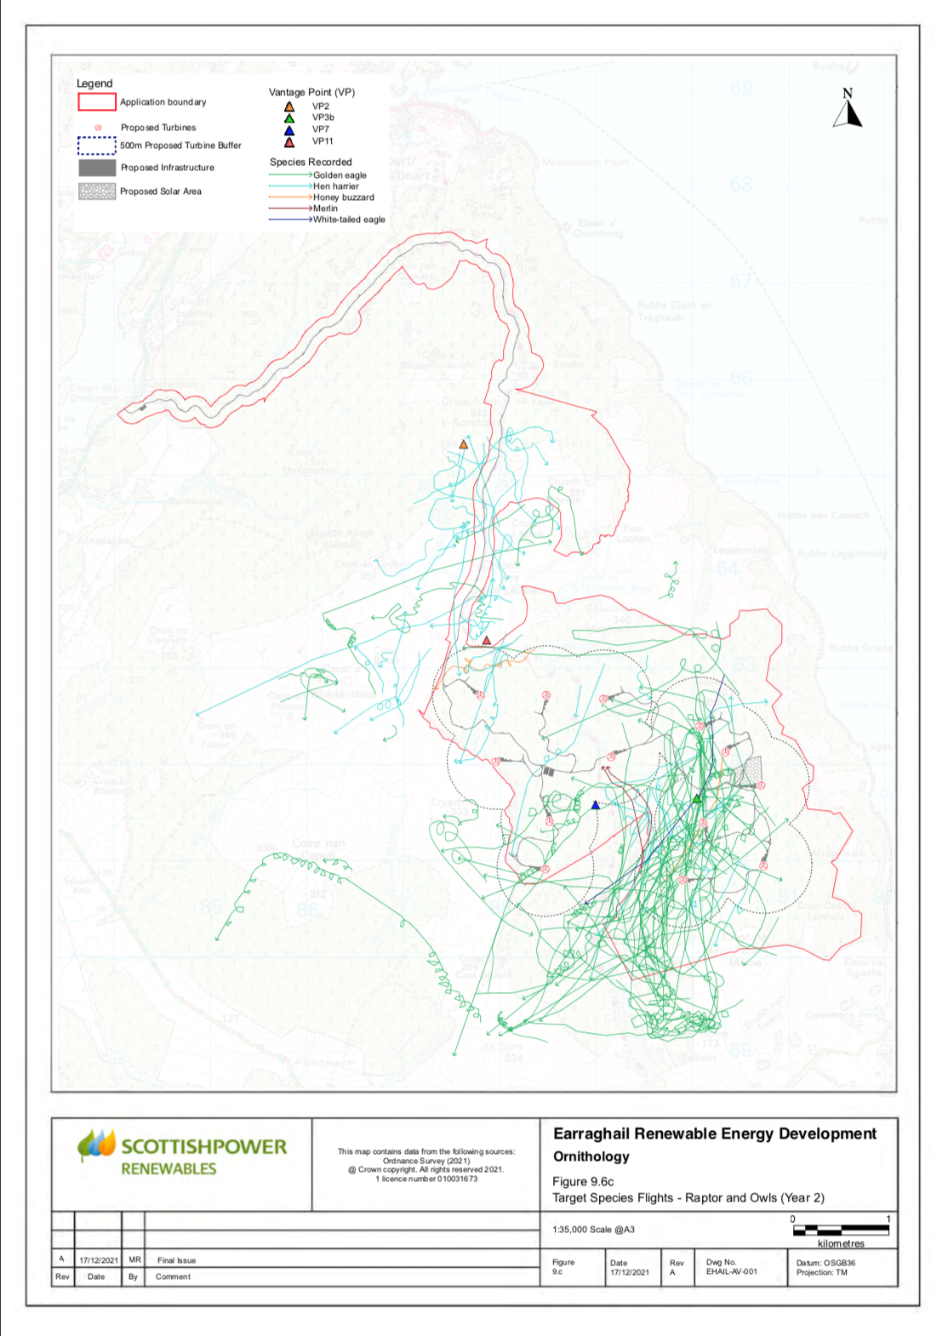

Image showing significant golden eagle movements throughout the turbine array

