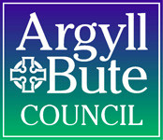
Argyll and Bute Council
Comhairle Earra Ghàidheal agus Bhòid

Executive Director: Douglas Hendry

Kilmory, Lochgilphead, Argyll, PA318RT

Telephone: 01546 605522
Our Ref: SMcA
If phoning or calling please ask for: Simone McAdam
e-mail: simone.mcadam@argyll-bute.gov.uk
Council Website: www.argyll-bute.gov.uk

1st November 2021

Skipness Primary School

Dear Consultee,

Review of Education Provision - Schools (Consultation) (Scotland) Act 2010 – Skipness Primary School

- Notice of public meeting on the Proposal for closure
- Notice of correction on the Proposal for closure

I am writing to you about two points in reference to the review of education provision at Skipness Primary School in regards to the Schools (Consultation) (Scotland) Act 2010. The first is to provide you with a notice of an arranged public meeting on the Proposal for closure. The second is to inform you of a correction to the Proposal paper in regards to the effective date noted within the paper.

- Notice of public meeting on the Proposal for closure - Skipness Primary School - Schools (Consultation) (Scotland) Act 2010

You will have received previous communications regarding the extension of the ongoing consultation for the proposed closure of Skipness Primary School, which has been extended until 23rd December 2021.

The extension of the consultation period was due to Covid-19 regulations that did not permit us to hold a public meeting in regards to Skipness Primary School. Due to the lifting of Covid-19 restrictions we are now able to invite you to attend a public meeting on the above Proposal. The meeting is arranged for:

Wednesday 10th November 2021, 6pm at Skipness Village Hall.

Covid-19 mitigations will be in place for the meeting and we ask that you observe social distancing and wear a mask.

2. Notice of correction on the Proposal for closure - Skipness Primary School -
Schools (Consultation) (Scotland) Act 2010

Due to Covid-19 restrictions on the holding of a public meeting and the extended timeframe of consultation on the Proposal, it has resulted a necessary correction to the Proposal paper. The Proposal states that:

- It is proposed that education provision at Skipness Primary School be discontinued with effect from 28th October 2020.

I would like to make you aware of the correction of the date of 28th October 2020 at all points stated in the Proposal paper to be replaced with 1st December 2022.

The content of the Proposal paper still stands as written other than the change to the proposed effective date.

Please note that the consultation remains open until 23rd December 2021 and it is still possible to submit written consultation responses in the meantime.

Full details of the consultation is available electronically via our website:
https://www.argyll-bute.gov.uk/school-consultations-and-proposals

Or, let us know what you think by writing to:

Education Services
School Consultations
Argyll & Bute Council
Argyll House
Alexandra Parade
Dunoon
PA23 8AJ

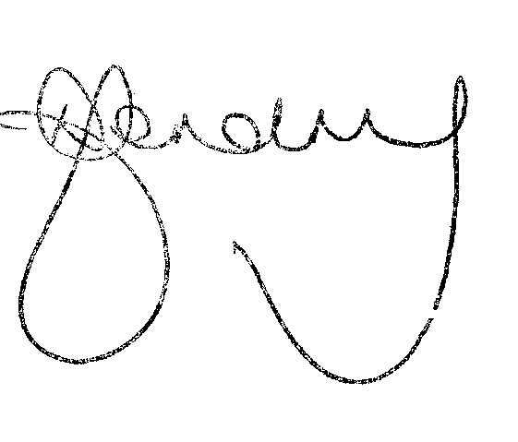
Yours faithfully,

Douglas Hendry
Executive Director with responsibility for Education

