Basics of Equine Tapping
by Charlotte Cannon, The Cannon Method

I’m here to teach you the easiest, way to relax and connect your horse to you, especially when stressed, it’s called Tapping.

It’s a revolutionary way to actually rewire the natural response to stress from Fear, Survival, Fight, Flight, Freeze, to Connection and Relaxation as their coping mechanism.
It’s very simple to begin, by creating a puzzle using a small stressor to condition the new relaxation and connection response. Once your horse knows how to solve the puzzle, we increase the stress and help the horse find the correct answer again and again, until he uses this pattern every time he feels stressed.

Stressors can be anything that could trigger a fear or Sympathetic Nervous System response. Movement or visual triggers, sound or auditory triggers, touch or tactile triggers are all very simple to use. Even energy from you or the environment can be used as a stress trigger.

The way this works is we are reprogramming the Autonomic Nervous System that controls our fear or stress response. Usually when one is confronted by a stressful trigger, your body goes into Survival or Sympathetic Nervous System. Adrenaline is released so one can fight, flight or freeze. The body gets tight, rigid and everything within us withdraws and focuses on survival.

Vision gets tight, tear production turns off, salivation turns off, swallow reflex turns off, heart rate and blood pressure go up, breathing gets fast and shallow, and the blood rushes out of the digestive tract and rushes to the big muscles of the extremities, bc it’s not important to digest a Big Mac, if you are about to be eaten by someone else.
In this fear survival Sympathetic state, not only is our ability to relax and digest turned off, but learning, healing, trusting and connecting are too. This is why we all know you cannot teach a horse or human anything through fear and intimidation. In this mental state, you are not using your brain, reason and thinking are turned off, reacting and doing whatever it takes to survive is all that matters. It’s a bad place to be.

Using our Tapping Technique, we show the horse that he has another choice, and by going to Relaxation and Connection, the Parasympathetic Nervous System, he can solve this stress puzzle in a positive way.

When you choose to go into Parasympathetic Nervous System, you are choosing the Rest, Digest, Play, Learn, Heal, Connect, Trust side of your Autonomic Nervous System. In this space Endorphins and Oxytocin are flowing. Endorphins give you an overall sense of well-being and have more pain relieving power than morphine. Oxytocin is our love, trust, connect, care for hormone. By focusing on signs of Relaxation and Connection, and rewarding those, I believe we trigger Endorphins and Oxytocin and they become the rewards our horses seek, they are where they go to solve that puzzle of stress.

There are some awesome physical things that happen in the body when we trigger the Parasympathetic Nervous System (rest, digest, play, learn, heal, connect, trust). A few are vision gets wide and soft, we see things all around us, tear production and blinking turn on, we know when our horse is blinking he is thinking, salivation and swallowing turn on, horse start to lick their lips, heart rate and blood pressure go down, and the blood comes back into the gut to start digestion. Healing and Learning are turned on, and when we are fully in PSNS, we have access to our maximum athletic potential and our most advanced problem solving abilities. It’s truly the place to be to feel good and really perform.

Another key piece to know about the SNS/Survival, and the PSNS/rest/digest/play/learn/heal/connect/trust, is that each of these have their own sets of muscles that engage when they are in each space.

The SNS/Survival muscles are called the Mobilizers. They are our big, gross motor skills, mechanical muscles. I often call them our robotic or dump truck muscles, you can take them to town, but they aren’t very sexy.

The PSNS/rest/digest/play/learn/heal/connect/trust muscles are called the Stabilizers. These are your fine tune, core, dancer muscles. They are what make one horse move, jump, turn, run vastly better than the others. They are what makes one horse really stand out above the rest. They are key to maximum athletic potential.

Now that you understand all the reasons why you want to get out of SNS, and get into PSNS, I’ve got the greatest info ever. I’ve got a simple way to trigger PSNS in horses and people using the Vagus Nerve.

The Vagus Nerve is key to getting all your mind and body into PSNS. If it’s stimulated, everything is great, everything works well, you can think, play, perform and heal. Life is happy. If the Vagus Nerve is not stimulated, if you have low Vagal Tone, everything starts shutting down to putting all energy and focus into survival.

So where is the Vagus Nerve, and how can we stimulate it?

The Vagus Nerve is the 10th cranial nerve, the longest in your body. The name Vagus means wandering, and this nerve wanders throughout the body connecting to all our major organs. By stimulating the Vagus Nerve in one spot, you are triggering PSNS throughout the whole body. It’s an epic discovery.

In humans stimulating the Vagus Nerve and improving Vagal Tone is the latest discovery to treat disease and improve health and the functioning of the body.

I’ve got 5 main Hacks to Relax that you can use to stimulate your Vagus Nerve and keep you relaxed and connected.

- Pull your belly button in
- Tip your pubic bone up.
- Breathe in through your nose, exhale through your mouth twice as long.
- Part your teeth.
- Relax your tongue down off the roof of your mouth.

I’ve also got 20 Hacks to Relax to help you cope when your stress level and emotions start to escalate. Using any or all of these strategies while you are with your horse is going to be key to getting your horse into and staying in the PSNS. See www.foxpointfarm.com for all 20.

Horses are hardwired to Mirror the rest of their herd for safety/survival and comfort. When you are connected to your horse, on the ground or when riding, you are, in effect, a herd of two. Whatever you do in your body, your horse is hard wired to do in his to stay safe. If you are acting fearful, nervous and reactive, he will mirror you. If you are relaxed, connected, focused on the task at hand, he will be too. Stimulating your Vagus Nerve and getting yourself into PSNS is the first step to getting your horse there too.

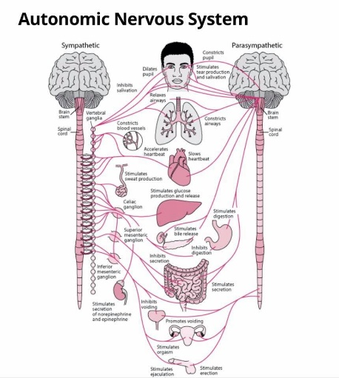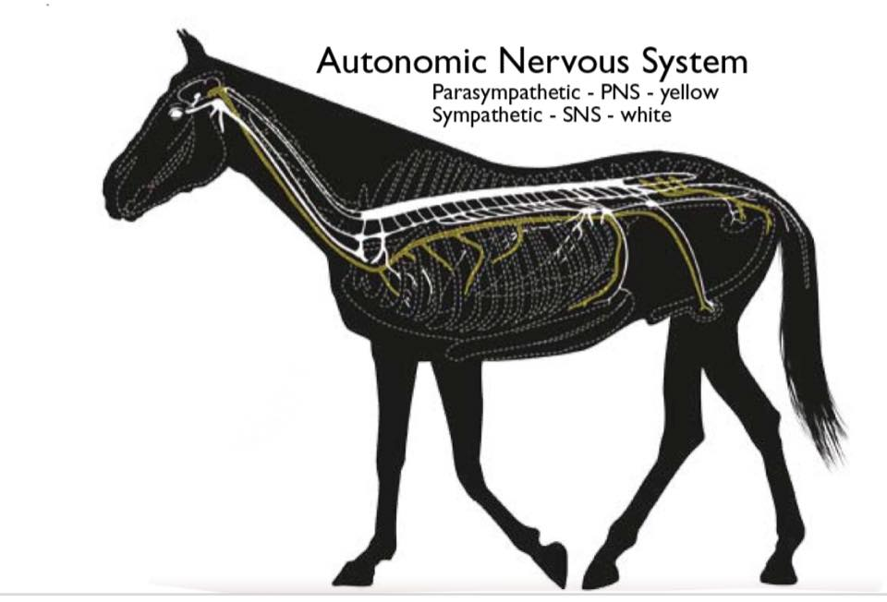

When we are doing our Tapping, we can physically stimulate the Vagus Nerve in many different parts of the horse. Knowing the best places to get, the must bang for your buck (Tap), is another key to getting your horse into PSNS.

The Basic Tapping Technique

To begin Tapping we must find a place where the horse is relaxed and comfortable.

I start with an exercise called Playground of Safety.

1.With the horse on a long rope, I stand still, relaxed on a spot, with my focus not on the horse.

2. I allow my horse to move around me as he needs to without any judgement from me. He can run, he can stand. My goal is that he starts to feel like he can relax in my presence. I’m here, like the lead horse, to watch over and protect him, while he does whatever he needed to do to relax.

3. I establish and protect a bubble of space around myself that the horse cannot enter. This is needed bc the horse needs to trust I’m going to protect him. If I won’t protect myself, he cannot trust me to protect him.

4. Once I start seeing the horse start to relax and get peaceful and still, I know I can proceed.

Many times our energy and nerves are what blows up our horses, so this first Playground of Safety and the next step Backing into the Friendly Spot, is as much about us being aware of what our presence and energy do to the horse, as it has to do with the horse ‘getting trained’. A huge part about being a good horseman, and human in general, is about our awareness, sensitivity to others and our ability to adjust ourselves to help others feel safe, comfortable and relaxed. If you strike fear in your horse, or those around you, you will never achieve as high goals as those that can adjust and work together.

Tapping Technique

1.Back into the Friendly Spot next to the horse, right behind his front leg, right at the girth line. Approach with your back bc it has the least amount of pressure, stressful energy coming out of it. Your belly button and your eyes have great power to stress your horse, and humans. By backing into this spot, you are being as soft as possible.

2. Stand relaxed in this spot. If the horse needs to move, he may not be completely comfortable and confident with you, or any human, at this close proximity. Keep turning the horse around you, moving enough to stay in the Friendly Spot position. Wait to proceed until your horse can be still, relaxed and comfortable behind you.

3. Before adding pressure, look for signs of Relaxation and/or Connection. If your horse is Frozen (SNS/Dorsal Vagal Response) this is just as fear filled as flight or fight. Wait for him to relax before proceeding. The signs you are looking for are blinking, head dropping, ear twitching, lateral flexion, swallowing, lip licking, body twitching, etc. If your horse is showing any of these good signs, you may proceed.

4. The first thing you will use to Tap on your horse is your Belly Button Energy. You are looking for the slightest sign of Relaxation, a Blink, to reward. You are also looking for the slightest sign of Connection, an Ear Twitch toward you, to reward. At this point, either of those responses gets a release.

5. Twist your body so that your Belly Button points toward your horse’s head/neck. As soon as you see the slightest blink or ear twitch, immediately turn away so that your back is again to your horse. The Turn Away is the reward.

6. Repeat turning your belly button toward the horse, and turn away immediately when you get either the blink or the ear twitch. Don’t proceed to Tap again if the ear is turned to you or the eye is soft and blinking.

7. Wait for the horse to disconnect, before Tapping again. The faster you reward, and the more you notice, the faster the horse will figure out this puzzle. The horse will love how he can solve the puzzle and he can feel the reward.

I believe the Ear Twitch is the beginning of Connection, and that gives an Oxytocin release. Each ear twitch gives that shot of oxytocin that feel great. The horse will then start to connect and trust more. Reward all signs of Connection.

Full Lateral Flexion/Head Turned to the side is Maximum Connection posture while still standing. If you get the lateral flexion head turned to you, especially with lip wiggling on you, you have both WON! I believe Lateral Flexion causes Cortisol to rush out and Oxytocin to rush in. That’s winning for the horse and human!

I believe the Blink is the beginning of Relaxation, and that it gives a little Endorphin release. Each blink gives that shot of endorphins that feel great. The horse will then start to relax more. Reward all signs of Relaxation.

Full Longitudinal Stretch/Head Down to the ground is Maximum Relaxation posture while still standing. If you get the head to the ground, especially with lip wiggling in dirt, you have both WON! Head down to ground causes Adrenaline to rush out and Endorphins to rush in. That’s winning for the horse and human!

Most horses are so tight that they will do Lateral Flexion/head turn toward you before they will do Head Down. Whatever your horse does, is right for him. Notice if relaxing or connecting is easier for him. It will help you create puzzles he can solve faster later.

Progressing Tapping

Once you have established the pattern of Stress-> Relaxation or Connection-> Release, and your horse responds correctly each time, you may progress.

1.Turn until you are facing your horse. Have your intention be that of release, no pressure. Stand relaxed waiting for your horse to start to offer relaxation and connection behaviors.

2. Lift your stick, or stressor, as the new stress/pressure puzzle. When your horse gives a relaxation or connection response, lower the stressor/stick immediately to reward.

3. Wait for the horse to unhook from you (look away, focus on something else away from you), then lift the stressor/stick again. Reward by lowering as soon as you see a good response.

4. Continue lifting and lowering until your horse is confident in the answers.

5. To proceed, you may now rub your horse with your stick/stressor as the pressure puzzle. Immediately pull stick/stressor away at any sign of Relaxation or Connection to reward.

6. Touch like this is often when horses start to freeze or overreact/trigger. Go slowly and gently. Do not proceed until your horse is confident how to solve the puzzle.

7. Now you may start to physically Tap on your horse with the stick/stressor. Immediately stop when you get a good response.

8. You have done enough when you feel your horse has given you a really good release. Each horse is different. Some will yawn, others blow out, some may even lay down. Watch your horse. When he gives you something a bit bigger than before, it’s a great place to stop.
Better to do small short baby steps of success, than try to do all of this in a single day. Take your time to build this response in a place your horse feels safe and comfortable, before trying it in an environment where he is stressed.
Proceed to being able to Tap all over his body. Every spot can be conditioned to deliver a good response and a good chemical release.
The better you get him solving this puzzle, the more effective this will be in stressful situations.

You are using several progressive Tapping Concepts:

1.You are conditioning behavior and posture.

2. The postures you are rewarding are triggering chemical releases of good happy trusting chemicals, Oxytocin and Endorphins. These chemicals feel great to the horse, and they are also a reward to him.

3. The horse learns if he goes into these good postures, he will get these good chemicals and they feel better than the chemicals he was getting when he went to fear and stress. He will want to feel good and seek these postures and chemical releases.

4. Once he finds things that triggered stress and fear in the past, can now be solved with these new postures and chemicals, he will start to be calmer and more relaxed in stressful situations and environments.

5. Once he has come this far, the world will now become an opportunity to get high on Endorphins and Oxytocin, as opposed to a place that triggered Adrenaline and Cortisol. He will start to hunt things that would have previously triggered fear, because now he gets hits of Endorphins and Oxytocin.

Advanced Tapping

We can use our Tapping Model in more advanced ways.

- We will use all sorts of scary objects, sounds, and environments to Tap on our horse to produce a relaxation and connection response. This pattern can neutralize fear/stress triggers in all situations and environments.

- We can use Tapping to reshape or horses in ways and at speeds we never thought possible. We can release muscles using the reflex innate to the muscles. We can then open new neural pathways to bring muscles back online. We can trigger the good PSNS muscles so that the horse can engage and use the best muscles for optimal performance.

- We can inspire fascia to release by releasing multiple muscles in an area using this reflex. We can inspire whole fascial planes to release potentially reliving pain, stiffness and immobility. It’s a new way to address lameness.

- We can release old memories, trauma, emotions that have become embedded and locked away in different parts of the body. By releasing the fascia, the old mental and emotional baggage can be loosened, processed and released, so that the horse can move forward without the old triggers.

- We can use this Tapping Model to inspire a whole new type of learning. We can inspire the horse to solve puzzles that before we just forced him to tolerate.

Tapping has numerous amazing applications and uses. It’s the perfect way for us to really learn about Approach, Retreat and Thresholds. It’s the perfect way for us to really learn how our horse best learns. It builds a bond through relaxation, connection and trust that cannot be touched with normal fear and intimidation models
.

Get yourself and your horse into PSNS to not only reach your goals, but to achieve a happiness, joy and success you never imagined possible. For more information www.foxpointfarm.com copywright 2/19/21

