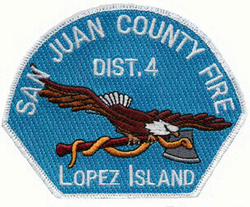
SAN JUAN COUNTY FIRE DISTRICT #4
Board of Commissioners Regular Meeting
Tuesday, June 15, 2021
Zoom Meeting

Join Zoom Meeting
https://zoom.us/j/94133705050?pwd=NHJKUVR2RTg3L2tDTXQvUS92RFI4dz09

Meeting ID: 941 3370 5050
Passcode: 792306

SJCFD#4
Lopez Island Fire and EMS
Regular Meeting
AGENDA

3:45 PM DISABILITY BOARD
4:00 PM CALL REGULAR MEETING TO ORDER
REQUEST FOR MODIFICATION AND APPROVAL OF AGENDA
Procedural Items – 10 minutes
- Public Input
- Correspondence
- Partner Agency Reports
- Approval of May 18, 2021, Regular Meeting Minutes
- Approval of May 2021 Vouchers
- Approval of May and June 2021 Staff Payroll

REPORTS
- Chief’s, Overtime, Fire, EMS, and Budget Reports

4:30 PM UNFINISHED BUSINESS
- Levy Report

NEW BUSINESS
- Preliminary 2022 Budget Discussion

BOARD MEMBER ITEMS

ADJOURN
Next Regular Meeting: July 20, 2021 at 4:00 PM

