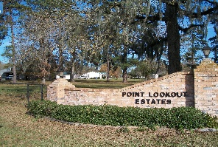
POINT LOOKOUT OWNER’S ASSOCIATION, INC.
P O BOX 145, POINT BLANK, TX 77364-0145
Address for FEDX, UPS: 30 Counts Road, #145, Point Blank, TX 77364
BOARD PHONE NUMBER: (936) 433-2220
ploeboard@gmail.com

Point Lookout Estates
Board Meeting
AGENDA
August 9, 2025
Open Meeting

I. Call to Order
Advising of meeting being recorded

II. Opening Prayer from a Volunteer

III. Advised minutes from July meeting on website. Motion to accept.

IV. Financial Report
a. Michael Kadell– July Report
1. Adjusted items from budget
b. Paula Smith – August Deposits- Status of Balance Summary for Property Owners

V. Updates
a. Repair Projects
1. Fishing Pier
2. Crestmont Culvert
3. Locks
b. 2025-2026 Board Applications

VI. New Business
a. Applications
1. Carport- approved
2. Fence- approved
3. Standby Electronic Generator - approved
4. Front Porch Extension – approved
5. Irrigation Equipment Cover- approved
6. Irrigation Equipment Cover- approved
b. Community Insurance Renewal

VII. News/Information
a. Civic Club News
b. Pool News
c. New Property Owners – introduction if any present
d. Time Permitting- Open floor for questions

