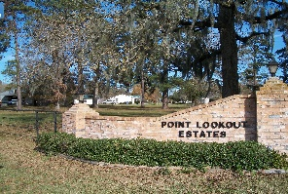
POINT LOOKOUT OWNER’S ASSOCIATION, INC.
P O BOX 145, POINT BLANK, TX 77364-0145
Address for FEDX, UPS: 30 Counts Road, #145, Point Blank, TX 77364
BOARD PHONE NUMBER: (936) 433-2220
ploeboard@gmail.com

Point Lookout Estates
Board Meeting
AGENDA
April 12, 2025
Open Meeting

I. Call to Order
Advising of meeting being recorded

II. Opening Prayer from a Volunteer

III. Advised minutes from March meeting on website. Motion to accept.

IV. Financial Report
a. Michael Kadell– March Report
1. Adjusted items from budget
b. Paula Smith – April Deposits- Status of Balance Summary for Property Owners

V. Updates
a. Repair Projects
1. Canal between Parkview & Crestmont
2. Fishing Pier
3. Road Repair
b. Annual Meeting/Splash Day
c. Deed Violation Letters
VI. New Business
a. Applications
1. New Construction- approved
2. New Construction- approved
3. Concrete Patio / Front Sidewalk – approved
b. No Trespassing Signs for common areas
c. Workday for Posts with Cable in Boat Ramp/Fish Pier/Pool Area

VII. News/Information
a. Civic Club News
b. Pool News
c. New Property Owners – introduction if any present
d. Time Permitting- Open floor for questions

