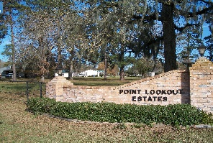
POINT LOOKOUT OWNER’S ASSOCIATION, INC.
P O BOX 145, POINT BLANK, TX 77364-0145
Address for FEDX, UPS: 30 Counts Road, #145, Point Blank, TX 77364
BOARD PHONE NUMBER: (936) 433-2220
ploeboard@gmail.com

Point Lookout Estates
Special Called Open Meeting
AGENDA
September 27, 2025
At 8:00 p.m.

I. Call to Order
Advising of meeting being recorded

II. Ballot Count Announcement

III. Election of Officers

IV. Vote- By-law Change for Frequency of Board Meetings

Article III, Section 8 reads:

Meetings: The regular meeting of the Board shall be held on the second Saturday of each month, at the Association offices, commencing at 9:00 o’clock a.m., unless otherwise directed by the President. Meetings of the Board, either regular or special, shall be held at least once each month.

Proposed Change:

Meetings: The regular meeting of the Board shall be held at least quarterly at the Association offices, unless otherwise directed by the Board.

