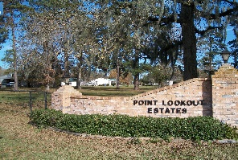
POINT LOOKOUT OWNER’S ASSOCIATION, INC.
P O BOX 145, POINT BLANK, TX 77364-0145
Address for FEDX, UPS: 30 Counts Road, #145, Point Blank, TX 77364
BOARD PHONE NUMBER: (936) 433-2220
ploeboard@gmail.com

Point Lookout Estates
Board Meeting
AGENDA
July 12, 2025
Open Meeting

I. Call to Order
Advising of meeting being recorded

II. Opening Prayer from a Volunteer

III. Advised minutes from May meeting on website. Motion to accept.

IV. Financial Report
a. Michael Kadell– May & June Report
1. Adjusted items from budget
b. Paula Smith – July Deposits- Status of Balance Summary for Property Owners

V. Updates
a. Repair Projects
1. Fishing Pier - lights
2. Crestmont Culvert – contract awarded
VI. New Business
a. Applications
1. Metal Carport- approved
2. Carport Extension- approved
3. Standby Electronic Generator - approved
4. Fence - approved
b. 2025-2026 Board Applications
c. Boat Ramp Lock
VII. News/Information
a. Civic Club News
1. Phone books for sale
b. Pool News
1. Need person to take over pool responsibilities
c. New Property Owners – introduction if any present
d. Time Permitting- Open floor for questions

