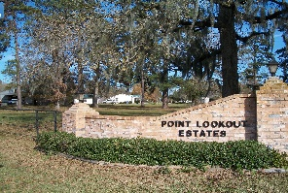
POINT LOOKOUT OWNER’S ASSOCIATION, INC.
P O BOX 145, POINT BLANK, TX 77364-0145
Address for FEDX, UPS: 30 Counts Road, #145, Point Blank, TX 77364
BOARD PHONE NUMBER: (936) 433-2220
ploeboard@gmail.com

Point Lookout Estates
Annual Board Meeting
AGENDA
May 17, 2025
Open Meeting

I. Call to Order
Advising of meeting being recorded

II. Opening Prayer from a Volunteer

III. Advised minutes from April meeting on website. Motion to accept.

IV. Financial Report
a. Michael Kadell– April Report
1. Adjusted items from budget
b. Paula Smith – May Deposits- Status of Balance Summary for Property Owners

V. Updates
a. Repair Projects
1. Canal between Parkview & Crestmont
2. Fishing Pier
b. Deed Violation Letters
c. Letter sent to property owner on Oakridge concerning culvert
d. Overgrowth property discussed at last meeting
VI. New Business
a. Applications
1. Culvert- approved
2. Fence- approved
b. Brian Easterwood – Proposed Amendments Discussion

VII. News/Information
a. Civic Club News
b. Pool News
c. New Property Owners – introduction if any present
d. Time Permitting- Open floor for questions

