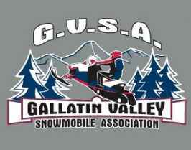
Make checks payable and send to:
Gallatin Valley Snowmobile Association
1780 4th Street
Bozeman, MT 59718

2022-23 GVSA Membership Dues

______ New ______ Family/Individual - Joint GVSA and MSA ($55)
______ Renewal ______ Family/Individual - GVSA only ($30)
______ Business Associate Membership - GVSA only ($50)
Please Print:
Name _______________________________________________________________________________
Address ________________________________________ Email________________________________
City ________________________ State _____ Zip _____________Phone _________________________
Spouse ______________________________________________
Children’s Names (at home) ______________________________________________________________

