Mocktails

**Nojito (Serves 2)**

Ingredients

* 1 tbsp [sugar](https://www.bbcgoodfood.com/glossary/sugar-glossary)
* small bunch [mint](https://www.bbcgoodfood.com/glossary/mint-glossary)
* 3 [limes,](https://www.bbcgoodfood.com/glossary/lime-glossary) juiced
* soda water

**Method**

**STEP 1**

Mix the sugar with leaves from the mint using a pestle and mortar (or use a small bowl and the end of a rolling pin).

**STEP 2**

Put a handful of crushed ice into 2 tall glasses. Divide the lime juice between the glasses with the mint mix. Add a straw and top up with soda water.

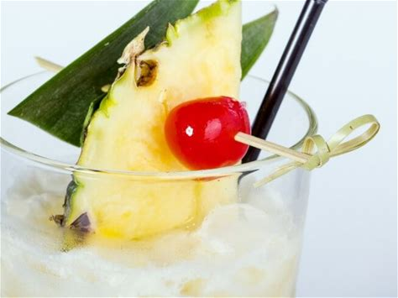**Virgin Pina Colada**(Serves 1)

Ingredients

* 150ml [pineapple juice](https://www.bbcgoodfood.com/glossary/pineapple-glossary)
* 50ml [coconut milk](https://www.bbcgoodfood.com/glossary/coconut-milk-glossary)
* 25ml [lime juice](https://www.bbcgoodfood.com/glossary/lime-glossary)
* ice
* [cherry](https://www.bbcgoodfood.com/glossary/cherry-glossary), to garnish

**For the mock rum syrup**

* 100g [dark brown muscovado sugar](https://www.bbcgoodfood.com/glossary/sugar-glossary)
* 1 [pineapple](https://www.bbcgoodfood.com/glossary/pineapple-glossary), a few strips of skin, plus leaves to garnish
* 5 black peppercorns
* 5 [cloves](https://www.bbcgoodfood.com/glossary/clove-glossary)
* 1 [cinnamon stick](https://www.bbcgoodfood.com/glossary/cinnamon-glossary)

**Method**

**STEP 1**

To make a mock rum syrup, put the dark brown muscovado sugar and 200ml water in a [saucepan](https://www.bbcgoodfood.com/review/five-best-saucepans), stir well and heat gently until the sugar has dissolved.

Add a few strips of skin from the pineapple, add the black peppercorns, cloves and a cinnamon stick, then bring to the boil. Turn off the heat and leave to infuse until cold.

Strain into a jug and set aside in the fridge until needed. *Will keep for up to three days.*

**STEP 2**

Pour the pineapple juice into a tall glass and add the coconut milk and lime juice. Stir gently.

Fill up the glass with a handful ice then slowly add 25ml of the syrup so it sinks to the bottom. Garnish with pineapple leaves and a tinned cherry.

**Apple, Elderflower & Mint Sparkle**

Ingredients

* 75ml elderflower cordial
* 1l [cloudy apple juice](https://www.bbcgoodfood.com/glossary/apple-glossary)
* small handful [mint](https://www.bbcgoodfood.com/glossary/mint-glossary) leaves, roughly chopped
* bottle sparkling water

**Method**

**STEP 1**

For a grown-up non-alcoholic drink, mix elderflower cordial with cloudy apple juice. Add a small handful mint leaf, stir well, then pour into a chilled flask.

**STEP 2**

To serve, pour half glasses of the juice and top up with sparkling water.