Energy Efficiency for Your Home

Take a tour of an energy efficient home
https://www.energy.gov/energysaver/energy-efficient-house-tour
It’s all about WEATHERIZATION
Weatherization consists of:
- Air Sealing
- Insulation
- Moisture Control
- Ventilation

“Weatherizing your home helps you save money by saving energy, and it can also improve the comfort of your home. Professionals who perform weatherization services are part of the "Home Performance" industry. They are trained to understand how a house works as a system and to offer solutions that can solve common and difficult problems using building science.”
Conduct a home energy audit (via NH Saves) to start building your strategy for weatherizing your home, learn about more about the elements of weatherization: air sealing, insulation, moisture control, and ventilation at the following links
https://www.energy.gov/energysaver/weatherize

Energy Saver Guide: Tips on Saving Money and Energy at Home

https://www.energy.gov/energysaver/energy-saver-guide-tips-saving-money-and-energy-home

NH SAVES Home Energy Audit
NH Saves is operated by New Hampshire electricity providers Eversource, Liberty Utilities, New Hampshire Electric Co-op, and Unitil. Just click on https://nhsaves.com/ to see if you qualify for a home energy audit to take advantage of available discounts.
Should you qualify, an approved contractor will inspect your home to determine where improvements may be made to insulation, mechanical systems, lighting and refrigeration, and run diagnostic tests to locate air leaks. It is offered to qualified enrollees for $100. If you decide to go forward with any of the audit recommendations this fee will be deducted from the total cost of the project. After the assessment, the approved contractor will prepare a detailed work proposal for improvements, explaining discounts and incentives available. Once work is done, it is inspected to make sure the work has been done up to spec.
To see if you qualify, you go to NHSaves.com where you are prompted to fill in the square footage of your home (without the garage footage), and the yearly cost of your heating fuel be it oil, propane, wood, kerosene, pellets or any combination of these. Also you include your hot water type, building type (single family, apartment, duplex, condo), age of building, # of occupants, be it a year-round home or seasonal, and whether you own of rent, along with your utility account #, name and address. You may also list the name of a contractor from the approved list. Once form is completed and submitted, via email or through the mail, you will be informed whether you can participate in the Visual Audit program.
AIR SEALING
Overview below– For lots of great additional and easy to understand information see Air Sealing Your Home | Department of Energy
( https://www.energy.gov/energysaver/air-sealing-your-home ) “Reducing the amount of air that leaks in and out of your home is a cost-effective way to cut heating and cooling costs, improve durability, increase comfort, and create a healthier indoor environment. Caulking (https://www.energy.gov/energysaver/caulking) and weatherstripping (https://www.energy.gov/energysaver/weatherstripping) are two simple and effective air-sealing techniques that offer quick returns on investment, often one year or less. Caulk is generally used for cracks and openings between stationary house components such as around door and window frames, and weatherstripping is used to seal components that move, such as doors and operable windows. “
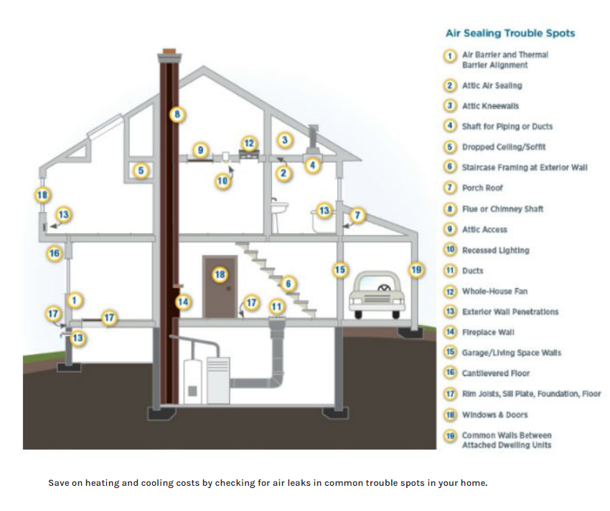

INSULATION
Overview below – For lots of great additional and easy to understand information see Insulation | Department of Energy (https://www.energy.gov/energysaver/insulation)
“For optimal energy efficiency, your home should be properly insulated from the roof down to its foundation. The illustration above shows all the areas of the home where there should be insulation. The numbered areas shown in the illustration are as follows:
1. In unfinished attic spaces, insulate between and over the floor joists to seal off living spaces below. If the air distribution is in the attic space, then consider insulating the rafters to move the distribution into the conditioned space.
(1A). Insulate the attic access door
2. In finished attic rooms with or without dormers, insulate (2A) between the studs of "knee" walls, (2B) between the studs and rafters of the exterior walls and the roof, (2C) and ceilings with unconditioned spaces above.
(2D) Extend insulation into joist space to reduce air flows.
3. Insulate all exterior walls, including (3A) walls between living spaces and unheated garages, shed roofs, or storage areas; (3B) foundation walls above ground level; (3C) foundation walls in heated basements.
4. Apply insulation to floors above unconditioned spaces, such as vented crawl spaces and unheated garages. Also insulate (4A) any portion of the floor in a room that is cantilevered beyond the exterior wall below; (4B) slab floors built directly on the ground; (4C) as an alternative to floor insulation, foundation walls of unvented crawl spaces. (4D) Extend insulation into joist space to reduce air flows.
5. Do not forget to insulate the band joists.
6. Caulk and seal around all windows and doors.
In addition to insulation, consider moisture and air leakage control (https://www.energy.gov/energysaver/moisture-control) in each area of your house. If radon is an issue where you live, you’ll also need to consider radon and radon-resistant construction techniques as you research foundation insulation options. In addition, if you live in an area with termites, you’ll have to consider how termite protection will affect the choice and placement of insulation in your home and plan for a means of inspection.”

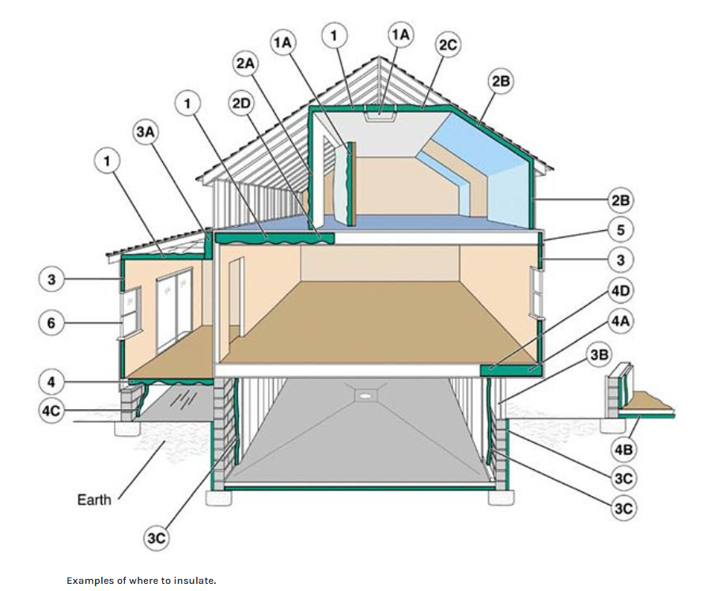

WINDOWS
After you have done air sealing and insulation, it’s then time to invest in windows.
Guide to Energy-Efficient Windows (https://www.energy.gov/sites/prod/files/guide_to_energy_efficient_windows.pdf)– Great info in this handout – a must read! Here’s some excerpts:
Replacing old windows represents a significant investment, but the payback in terms of improved thermal comfort, reduced energy usage, and money saved over the long term makes replacement a smart choice. Upgrading to ENERGY STAR qualified models can save you 7%-15% on annual household energy bills, or roughly $71-$501 annually, depending on your geographic location and the type of window being replaced. Before replacing your windows, be sure you have already properly insulated, and air sealed your home.
Factors to Consider When purchasing ENERGY STAR qualified windows, look for the U-Factor and the Solar Heat Gain Coefficient (SGHC). The U-Factor measures how well the window insulates. While the U-Factor can take any value, in general for windows it ranges from 0.20 to 1.20. The lower the U-Factor, the better the window insulates. The SHGC measures how much of the sun’s heat comes through the window. It can range in value from 0 to 1. The lower the SHGC, the less solar heat the window lets in.

