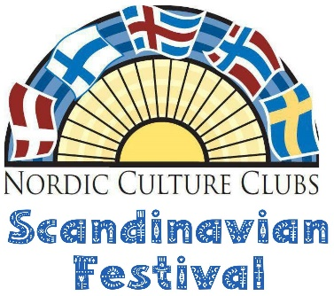
2026 ANNUAL SCANDINAVIAN FESTIVAL VENDOR REGISTRATION FORM
APPLICATION DEADLINE DATE: May 15, 2026
PLEASE PRINT Name______________________________________________________________ Business/Organization__________________________________________________ MNtaxID#____________________________________________________________ Address_______________________________________________________________ City/State/Zip_________________________________________________________
Display Requirements:
_____ #Chairs. Electricity: yes/no (circle)
List Accessibility Needs:_________________________________________________
______ I will provide a demonstration/public hands-on activity at my booth.
______ I will be a Passport Stop and provide a short “cultural lesson.”
Booth description:______________________________________________________
CIRCLE APPROPRIATE BOOTH CATEGORY
$25 DISCOUNT IF YOU ARE WILLING TO BE ON THE ATRIUM LEVEL. Requests for main/ship level will be on a first come/first serve basis (once payment received).
Booth Category | Folk Artist/ Nonprofit | Commercial Retailer | #8 foot tables needed ($30/table for 2 days) | Atrium level discount (Less $25) | Total Fee (Add across)
4’ x 4’ Author table | $75 | $100
8’ x 10’ Single | $150 | $250
8' x12’/6’ x16’Double | $200 | $325
CERTIFICATION
I HEREBY AFFIRM THAT ALL INFORMATION SUPPLIED IS TRUE AND ACCURATE TO THE BEST OF MY KNOWLEDGE AND BELIEF, AND I UNDERSTAND THAT THIS INFORMATION WILL BE CONSIDERED MATERIAL IN THE EVALUATION OF APPLICATION. NOTICE MUST BE GIVEN OF ANY CHANGE IN STATUS IMPACTING THE INFORMATION PROVIDED WITHIN TEN (10) DAYS OF SAID CHANGE. I AGREE TO INDEMNIFY AND HOLD HARMLESS THE NORDIC CULTURE CLUBS BOARD OF DIRECTORS, STAFF AND CONTRACTORS, FESTIVAL VOLUNTEERS, AND THE HJEMKOMST CENTER (CITY OF MOORHEAD) STAFF FROM ANY LOSSES, CLAIMS OR LIABILITIES FOR PROPERTY LOSS OR DAMAGE THAT MAY ARISE AS A RESULT OF MY PARTICIPATION IN THE NORDIC CULTURE CLUBS JUNE 19-20, 2026 SCANDINAVIAN FESTIVAL. Signature______________________________________Date__________
FOLK ARTISTS: Must be demonstrating their craft to be eligible for the lower rate
THE NORDIC CULTURE CLUBS SCANDINAVIAN FESTIVAL IS A 2-DAY EVENT HELD AT THE HJEMKOMST CENTER IN MOORHEAD, MN FEATURING MUSIC, ENTERTAINMENT AND CULTURAL PROGRAMMING OF DENMARK, FINLAND, ICELAND, NORWAY AND SWEDEN. THE SCANDINAVIAN FESTIVAL DRAWS MANY VISITORS TO THE FARGO/MOORHEAD AREA WHO WANT TO “CELEBRATE THEIR NORDIC HERITAGE”. THE INDOOR FOLK ARTIST VENDORS BOOTH SPACES ARE IN THE HJEMKOMST SHIP GALLERY/ENTRANCE and ATRIUM LEVEL. YOU MUST BE DEMONSTRATING YOUR CRAFT.

Make Checks payable to : NORDIC CULTURE CLUBS
Address: 2419 12th Ave. SW Suite #2E, Moorhead MN, 56560
OR
For credit card payments:
Name on Card (Please Print)_________________________________________
Credit Card Type: ________________________________________________
Credit Card Number:______________________________________________ CVV:_________________________Expiration:_________________________
There is a 4.25% Processing fee for all credit card payments. Cancellation Policy: 90% refund with cancellation notification by May 1. No refund after May 1. No refund of credit card fees.
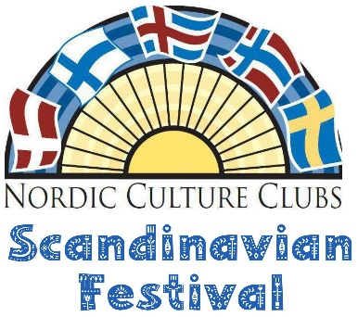
2026 ANNUAL SCANDINAVIAN FESTIVAL VENDOR APPLICATION
APPLICATION DEADLINE DATE: May 15, 2025
EVENT LOCATION NAME: Hjemkomst Center
EVENT ADDRESS: 202 1 st Ave. N., Moorhead, MN 56560
EVENT DATES: June 19-20, 2026
EVENT CONTACT: Tamara Eade, Nordic Culture Clubs Event Coordinator
TEXT: 701-526-6347 EMAIL: nordiccultureclubscoordinator@aol.com
VENDOR MOVE-IN: Thursday, June 18, 2025 11:00am-4:30 p.m. and
Friday, June 19, 2025 7:30 a.m. – 9:00 a.m
EVENT SCHEDULE
EVENT HOURS: Friday & Saturday June 19-20, 2025 9:30-4:30
VENDOR MOVE-OUT: Saturday, June 20, 2026 4:30 p.m. – 6:00 p.m.
COMPLETED FORM SUBMISSION PROCESS
Complete this form, save/download, and mail in or send to provided email address. You will receive email verification from nordiccultureclubscoordinator@aol.com. Upon acceptance as a 2026 Scandinavian Festival Vendor, you will be emailed an invoice with remittance instructions. You need to submit a MN ST19 Operator Certificate of Compliance with Vendor Booth Fee. http://www.revenue.state.mn.us/minnesota-tax-id-requirements

WHAT WE PROVIDE:
Chairs for the booths
Social media marketing with vendor profile on website
Listing in the 2026 Scandinavian Festival Program
Stickers or stamper for those vendors who are passport stops.
WHAT VENDOR NEEDS TO PROVIDE:
TABLES, TABLE COVERING, SIGNAGE IS MANDATORY, CASH BOX/CHANGE, CREDIT CARD PROCESSING
DO YOU NEED TABLE(S)? ______________
We will rent tables for you if you are unable to bring your own. Additional charges for table rental: $15 per 8-foot table per day(e.g. $30 for one 8 foot table for both days).
We DO NOT provide/rent 4 or 6 foot tables.
Please add table rental cost to fee table on first page. Thank you.
WHO WILL BE WITH YOU? LIST ALL THE NAMES OF THE PEOPLE WHO WILL BE STAFFING YOUR BOOTH (FOR THE NAME TAGS). (Please list yourself). Please Print.
1. ________________________________________________
2. ________________________________________________
3. ________________________________________________
4. ________________________________________________
5. ________________________________________________
6. ________________________________________________
7. ________________________________________________
8. _______________________________________________

