Did You Know You Can Pay
Your Rent Online?

Watts Property Management offers a convenient way for you to pay your rent online via the secure Online Portal.

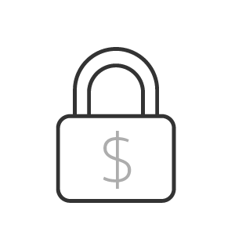 |  | 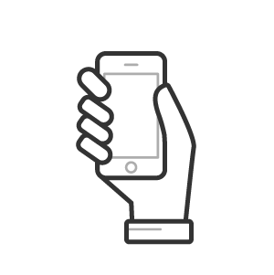
Secure  Online payments are encrypted using  bank-grade security. | Fast  Your charges are immediately marked as paid. | Convenient  You can pay your rent from anywhere with your mobile device. | Flexible  Choose the method that best fits your needs.

We offer you the following payment options:

eCheck (100% free to you!)
Enter your routing and account numbers in your secure Online Portal to pay rent or any other
charge directly from your checking or savings account.

Credit or Debit Card
Use your debit or credit card to pay rent or any other charge through the secure Online Portal. (An online convenience fee applies and is based on your monthly rent charges.)

Electronic Cash Payments
If you choose this method, we will provide you with a reusable PaySlip that you can use at 7-Eleven, CVS, Casey’s, or Ace Cash Express to pay your rent in cash (a $3.99 transaction fee applies; $1,500 maximum per transaction.)

How to get started:

- Visit [yourdatabasename].appfolio.com/connect and click Request Access to the Portal at the bottom.
- Fill in the fields with your name, phone, and email.
- You will then receive an email with a link to your personal, secure Online Portal.
- Create a password and access right away!

If you have any questions, please email us at crystal@wattsara.com or call 434-821-5205.

