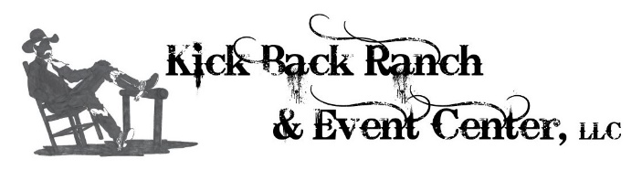
414 Union Academy Ada Rd. Ramer AL, 36069

Frontier Day and Marketplace 2019
Saturday March 30th, 8:00 A.M. – 5:00 P.M.

Contact: Darya Farsinejad, (334) 286-4140
Email: darya@thekickbackranch.com

Vendor Application

Name of Business: ________________________________________________________________________________
Name(s): ________________________________________________________________________________________
Address: ________________________________________________________________________________________
Phone number: _________________ Email address: _____________________________________________________
Product/Craft Description: __________________________________________________________________________
________________________________________________________________________________________________
Additional Info/Request: ____________________________________________________________________________
________________________________________________________________________________________________
Pet(s): ___ Yes ___ No Type: __________

Application deadline is March 1st. You will be contacted regarding your approval status within 3 business days after receipt of your application. DO NOT send payment with application.
**Please send three photos of your product/craft with your application.
**Email all applications to darya@thekickbackranch.com
Standard Booth - $85.00 (10x12 space), Optional Power Usage - $15.00
Premium Booth - $155.00 (Front porch and interior of a Cowboy Cabin. Cabins are 192 sqft plus porch. No removal or rearrangement of any furniture. Premium Booth rate allows you a one-night stay Friday 29th in your cabin.
Payment for all accepted applications must be made payable to Kick Back Ranch & Event Center with check, cash, money order or credit card. All credit cards are subject to a 3% processing fee. Montgomery County Business license is required. License to be displayed at your booth during event.
Your space is not reserved until payment is received.

414 Union Academy Ada Rd. Ramer AL, 36069

Frontier Day and Marketplace 2019
Saturday March 30th, 8:00 a.m. – 5:00 p.m.

Contact: Darya Farsinejad, (334) 286-4140
Email: darya@thekickbackranch.com

Rules and Regulations

Kick Back Ranch & Event Center is excited for our 1st Annual Frontier Day and Marketplace
We will be hosting a full day of beautiful crafts, along with showcasing unique trades.
Below you will find rules and regulations for the day.

- If bringing pets, you must notify us when you apply. You must also keep them on a leash at all times, comply with our facility pet policy, and pick up after your pet.

- Knock-offs of any kind are not allowed.
- Use of personal propane heat of any kind is not allowed.
- All tables must have table cloths. Additional Rental Options: Tables $8 each, Folding Chairs $2 each.
- Yard-sale booths are not allowed.
- We are looking for handmade/specialty goods, but that does not limit boutique clothing or vintage/antique items.

Kick Back will be marketing this event on TV, Radio, Print, & Social Media

