NAME: DOB:

BACKGROUND INFORMATION
What is sex? What is your sexual orientation? Describe in detail any difficulties in this area.

What is your ethnicity and religious background? Do you participate in any religious or spiritual activities?

How were you referred to the “Energy & Personal Excellence” program?

CURRENT LIFE CIRCUMSTANCES
What Do You Feel Are Causes of Your Current Difficulties/Deficiencies/Challenges?
Type your answer below:

What Do You Feel Are Causes of Your Current Difficulties/Deficiencies/Challenges?
Type your answer below:

What Are Your Current Difficulties/Deficiencies/Challenges? Type your answer below:

Describe your history of past problems in your life. These can be physical, mental, social, and/or spiritual problems.
Type your answer below:

How do you feel about your physical appearance?
Type your answer below:

What “poor decisions have you made in your life thus far?”
Type your answer below:

What “good decisions have you made in your life thus far?”
Type your answer below:

Describe your physical activity? Describe also any problems with overall motor activity.
Type your answer below:

Describe what is meant by “personal insight” when you look within yourself.
Type your answer below:

What Type of Clothing Do You Prefer?
Type your answer below:

Where In Your Life Do You Feel There Are Imbalances?
Type your answer below:

Describe your flow of emotions/feelings within the past 30 days?
Type your answer below:

Describe any difficulties with mental orientation: remembering where you are, who you are, and timing?
Type your answer below:

Describe your flow of emotions/feelings within the past 6 months to 2 years?
Type your answer below:

Describe any problems with your memory? If you have had any injuries that affect your memory, please describe them in detail.
Type your answer below:

Describe any problems with attention/concentration. Please describe them in detail.
Type your answer below:

Describe any thought disturbances that may have occurred in the past or are present now? Also describe any problems in the flow of thought.
Type your answer below:

How important do you think physical attractiveness is in day-to-day social interaction for most people?
Type your answer below:

Describe any hallucinations/delusions that may have occurred in the past or are present now?
Type your answer below:

Describe any safety issues that have occurred in the past or are present now? This includes suicidal thoughts and/or attempts in the past or occurring now.
Type your answer below:

Describe any speech problems that may have occurred in the past or are present now?
Type your answer below:

Were you ever in a psychiatric hospital? If so, please write the dates and reasons as to why you were in a psychiatric hospital.
Type your answer below:

Are you currently seeing a psychiatrist, psychotherapist, or other counselor? If so, please give the name, contact information. Please describe why you are seeing that person, describe if the
therapy is helping you.
Type your answer below:

Were you ever in a psychiatric hospital? If so, please write the dates and reasons as to why you were in a psychiatric hospital.
Type your answer below:

Please describe any CURRENT medical problems that you may have. These are problems in your physical health.
Type your answer below:

Please describe any family history of major physical and/or mental health problems.
Type your answer below:

Please describe any trauma that you may have experienced in your life? Please describe when the trauma it occurred, persons involved, circumstances, etc.
Type your answer below:

Please describe any PAST medical problems that you may have. These are problems in your physical health.
Type your answer below:

Please write all CURRENT medications you are taking. Please write names of doctors that have prescribed these medications.
Type your answer below:

GO TO NEXT PAGE ….

Please describe any CURRENT drug use, alcohol use, and/or gambling activity?
Type your answer below:

Please write all PAST medications you are taking. Please write names of doctors who have prescribed these medications.
Type your answer below:

GO TO NEXT PAGE ….

Please describe any PAST drug use, alcohol use, and/or gambling activity?
Type your answer below:

FAMILY RELATIONSHIP STRUCTURE/FUNCTION ASSESSMENT
Please answer questions below about your family:

NAME AND AGE OF BIOLOGICAL MOTHER:

NAME AND AGE OF BIOLOGICAL FATHER:

NAME AND AGE OF MOTHER (IF OTHER THAN BIOLOGICAL):

NAME AND AGE OF FATHER (IF OTHER THAN BIOLOGICAL):

NAME AND AGE OF MATERNAL GRANDFATHER:

NAME AND AGE OF PATERNAL GRANDFATHER:

NAME AND AGE OF MATERNAL GRANDMOTHER:

NAME AND AGE OF PATERNAL GRANDMOTHER:

GO TO NEXT PAGE ….

Please answer questions below about your family:

NAMES AND AGES OF OTHER SIGNIFICANT RELATIVES:

Please answer questions below about your family:

NAMES AND AGES OF SIBILINGS:

GO TO NEXT PAGE ….

Please answer questions below about your family:

NAME OF SIGINIFICANT OTHER OR SPOUSE:

PLEAESE DESCRIBE ANY IMBALANCES, PROBLEMS, OR DIFFICULITES THAT YOU ARE EXPERIENCES IN YOUR RELATIONSHIP WITH YOUR SIGINIFICANT OTHER OR SPOUSE:

PLEASE DESCRIBE WHAT IS GOING WELL IN THE RELATIONSHIP WITH YOUR SIGNIFICANT OTHER OR SPOUSE:

Please answer questions below about social supports and social relationships:

PLEASE LIST NAMES OF CLOSE FRIENDS:

PLEASE DESCRIBE ANY ISSUES/PROBLEMS IN THE RELATIONSHIP WITH YOUR FRIENDS:

PLEASE DESCRIBE POSITIVE ASPECTS OF YOUR RELATIONSHIP WITH YOUR FRIENDS:

DO YOU FEEL THAT YOU HAVE ADEQUATE SOCIAL SUPPORTS? PLEASE DESCRIBE IN DETAIL:

OVERALL, HOW WOULD YOU DESCRIBE THE QUALITY OF YOUR SOCIAL RELATIONSHIP?

DEVELOPMENTAL MILESTONES
Definition of Developmental Milestones:

Developmental milestones are behaviors or physical skills seen in infants and children as they grow and develop. Rolling over, crawling, walking, and talking are all considered milestones. The milestones are different for each age range. There is a normal range in which a child may reach each milestone.

AS A CHILD, DID YOU HAVE ANY PROBLEMS WITH DEVELOPMENTAL MILESTONES THAT STILL ARE CAUSES PROBLEMS CURRENTLY IN YOUR LIFE? PLEASE WRITE ABOUT ANY DELAYS IN PHYSICAL/MENTAL/OR SOCIAL DEVELOPMENT.

LEGAL PROBLEMS

PLEASE DESCRIBE IN DETAIL ANY LEGAL PROBLEMS THAT YOU MAY HAVE FACED IN THE PAST OR ARE CURRENTLY FACING?

EDUCATIONAL HISTORY & FURTHER DEVELOPMENT

PLEASE DESCRIBE YOUR EDUCATIONAL BACKGROUND: (PLEASE SEND AN UPDATED RESUME, IF APPLICABLE, TO sachinkarnik@yahoo.com). (PLEASE LIST NAMES OF HIGH SCHOOL AND ALL COLLEGES ATTENDED).

PLEASE DESCRIBE ANY EDUCATIONAL PROBLEMS YOU MAY HAVE HAD IN THE PAST OR ARE CURRENT HAVING?

PLEASE DESCRIBE POSITIVE ASPECTS OF YOUR EDUCATIONAL BACKGROUND AND/OR CURRENT EDUCATIONAL STATUS:

DO YOU HAVE FURTHER EDUCATIONAL GOALS? IF SO, PLEASE DESCRIBE THEM IN DETAIL:

EMPLOYMENT HISTORY & FURTHER DEVELOPMENT

PLEASE DESCRIBE YOUR EMPLOYMENT BACKGROUNT: (PLEASE SEND AN UPDATED RESUME, IF APPLICABLE, TO sachinkarnik@yahoo.com). (PLEASE LIST NAMES OF RECENT EMPLOYERS AND CURRENT EMPLOYER):

PLEASE DESCRIBE ANY EMPLOYMENT PROBLEMS THAT YOU MAY HAVE HAD IN THE PAST OR ARE CURRENT HAVING?

PLEASE DESCRIBE POSITIVE ASPECTS OF YOUR EMPLOYMENT HISTORY AND/OR CURRENT EMPLOYMENT:

DO YOU HAVE FURTHER OCCUPATIONAL GOALS? IF SO, PLEASE DESCRIBE THEM IN DETAIL:

GO TO NEXT PAGE ….

PERSONAL STRENGTHS
PLEASE BOLD (use ctrl-B) or CIRCLE EACH WORD BELOW THAT IS A STRENGTH FOR YOU:

Accuracy - Action oriented – Adventurous – Ambitious – Analytical – Appreciative - Artistic
Athletic – Authentic – Caring – Clever – Compassionate – Charm – Communicative - Confident
Considerate – Courage – Creativity - Critical thinking – Curiosity – Dedication - Determination
Discipline – Educated – Empathetic – Energetic – Entertaining - Enthusiastic - Fair – Fast - Flexible
Focused – Forceful – Friendliness – Generosity – Gratitude – Helpfulness – Honesty – Hope - Humility
Humor – Idealism – Independence – Ingenuity – Industriousness - Inner peace - Inspirational
Integrity – Intelligence – Kindness – Knowledgeable – Leadership – Lively – Logical - Love
Love of learning – Mercy – Modesty – Motivation – Observant – Optimistic - Open minded
Orderly – Originality – Organization – Outgoing – Patient – Perseverance - Persuasiveness
Persistence – Practical – Precise - Problem solving - Prudence - Respect - Responsibility
Self-assurance – Seriousness - Self-control - Spirituality – Spontaneous - Social intelligence
Social skills – Straightforward - Strategic thinking - Tactful - Team oriented - Thoughtful
Thrifty – Tolerant – Trustworthy – Versatile – Visionary – Vitality - Warmth - Willpower
Wisdom

PLEASE BOLD (use ctrl-B) or CIRCLE EACH STATEMENT BELOW THAT APPLIES TO YOU:

Communication Strengths
Clear and concise in verbalizing ideas
Allow effective communication
Able to summarize and clarify
Actively listen to ideas
Give constructive criticism
Take time to make a personal connection

Strengths for Providing Direction
Make objectives and outcomes specific
Clearly communicate objectives and outcomes
Able to fully explain tasks and delegate them
Create and provide clear standards and expectations
Develop checks and controls
Oversee staff to keep them on task

Strengths for Decision Making & Judgment
Clearly define and communicate issues
Gather important information
Make decisions on the best action to take
Implements the course of action
Communicate and explain decisions
Follow up on progress of action
Learn from previous mistakes
PERSONAL DEFICITS
PLEASE BOLD (use ctrl-B) or CIRCLE EACH WORD BELOW THAT IS A DEFICIT FOR YOU:

Not taking criticism well – Impatient – Lazy - Easily bored – Procrastinate – Persistent - Takes things personally - Strong willed – Passive - Does not like conflict – Shy – Lethargic - Long-term planning – Strict - Short-sighted – Selfish - Focusing on small details - Takes blame for others - Being straight forward – Greedy - Delegating tasks - Needs to be right – Stubborn – Multitasking - Allows emotions to show – Blunt – Presenting – Impulsive – Bossy - Takes on to much -– Aggressive - Likes to take risks - Critical of others – Passive - Works to much – Perfectionist Fearful - Self critic - Trouble with teams - Close-minded – Unorganized - Does not like pressure

PLEASE READ BELOW THE FOUR PERSONALITY TYPES:
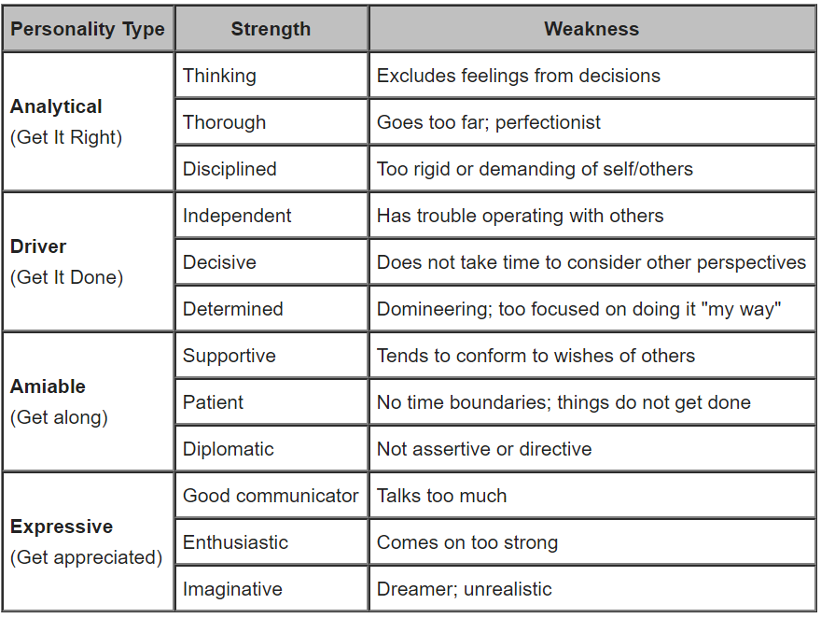
PLEASE TYPE BELOW YOUR PERSONALITY TYPE(S), STRENGTHS, AND WEAKNESSES BASED ON THE INFORMATION SHOWN ABOVE:

PLEASE DESCRIBE IN DETAIL ANY DIFFICULTIES YOU HAVE FACED IN THE PAST OR ARE CURRENTLY FACING ON YOUR RELIGIOUS PATH / SPIRITUAL PATH? DESCRIBE ANY OBSTACLES OR CONCERNS THAT YOU HAVE ABOUT RELIGION/SPIRITUALITY.

PLEASE DESCRIBE IN DETAIL YOU RELGIOUS BACKGROUND. PLEASE DESCRIBE YOUR CURRENT RELIGIOUS PRACTICES. (INCLUDE SPIRITUAL PRACTICES ALSO.)

IN VIEWING YOUR LIFE, WHAT LIMITATIONS DO YOU HAVE?

WHAT ARE YOUR THOUGHTS ABOUT MEDITATION? HAVE YOU DONE ANY MEDITATION BEFORE? IF SO, PLEASE DESCRIBE THE TYPE OF MEDITATION YOU HAVE DONE.

12 AREA SELF-ASSESSMENT
HEALTH AND FITNESS– What do you want to weigh? How do you want to feel with regards to your weight? What do you need to do to improve your health and fitness? Please also write specific recommendations from doctors, etc., about your health in general.

EMOTIONAL LIFE – Where would you like your emotional energy and happiness levels to be? How would you like to feel throughout your day (including the afternoon time when a lot of us normally feel a “slump”)? Describe your flow of emotions on a day-to-day basis.

INTELLECTUAL LIFE – Please describe your intellectual interests. Describe your intellectual development up to this point in your life. Please write about further development that you want to see in your life.

GO TO NEXT PAGE ….

PERSONAL CHARACTER – How would you describe your personal character? With values do you hold in your life that are extremely dear to you? How would you describe your ethical and moral standards? What do you want to stand for? What values do you possess and practice? What level of integrity would you like to operate at? (Please write freely…)

SPIRITUAL LIFE – What personal spiritual practices would you like to maintain or begin? How often do you want to pray or meditate? How often do you want to visit church, a meeting, a service, a temple, etc.?

GO TO NEXT PAGE ….

LOVE RELATIONSHIPS– Who do you want to be with? What kind of partner do you want to be? What type of life do you want to live with your partner? Describe your current love relationship(s).

IS THERE A DIFFERENCE BETWEEN LOVE AND PLEASURE? WHAT IS THE RELATIONSHIP BETWEEN THE TWO. PLEASE TYPE YOUR ANSWER.

PLEASE DESCRIBE YOUR CURRENT SEXUAL FUNCTIONING. (IF YOU WANT TO SKIP THIS, IT IS YOUR CHOICE, YET IT IS RECOMMENDED TO ANSWER THIS QUESTION.)

PARENTING VISION – If you have children, how do you want to parent your children? What values do you want to instill in them? How much time do you want to spend with your children each day/week? What deficiencies do you see in your relationship with your children? What strong parenting skills do you feel you have?

FINANCIAL LIFE – Please describe your financial situation. What is going well and what is not going well. What difficulties have you had in the past and what is your current situation? What goals do you have in your financial life?

WHAT IS THE DIFFERENCE BETWEEN THE FOLLOWING: PROPER USE OF MONEY, MISUSE OF MONEY, AND ABUSE OF MONEY?

WHAT IS THE DIFFERENCE BETWEEN YOU RUNNING AFTER MONEY VS MONEY FOLLOWING YOU?
SOCIAL LIFE – What types of friendships would you like to establish? What kind of friend would you like to be? What types of activities would you like to experience or enjoy in your social life? Describe your current social life. Describe any problems, difficulties, etc. Describe things going well in your social life.

GO TO NEXT PAGE….
QUALITY OF LIFE - Where would you like to live? What would you like your home or car to look like? Where would you like to travel? How does your daily life look? Please elaborate as you see fit….

RECREATIONAL LIFE – Please describe your ideal recreational life. What type of recreation activities do you do at this time?

OTHER AREAS: Please describe any other are in your life where you want to see further progress:

CAREER – Please describe your career status at this time. Please describe any problems in the past with career. Please also describe your short-term and long-term career goals.
LIFE VISION – What is your long-term vision for your life. Please describe openly as you see fit…

EXTRA PAGE TO WRITE OTHER INFORMATION

