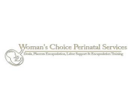Client Placenta Data Form

Client Name:

Date of Delivery:

Multiple pregnancy?

Method of preparation? (Raw or Heated)

Number of Capsules yielded:

Was a tincture made?

Was a keepsake made?

Was a print made?

Area below to be filled out by the client:

Dear client,

Congratulations on your delivery! As you know, your encapsulation was processed by a student of Woman’s Choice Perinatal Service’s training program. We would like if you could take a moment to tell us in one or two sentences about your experience. (This is not mandatory)

We hope you received excellent service.