Whispering Palms HOA
Newsletter March 2024



From the President…………………………
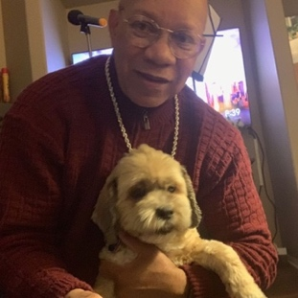

Happy Saint Patrick’s Day! (March 17, 2024)
We Celebrate Woman’s History Month
The next Board meeting will be held on Saturday March 23, 2024.
Annual Election Saturday March 23, 2024. In March we will be holding our elections for new Board members. There are two openings and two members running for the open positions. Jerri-Beth Scott and I have volunteered to run to continue to be on the Board of Directors. We are giving away prizes with a raffle drawing for those who return their ballots quickly. Remember we must fill these positions to keep our dues reasonable. Without a Board we are subject to being managed by the court and doubling of our HOA fees. Complete and return Ballots no Later than March 16, 2024 to be eligible for the FREE PRIZES (Cash, Vouchers, Mystery Gifts). As of February 28, 2024 we have received 42 Ballots. We need a minimum of 65 to elect the Board in March else it will be delayed until April.
Our next social event.
Appreciation Dinner –March 16, 2024 (Sue Fishman and Sharon Peppy)

The CCR’s and By-Laws drafts have been returned by the attorney. They will be reviewed by the new Board of Directors, distributed for community review, hold a town hall with the attorney, then distribute for vote requiring 2/3 or 90 votes to approve. The CCR’s have not been updated in over 10 years.
Becoming a volunteer and participating is part of what makes this community what it is and you might have some fun along the way. Come to a meeting and volunteer to help us build a safe and strong community.
Please turn off your sprinklers for 3-5 days or more after it rains to help us save money. Our clubhouse sprinklers have been off for weeks to conserve money and resources. Thank you to everyone who is conserving water.

Contact Mike Galante if you need to have the water shutoff for emergency repairs.

All of our streets within the community will receive an update along with some new parking places sometime during this year. The Board is in final negotiations.
We will be creating a Standing Operating Procedures (SOP) for Community Events so that our future volunteers and committee chairpersons will have more specific guidance to make our events successful. Our Clubhouse is beautiful, clean and organized. In the meantime, there is no decorating committee. Please do not remove from the clubhouse tables, chairs, kitchen ware, etc. from the clubhouse without asking me or Lynn White first. Also, the Library is clear of clutter. Do not move furniture or other items in that room without Board permission. You can move things like chairs as necessary but put them back the way you found them. Ask Jerri-Beth Scott before placing items or books in that room. Schedule during the next 30 days is the maintenance and paint to Cayman Drive Gate, lock repair for Bermuda pedestrian gate, and the replacement of damaged street light on Bahama Dr. DG area and all gutters have been sprayed for weeds and the Clubhouse Palm Trees were trimmed in February.

Thank you,

Jordan B Smith Jr. (PS. The Golden Rule still works!)

On April 28, 2023 the Board of Directors approved the following Abusive Conduct provisions PERSONAL CONDUCT WITHIN THE COMMUNITY:

- All owners and residents of the Community are expected to behave in a respectful and courteous manner towards each other, including board members, staff, and contractors.
- No owner or resident may direct any abusive language, threats, physical intimidation, vulgar hand gestures, or any other form of harassment or aggressive conduct (“Abusive Conduct”) toward any other person within the Community. (
- No owner or resident may take any action in retaliation against another owner or resident for reporting alleged violations of the governing documents to the Association (“Retaliation”).

New Rules Forthcoming: Curb Parking

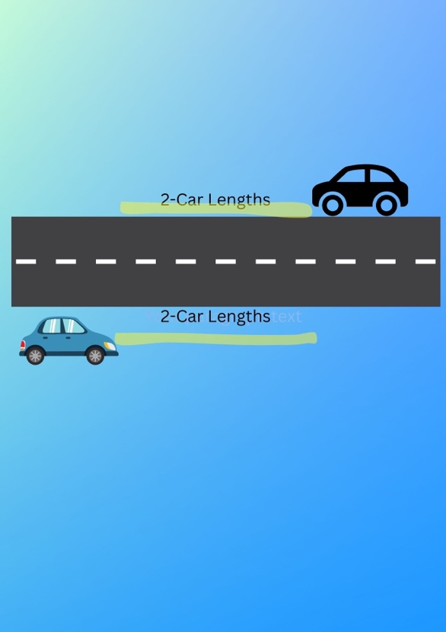
DO NOT DOUBLE PARK – AVOID PARKING ON THE CURB for CORNER HOUSES

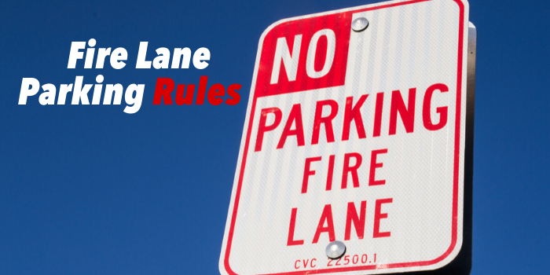

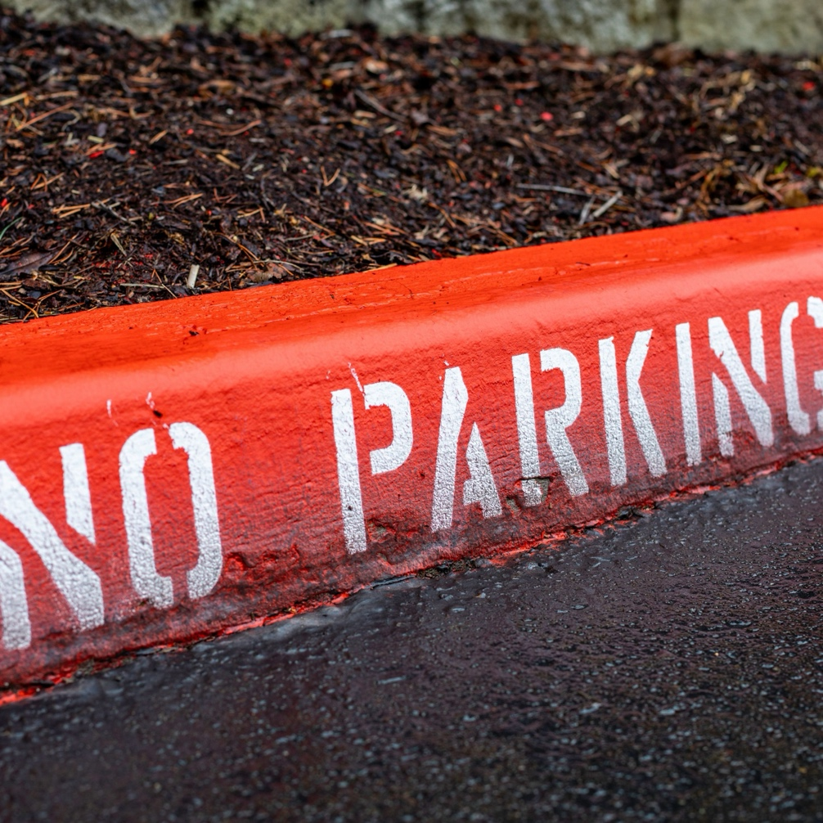
We must keep our streets clear so that emergency vehicles can access our homes. When access to a fire lane is impeded, emergency officials may be unable to reach their destination, thereby significantly delaying their response time. The fire department may issue fines directly to the HOA if cars within the neighborhood are found to be blocking the fire lines (our community streets). The Board will be revising the parking rules and posting no parking signs in the near future. Please do not park your car within 2 car lengths of a car parked on the other side of the street. Guest Parking is in designated locations at the clubhouse. Do not double park and DO NOT PARK ON THE CURB IN FRONT OF CORNER HOUSES. Have guests use the parking spots at the clubhouse.

Red Curbs are Coming Soon!

ARC

The paint survey that went out to all homeowners was a success. We have added some beautiful new colors for painting of the pop outs and the trim on the stick built homes. Also, the manufactured homes will have the option of using the same colors as the stick built homes. All color charts are on the WPHOA website.
https://whisperingpalmshoa.org/arc-2024-proposal
If you plan on painting your home please fill out the ARC request for approval. If you have any questions contact Vickie Galante 760-613-3325.
Please check your home and see if it needs painting. Keeping your home’s appearance up not only makes your home beautiful but makes our community beautiful!
Please check your yards for maintenance and appearance. What a beautiful community we live in and we can all work together to keep our property values up.
Some homes are in need of cleaning the spider webs off.
Reminder: the ARC committee meets each month directly after the board meeting so if you have any ARC requests please get them to us at or prior to the board meeting.
Let’s keep our community beautiful. Thanks for all your support!
Reminder that ALL concrete, block or brick work in your front yards (especially for parking purposes) must be approved by the ARC prior to beginning work.
The ARC members will be available on the same day as the Board meetings to make it easy to submit and get your requests approved quickly.
Please check the condition of the exterior of your homes. If painting is needed, have your request to Vickie Galante prior to painting. The current colors for site-built homes are on display in the foyer of the clubhouse as are the approved colors for the modular homes. Stop by and take a look.
Any community member who has a paint request or landscaping change request should have the paperwork to Vickie Galante or in the clubhouse office prior to beginning work. The request forms can be found at the clubhouse, from Vickie Galante, or printed directly from the community
website, www.whisperingpalmshoa.org.

Message from Welcome Committee
Phone Books
Speaking of our community phone book. Please review your contact information in the community phone directory. If there are any changes (corrections or additions), submit the information to Jerri-Beth Scott at 909-605-3256 by April 1 for the 2024 book. The new directories will be distributed in May. Questions about codes should be referred to Jordan at 951-306-5165.
Changes to phone book resident information:
Thomas Garcia 951-514-0663
Martha Garcia 909-615-1104

Welcome to our New Residents:
New residents as of January 2024
Jerry Fullerton 714-393-6220
740 Bahama Dr
Please add to your phone directories.

Library News

Our clubhouse library is organized and open. We have a wide range of books that can appeal to a variety of reading tastes as well as jigsaw puzzles and magazines. Come by and check it out. If you want to donate books to the library please call Jerri-Beth at 909-605-3256 before dropping them off at the clubhouse. Also, there will be a box on a chair for book returns. Enjoy reading and puzzling!

Please Turn Off
Clubhouse Lights and Air Conditioning when you leave the Club house.
Waste Not - Turn off the lights and A/C
Please, Lock the Outside Bathroom Doors to Our Clubhouse

 | 3/6 Hilda Quintana  3/10 Jim Reilly  3/11 Gigi Sloan  3/12 David Scott  3/15 Kathy Idomoto  3/16 Ann Miller  3/16 Mike Galante  3/18 Valerie Hiett  3/21 Lizbeth Sheres  3/22 Jay Sloan  3/23 Bill Bastian  3/28 Ron Apodaca  3/29 Mary Sargent  3/30 Jordan Smith  3/31 Paul Foulger



OFFICERS OF THE WPHOA BOARD 2023/2024
Revised June 24, 2023
President — Jordan B Smith Jr. | Phone 951-306-5165
Supervision of Rule Enforcement | Landscape & Streets
Liaison with Ralston Management | Rules and Regulations
Supervision of All Committees | CC&R's
Utilities | Newsletter
Vendor Contracts | Website/Technology
 | Update Gate Directory
Vice President — Mike Galante | Phone 760-605-5313
Safety & Emergency Communication | Estate Sale Requests
Oversize Lot & Maintenance | Swimming Pool
Supervision of Marty's Place | Energy Conservation
Treasurer — Gregg Reynante | Phone 818-332-6629
Financial Records ARC Committee Oversight  Financial Audit Supervision | Community Liaison  Welcome Committee  Sunshine Committee
Secretary — Lynn White | Phone 206-300-0277
Association Records | Clubhouse Reservations
Board Meeting Agenda/Minutes  Supervision of Social Committee | Clubhouse Supplies
Member-at-Large — Jay Sloan | Phone 209-321-0609
HOA Gates | Maintenance Supervision
Clubhouse Parking and Permits  Street Lights & Signs | Street Parking Issues

Whispering Palms HOA Committees 2023/2024

Sunshine Member
Sue Fishman 626-394-1876
Sunshine Committee
I Need your Help

Sunshine sends cards of encouragement and sympathy to our Whispering Palms Community. It only works if I get news that someone could use a card. If you know of someone, please let me know.

Thanks for your help. Sue Fishman 951-765-9003 or 626-394-1876.

Welcome / Phone Book Additions & Corrections

Jerri-Beth Scott 909-605-3256
Kathy Idomoto

Communication Committee - Phone Tree .
Sue Wilhoff 909-228-0257
Carolyn Powers Smith. 951-357-2106

Clubhouse Trash Cans
Jim Reilly 951-929-0459

Emergency Gilbert Street Gate

Richard Juliano 951-260-7824

Bulletin Board/Veterans Wall of Honor

Sharon Peppy 310-869-4323

Architectural Review Committee (ARC)
Vickie Galante------------------760-613-3325
Ann Miller
Charlie Shindledecker
Penny Dixon
Sue Wilhoff
Ido Idomoto
Susan Foulger

Maintenance & Gate Keepers Committee Members

Jay Sloan 909-772-7886
Vern Tennis. 951-295-4942
James Maxwell 909-772-7886
Allan Bernal. 951-719-6778

Power Outage Procedures

- When the power goes out the front entrance gate will automatically open within 30 seconds.
- When the power goes out Call Jay Sloan only if the Gates are not open.
- Bermuda/Gilbert Gate will be opened first by Richard Juliano, who lives next to that gate within 15 minutes of no power.
- The Bahama /Gilbert Street gate will be opened manually by Jay Sloan, a member of the WPHOA Board or by one of the Gate Keepers.
- The Palm Street Exit gate will be opened manually if needed by Jay Sloan who is in charge of the gates or by a member of the WPHOA Board.
- The Gates will be closed after power has been restored for 1 hour.

People with keys to Bermuda/Gilbert Gate
- Richard Juliano 951-260-7824
- Allan Bernal 951-719-6778
- Jay Sloan 209-321-0609

