Whispering Palms HOA
Newsletter

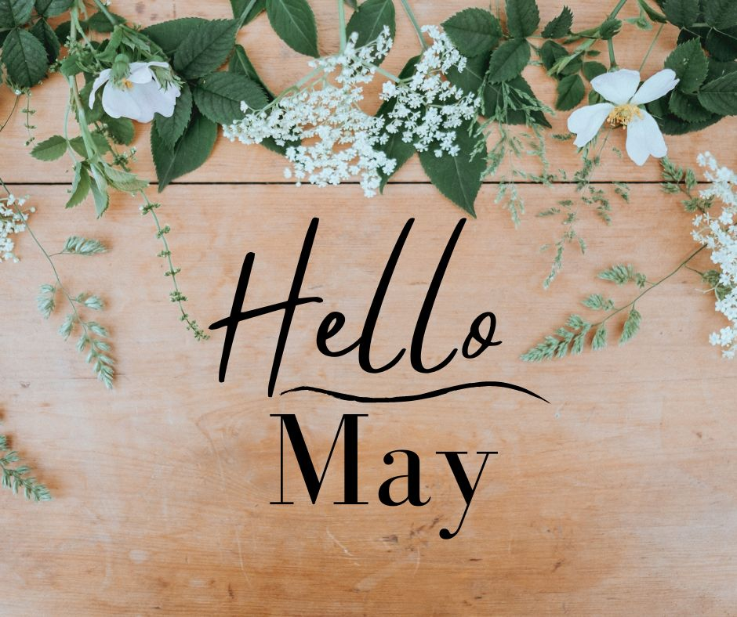

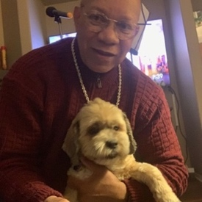
From the President…………………………

Happy May, Happy Mother’s Day, Happy Cinco De Mayo, Memorial Day
Soon schools will be out and I will be retired. Can’t wait!!!!
The next Board meeting will be held on Saturday May 25, 2024.
Our next social event.
Memorial Day BBQ –Monday May 27, 2024 (Sue Fishman and Carolyn Powers)

The CCR’s and By-Laws drafts have been returned by the attorney. They are under review by the new Board of Directors, next they will be distributed for community review. We will hold a town hall with the attorney if necessary. In June we intend to distribute for vote requiring 2/3 or 87 votes to approve. We must approve the new CCR’s to remain an HOA and keep our non-profit and 55+ community status. We are currently out of compliance.
Becoming a volunteer and participating is part of what makes this community what it is and you might have some fun along the way. Come to a meeting and volunteer to help us build a safe and strong community.
Please turn off your sprinklers for 3-5 days or more after it rains to help us save money. Our clubhouse sprinklers have just been turned back on after being off since January to conserve money and resources. Letters are going out for violations. Thank you to everyone who is conserving water.

Contact Mike Galante if you need to have the water shutoff for emergency repairs.

All of our streets within the community will receive an update along with new speed bumps on our streets and new signs. The Board has approved the contract to give our roads a new facelift which includes speed bumps on every street. Work will be done in June or July 2024. A work and street closure schedule plan will be distributed before work begins to allow homeowners to prepare for any deliveries. I would cut down or delay Amazon deliveries during the month of June.
We are working on a Standing Operating Procedures (SOP) for Community Events so that our future volunteers and committee chairpersons will have more specific guidance to make our events successful. Our Clubhouse is beautiful, clean and organized. In the meantime, there is no decorating committee. Please do not remove from the clubhouse tables, chairs, kitchen ware, etc. from the clubhouse without asking me first. Also, the Library is clear of clutter. Do not move furniture or other items in that room without Board permission. You can move things like chairs as necessary but put them back the way you found them. Ask Jerri-Beth Scott before placing items or books in that room.

Thank you,

Jordan B Smith Jr. (PS. The Golden Rule still works!)

On April 28, 2023 the Board of Directors approved the following Abusive Conduct provisions PERSONAL CONDUCT WITHIN THE COMMUNITY:

- All owners and residents of the Community are expected to behave in a respectful and courteous manner towards each other, including board members, staff, and contractors.
- No owner or resident may direct any abusive language, threats, physical intimidation, vulgar hand gestures, or any other form of harassment or aggressive conduct (“Abusive Conduct”) toward any other person within the Community.
- No owner or resident may take any action in retaliation against another owner or resident for reporting alleged violations of the governing documents to the Association (“Retaliation”).

New Rules Forthcoming: Curb Parking

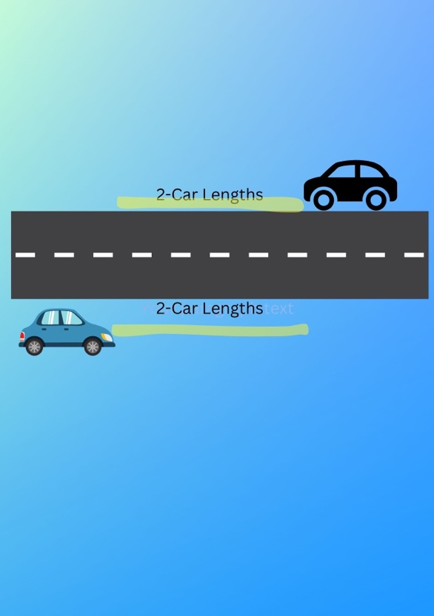
DO NOT DOUBLE PARK – AVOID PARKING ON THE CURB for CORNER HOUSES
New Rules & Regulations forthcoming will add fines
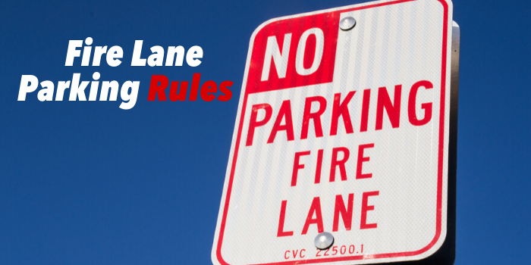

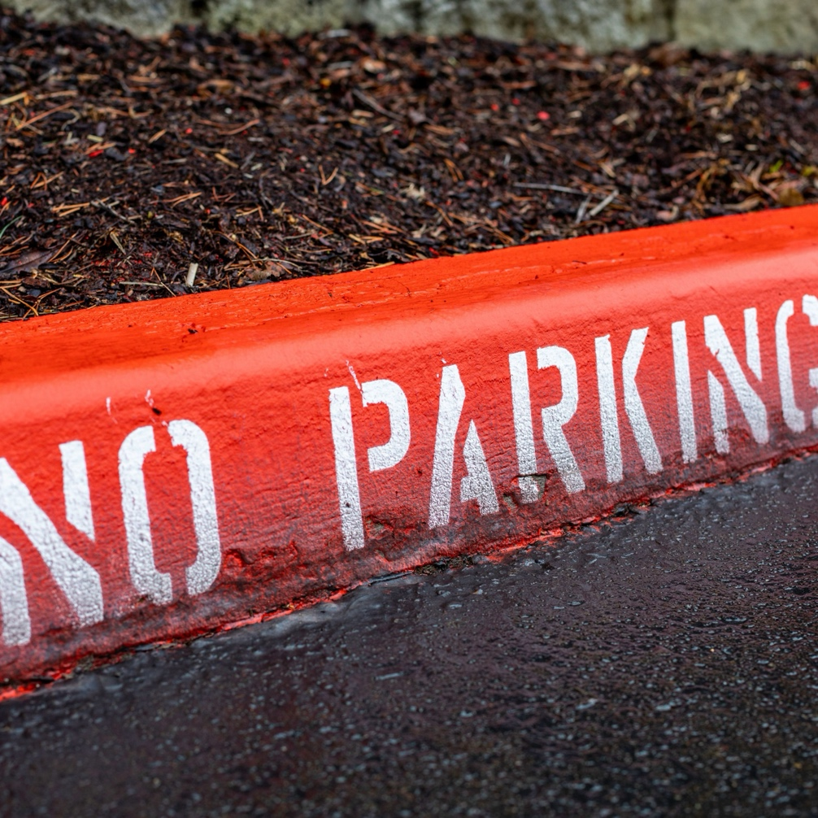
We must keep our streets clear so that emergency vehicles can access our homes. When access to a fire lane is impeded, emergency officials may be unable to reach their destination, thereby significantly delaying their response time. The fire department may issue fines directly to the HOA if cars within the neighborhood are found to be blocking the fire lines (our community streets). The Board will be revising the parking rules and posting no parking signs in the near future. Please do not park your car within 2 car lengths of a car parked on the other side of the street. Guest Parking is in designated locations at the clubhouse. Do not double park and DO NOT PARK ON THE CURB IN FRONT OF CORNER HOUSES. Have guests use the parking spots at the clubhouse.

Red Curbs are Coming Soon!

ARC

It’s time to enjoy the outdoors more and the beauty that surrounds us.

Once again, thank you to all who are diligent in keeping your homes and yards well kept.

Please continue to be observant of areas in your yards and side yards that may need attention.

Last month we noted that several homes are in need of painting. Thank you to those who have recently done so and thank you to those of you who have previously received letters and are making arrangements to do so. Fresh paint not only keeps the community attractive but also protects your investment.

The ARC committee is here to work as your friend to help keep our neighborhood a desirable place to live. It takes everyone doing their part to keep it that way.

If you have any questions on paint colors, changes to your front yards, etc. please contact Vickie Galante.

Thank you.
The ARC members will be available on the same day as the Board meetings to make it easy to submit and get your requests approved quickly.
The ARC request forms can be found at the clubhouse, from Vickie Galante, or printed directly from the community website, www.whisperingpalmshoa.org.

Message from Welcome Committee
WPHOA Community-wide Garage Sale is being planned for October. Begin putting all of your treasures--clothing, books, appliances, etc.- aside for this event. More information will be forthcoming in the June and later newsletters.

Phone Books
Speaking of our community phone book. The new directories were distributed April 27, 2024. Questions about codes should be referred to Jordan at 951-306-5165.
New Residents in April 2024:
Greg Perry and 949-395-5937
Rochelle Davis. 805-405-4339o
718 Bermuda Dr
Please add their names, address, and phone numbers to the 2024 Telephone Book you received on April 27th

Library News

Our clubhouse library is organized and open. We have a wide range of books that can appeal to a variety of reading tastes as well as jigsaw puzzles and magazines. Come by and check it out. If you want to donate books to the library please call Jerri-Beth at 909-605-3256 before dropping them off at the clubhouse. Also, there will be a box on a chair for book returns. Enjoy reading and puzzling!

Please Turn Off
Clubhouse Lights and Air Conditioning when you leave the Club house.
Waste Not - Turn off the lights and A/C
Please, Lock the Outside Bathroom Doors to Our Clubhouse
Please do not put tissue in the door jams. Use your key!

May 2024 Birthdays
 | 5/4 Jesse Gidley  5/6 Irene Rue  5/12 Crystal Dixon  5/15 Cody Maxwell  5/17 Isaac Brown  5/18 Meity Hartawan  5/17 John Mitchell  5/19 Cheryl Piazza  5/22 James McIntosh  5/23 James Maxwell  5/27 Steven Cope  5/29 Richard Juliano  5/31 Sheri Purvis



OFFICERS OF THE WPHOA BOARD 2023/2024
Revised March 23, 2024
President — Jordan B Smith Jr. | Phone 951-306-5165
Supervision of Rule Enforcement | Landscape & Streets
Liaison with Ralston Management | Rules and Regulations
Supervision of All Committees | CC&R's/By-Laws
Utilities | Newsletter
Vendor Contracts | Website/Technology
Clubhouse Reservations/Supplies | Update Gate Directory
Clubhouse/Social Committee
Vice President – Mike Galante | Phone 760-605-5313
Safety & Emergency Communication | Estate Sale Requests
Oversize Lot & Street Maintenance | Swimming Pool
Supervision of Marty's Place | Energy Conservation
Treasurer — Gregg Reynante | Phone 818-332-6629
Financial Records | Community Liaison
ARC Committee Oversight | Financial Audit Supervision
Secretary — Jerri-Beth Scott | Phone 909-605-3256
Association Records | Welcome Committee
Board Meeting Agenda/Minutes | Sunshine Committee
Member-at-Large — Jay Sloan | Phone 209-321-0609
HOA Gates | Maintenance Supervision
Clubhouse Parking and Permits | Street Parking Issues
Street Lights & Signs

Whispering Palms HOA Committees 2023/2024

Sunshine Member
Sue Fishman 626-394-1876
Sunshine Committee
I Need your Help

Sunshine sends cards of encouragement and sympathy to our Whispering Palms Community. It only works if I get news that someone could use a card. If you know of someone, please let me know.

Thanks for your help. Sue Fishman 951-765-9003 or 626-394-1876.

Clubhouse/Event Committee
Sue Fishman (Reservations)
Sue Wilhoff
Carolyn Powers
Laura Trapper
Anne Bridges

Welcome / Phone Book Additions & Corrections
Jerri-Beth Scott 909-605-3256
Kathy Idomoto

Communication Committee - Phone Tree .
Sue Wilhoff 909-228-0257
Carolyn Powers Smith. 951-357-2106

Clubhouse Trash Cans
Jim Reilly 951-929-0459

Emergency Gilbert Street Gate
Richard Juliano 951-260-7824

Bulletin Board/Veterans Wall of Honor
Sharon Peppy 310-869-4323

Architectural Review Committee (ARC)
Vickie Galante------------------760-613-3325
Ann Miller
Charlie Shindledecker
Penny Dixon
Sue Wilhoff
Ido Idomoto
Susan Foulger
Gigi Sloan

Maintenance & Gate Keepers Committee Members
Jay Sloan 909-772-7886
Vern Tennis. 951-295-4942
James Maxwell 909-772-7886
Allan Bernal. 951-719-6778

Power Outage Procedures

- When the power goes out the front entrance gate will automatically open within 30 seconds.
- When the power goes out Call Jay Sloan only if the Gates are not open.
- Bermuda/Gilbert Gate will be opened first by Richard Juliano, who lives next to that gate within 15 minutes of no power.
- The Bahama /Gilbert Street gate will be opened manually by Jay Sloan, a member of the WPHOA Board or by one of the Gate Keepers.
- The Palm Street Exit gate will be opened manually if needed by Jay Sloan who is in charge of the gates or by a member of the WPHOA Board.
- The Gates will be closed after power has been restored for 1 hour.

People with keys to Bermuda/Gilbert Gate
- Richard Juliano 951-260-7824
- Allan Bernal 951-719-6778
- Jay Sloan 209-321-0609

