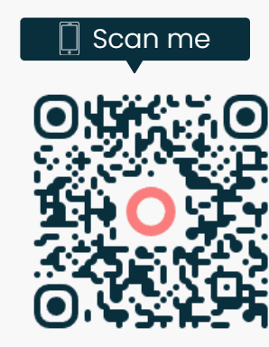

SAMPLE QR (Quick Response) CODE
The above QR code is a sample and will not work. When making a luncheon reservation or paying for Membership Dues. First scan the QR (Quick Response) code included in the actual luncheon flyer or from the Membership Form.

How do I pay via Omella?

Step #1 - Open the camera on your cell phone (or other device with a camera) just as if you were going to take a picture and point it towards the QR (Quick Response) Code.
Step #2 – You do not take a picture. Rather tap on “Omella.com” which is highlighted in yellow at the bottom of the QR Code. This will open the HELO Club luncheon reservation form or the Membership Form. It is incredibly easy to do.
Step #3 - Answer the questions regarding the luncheon or Membership.
Step #4 – At the beginning of the payment page, you will see a banner titled “Link by Stripe”. – see the example below. If you want your payment information to be saved for future use, simply click on the green stripe and then follow the prompts.
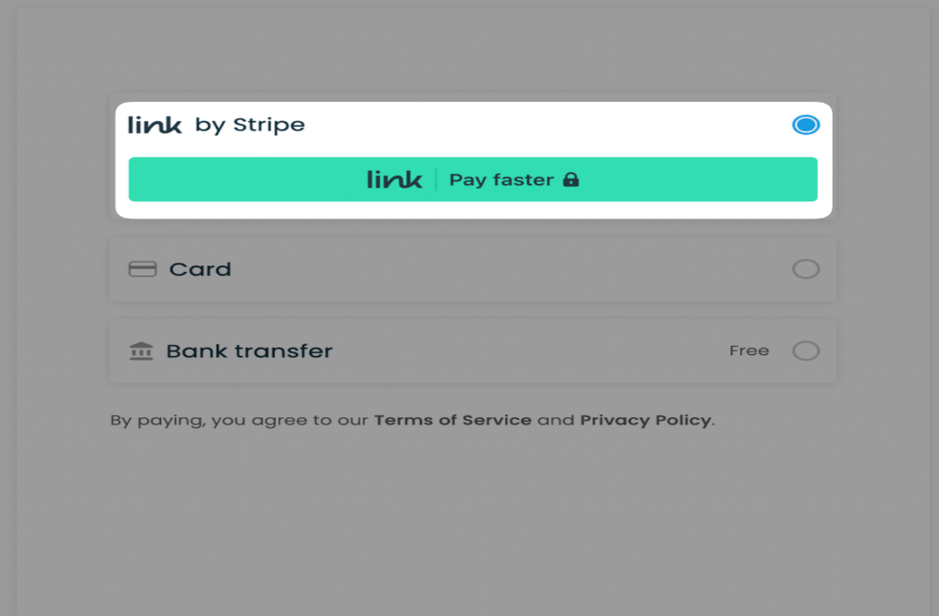
If you do not wish to have your information saved, do not select the rink.
Step #5 - Select either “Credit Card” or “Bank” to pay.
If you choose to have the funds deducted directly from your bank account there is no fee. However, you will need your bank account username and password.
If you pay by credit or debit card an additional minimal fee will be added to the luncheon or membership dues cost of 3.5%
A tip of 10% to Omella is automatically added to your reservation. If you do not wish to pay this tip you will need to change the amount to zero by clicking on the tab shown before hitting submit to save the information.
You will receive an email confirming your payment. Be sure to keep this email until the payment processes in case there are any questions. If you do not receive the email check your spam folder.

