Activities to Build Partnerships

- Volunteer in your child’s classroom or on campus in other capacities, such as at kindergarten supervision, Kiss N Go, Free Play, or in other areas as needed
- Come to Back to School Night and Open House
- Get involved with our School Site Council and English Learner Advisory Committee to collaborate with school administration and staff on behalf of our students
- Join us for school events such as our Winter Performances
- Attend parent workshops
- Chaperone on field trips
- Join and get involved in the PTA
If you would like to volunteer, participate in, and/or observe a classroom, please make arrangements with your child’s teacher ahead of time. All visitors to campus must obtain a visitor’s pass from the office. Long term volunteers must submit a volunteer application and current TB test results. See our Community Representative, Sharon Keimon, for details.
What is a School-Parent Compact?

A School-Parent Compact for Achievement is an agreement that parents, students and teachers develop together. It explains how parents and teachers will work together to make sure all our students reach or exceed grade-level standards.
Effective compacts:
- Link to goals of the school improvement plan
- Focus on student learning skills
- Describe how teachers will help students develop those skills using high-quality curriculum and effective instruction in a supportive learning environment
- Share strategies parents can use at home
- Explain how teachers and parents will communicate about student progress
- Describe opportunities for parents to volunteer, observe, and participate in the classroom

Kester Avenue/ Kester Magnet Elementary

School-Parent Compact for Achievement
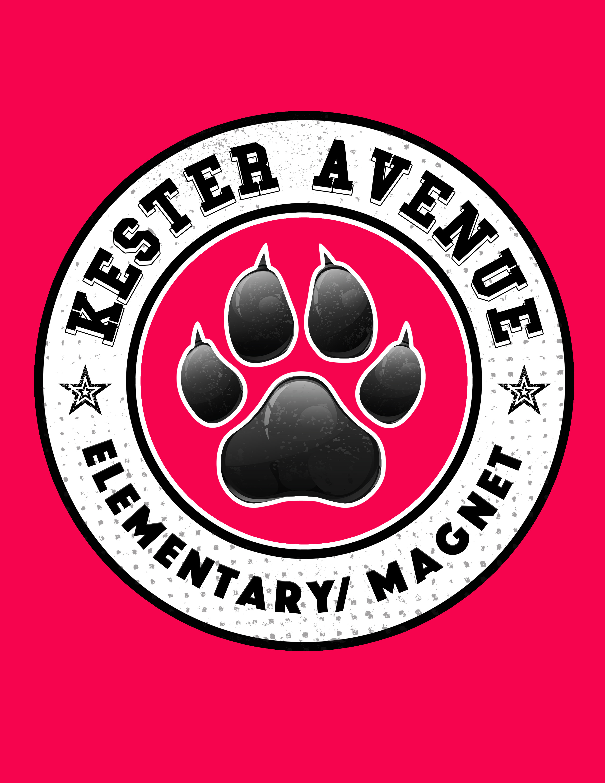
School-Parent Compact 2019-2020
Communication about Student
Learning
Our school is committed to regular two-way communication with families about their children’s learning. Some of the ways parents and teachers communicate all year are:
- Activities to build partnerships (above)
- Backpack Thursday
- Weekly Connect-Ed messages (robocall and email)
- Monthly calendar
- Coffee with the Principal meetings
- Parent-teacher conferences (twice annually and upon request)
- Parent Portal/ Schoology
- Regular progress reports
- Updated website & marquee
Jointly Developed

Kester Avenue/Kester Magnet’s School-Parent Compact has been developed and created jointly by parents and teachers who represent the stakeholders in our school community on our English Language Advisory, Instructional Leadership Team and School Site Council.
Safe • Respectful • Responsible
Mission: To empower children to achieve their personal best in school.
Vision: To provide a collaborative, nurturing environment that gives students a solid academic foundation for advanced studies in middle school and beyond.
5353 Kester Avenue
Sherman Oaks, CA 91411
818-787-6751
www.kesterelementary.org

School-Parent Compact 2019-2020
Students
I know that I must try my best to get the most out of my education. I will:
- Come to school on time every day, unless I am sick.
- Do my homework and study every day.
- Turn my work in on time.
- Read at least 20 minutes every day outside of school time.
- Give my parents or guardian all flyers and information sent home from my school.
- Follow directions and all school rules.
- Meet Kester’s behavior expectations to be safe, respectful, and responsible.
- Treat my teacher, school staff, volunteers, and peers with respect.

District Goal
100% graduation from high school, promoted through:
- Proficiency for all
- 100% attendance
- Parent, community, and student engagement
- School safety
- Building a solid foundation for early learners
School Goals
- Encourage our students to develop a lifelong love of learning
- Teach responsible citizenship
- Develop effective communication and problem-solving skills in our students

Our school provides high quality curriculum and instruction in supportive and effective classroom environments to enable students to meet state academic standards. We support our students and work hard to provide a welcoming, safe school environment.
In the Classroom - Teachers
Classroom instruction is the foundation of a positive school experience. Therefore, we will support our students by:

- Providing high-quality instruction aligned to Common Core standards.
- Ensuring all necessary concepts are taught before assigning homework to review them.
- Being aware of the individual needs of each student.
- Communicating with parents regularly about student progress, both at regular Parent-Teacher conferences and throughout the year.
- Establishing and maintaining a positive, supportive class atmosphere.
- Teaching school-wide and classroom behavioral expectations.
- Responding to individual parent inquiries in a reasonable time frame, outside of class time.
- Providing parents opportunities to volunteer, participate, and observe classroom activities.

At Home – Parents/Guardians
Parent involvement is a critical component of student success. Therefore, I will support my child by:
- Making sure my child arrives at school on time every day.
- Making sure my child completes their homework .
- Monitoring how much screen time (TV, computer, tablet, etc.) my child has each day.
- Making sure my child gets a good night’s sleep.
- Promoting positive use of my child’s extracurricular time.
- Staying informed about my child’s education by promptly reading all notices from the school or school district and responding as appropriate.
- Attending Back to School Night, parent conferences, and Open House.
- Volunteering at my child’s school when I can (in classroom or outside the classroom).

Our Goals for
Student Achievement
Teachers, Parents, Students—Together for Success
* Numbers correspond to sections in the School-Parent Compact Guide to Quality. Note: Adapted by the Title I Policy and Program Guidance Office, California Department of Education, with permission from the Connecticut State Department of Education. 2016. Building Powerful Partnerships with Families: Transforming Your Old Title I School-Parent Compacts into Effective Action Plans. Tool #7B: Blank Template. Available at http://www.ctschoolparentcompact.org Approved by SSC _____10/17/19

