

AI Readiness & Implementation:
A Practical Guide for Business Owners

Where Are You in Your AI Journey?

AI is changing how businesses operate, but not everyone is at the same stage. Some are just starting to explore AI, while others are already using it daily. No matter where you are, the goal is to take the next step forward without overcomplicating things.

Created by the Minnesota SBDC

Funded in part through a Cooperative Agreement with the U.S. Small Business Administration, the Minnesota Department of Employment and Economic Development, and regional support partners. The West Central SBDC is a proud member of the Minnesota SBDC Network. All opinions, conclusions, or recommendations expressed are those of the author(s) and do not necessarily reflect the views of the program sponsors. Programs are open to the public on a nondiscriminatory basis. Reasonable accommodations will be made upon request. Contact the West Central SBDC at (218) 299-6605 or sbdc@minnesota.edu.
How This Guide Works
🔹 Simple Profiles: Find the description that sounds like you.
🔹 Real-World Insights: Learn from other business owners’ experiences.
🔹 Clear Next Steps: Take action with easy, straightforward guidance.
As you read through the stages, take a few notes. Write down where you see yourself today — and one or two small actions you can take next.

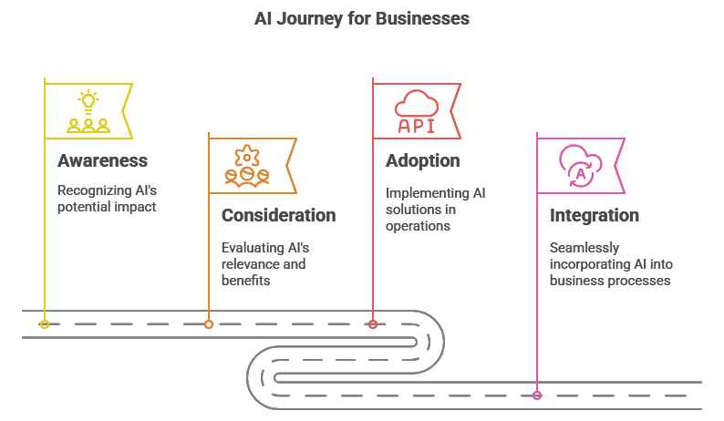
Read ahead for more info on each stage, you might even find yourself or your business in more than one stage of adoption, that’s ok!

One Step at a Time
✔ Understand where you are.
✔ Take one step forward.
✔ Build AI into your business, one move at a time.
Your journey starts now.
1. Awareness: "I’ve Heard About AI, But I Have No Idea Where to Start."
(Written by a business owner just starting to explore AI)
AI is everywhere, and I keep hearing how it can help businesses. But honestly? I have no clue how it works or what I should even be looking for. I run my business the way I always have—spreadsheets, emails, and handling everything manually. AI sounds cool, but it also sounds complicated, expensive, and probably not for me.

🔹 What I realized: AI isn’t just for big corporations. Even small businesses like mine can use it to save time. But I have to start somewhere.

What I did to move forward:
✅ I asked my team if they’ve used AI before—turns out, some of them already have!
✅ I found one small thing AI could help with (for me, it was writing marketing emails faster).
✅ I watched a quick tutorial to see what AI can actually do.

🚀 Your Next Step: Pick one simple thing in your business (emails, scheduling, invoices) and test an AI tool for it. Don’t overthink it—just experiment.
__________________________________________________________________________________________________________________________________________________________________________________________________________________________________________________________________________________________________________________________________________________________________________________________________________________________________________________________________________________________________________________

2. Consideration: "I’m Curious About AI, But I Don’t Know Which Tool to Pick."
(Written by a business owner who is researching AI options)
I’ve played around with some AI tools, and I see the potential. But now I’m stuck—I don’t know which one is actually worth using. There are a million options, and I don’t want to waste time on something that won’t fit my business. I need something simple, useful, and not another tech headache.

🔹 What I realized: AI isn’t about finding the “best” tool—it’s about finding the right tool for what I actually need.

What I did to move forward:
✅ I picked one tool and committed to testing it for 30 days.
✅ I stopped chasing trends and focused on what would make my life easier.
✅ I set a tiny goal—if AI could save me even 30 minutes a week, it was worth it.

🚀 Your Next Step: Choose one AI tool and apply it to one business task. Don’t try to overhaul everything at once—just get started.
__________________________________________________________________________________________________________________________________________________________________________________________________________________________________________________________________________________________________________________________________________________________________________________________________________________________________________________________________________________________________________________

3. Adoption: "AI Is Helping My Business, But It’s Not Fully Integrated Yet."
(Written by a business owner actively using AI but not at full adoption yet)
AI is already making a difference in my business. I use it for content creation, customer support, or organizing my workflow. But right now, it feels like AI is just another tool I use occasionally—not something I fully rely on. I want to take it further, but I don’t know how to do that without making things too complicated.

🔹 What I realized: AI works best when it’s built into my routine, not just something I pull out when I remember.

What I did to move forward:
✅ I created a process—now AI is part of my daily workflow, not an afterthought.
✅ I trained my team so we’re all using AI the same way.
✅ I started tracking results to see how much time/money AI was actually saving me.

🚀 Your Next Step: Look at what AI is already working for you, and build on it. Make it part of your process, not just a one-off tool.
__________________________________________________________________________________________________________________________________________________________________________________________________________________________________________________________________________________________________________________________________________________________________________________________________________________________________________________________________________________________________________________

4. Integration: "AI Is Now a Core Part of My Business."
(Written by a business owner who has fully integrated AI into their operations)
AI isn’t just a tool in my business—it’s part of how we operate. We use AI to streamline tasks, make better decisions, and free up our team for bigger things. Instead of debating whether AI is “worth it,” we treat it like a necessary part of how we grow.

🔹 What I realized: AI is never “done.” It’s something we keep refining, testing, and improving as we go.

What I did to move forward:
✅ I set up a feedback loop to measure how well AI is working for us.
✅ I encourage my team to keep experimenting and sharing what they learn.
✅ I stay updated on AI trends so we can keep improving.

🚀 Your Next Step: Review your AI tools regularly—what’s working? What’s not? Keep refining your process so AI keeps adding value.
__________________________________________________________________________________________________________________________________________________________________________________________________________________________________________________________________________________________________________________________________________________________________________________________________________________________________________________________________________________________________________________

