

AI Readiness & Implementation:
A Practical Guide for SBDC Consultants

Where Are You in Your AI Journey?

AI is changing how businesses operate, but not everyone is at the same stage. Some are just starting to explore AI, while others are already using it daily in their consulting process.

No matter where you are, the goal is to take the next step forward without overcomplicating things.

Created by the West Central Minnesota SBDC

Funded in part through a Cooperative Agreement with the U.S. Small Business Administration, the Minnesota Department of Employment and Economic Development, and regional support partners. The West Central SBDC is a proud member of the Minnesota SBDC Network. All opinions, conclusions, or recommendations expressed are those of the author(s) and do not necessarily reflect the views of the program sponsors. Programs are open to the public on a nondiscriminatory basis. Reasonable accommodations will be made upon request. Contact the West Central SBDC at (218) 299-6606.
Disclaimer: The tools provided by the West Central SBDC AI Resource Lab are experimental and intended for educational purposes only. They are not designed to provide legal, financial, or professional advice. Users should always consult with a qualified professional and fact-check all outputs before making decisions. The use of these tools is at the user’s own risk, and users are solely responsible for any actions taken based on the information provided. This and other materials were created in collaboration with AI.

How This Guide Works
🔹 Simple Profiles: Find the description that sounds like you.
🔹 Real-World Insights: Learn from other business owners’ experiences.
🔹 Clear Next Steps: Take action with easy, straightforward guidance.
As you read through the stages, take a few notes. Write down where you see yourself today — and one or two small actions you can take next.

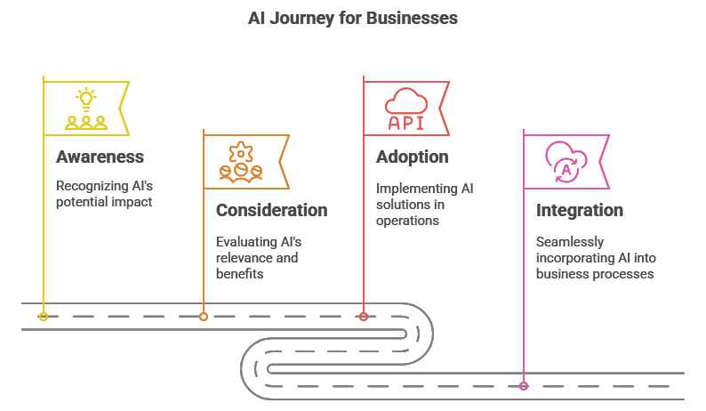
AI Journey for Consultants
Read ahead for more info on each stage, you might even find yourself in more than one stage of adoption, that’s ok!

One Step at a Time
✔ Understand where you are.
✔ Take one step forward.
✔ Build AI into your process, one move at a time.
Your journey starts now.
1. Awareness: "I Know AI Exists, But I Don't Use It in My Consulting."

(Written by a consultant just starting to explore AI.)
I hear about AI all the time, but I haven’t really used it in my consulting work. Sure, I’ve seen a few AI-generated ads, and I know people use ChatGPT, but I wouldn’t call myself ‘tech-savvy.’ I help my clients with business fundamentals—marketing, finance, operations—not AI. I’m not sure how relevant it is for my role, and honestly, I worry it’s too complicated or that it might replace what I do.

🔹 What I realized: AI isn’t here to replace consultants—it’s here to help us work faster and smarter. I don’t need to be an expert overnight, but I should at least know what AI can do so I can have conversations with my clients.

What I did to move forward:
✅ I asked my clients if they were using AI—turns out, some were already experimenting.
✅ I tested a basic AI tool (like ChatGPT or an AI writing assistant) just to see how it works.
✅ I watched a short AI tutorial on how it applies to small businesses (ASBDCs AI U!)

🚀 Your Next Step: Pick one area of your consulting work (emails, reports, research) and test an AI tool for it. Don’t overthink it—just experiment.
____________________________________________________________________________________________________________________________________________________________________________________________________________________________________________________________________________________________________________________________________________________________________________________________________________________________________________________________________________________________________________________________________________________________

2. Consideration: "I’ve Used AI a Few Times, But Don’t Have a Real System Yet."

(Written by a consultant who is researching AI but hasn’t committed to a process.)
I’ve played around with AI tools, and I see the potential. I’ve used ChatGPT for brainstorming, and I’ve tested a few automation tools. But right now, AI isn’t part of my actual consulting process—it’s more of a side experiment. I don’t know which tools are actually worth using long-term, and I don’t want to waste time on things that won’t make a real impact.

🔹 What I realized: AI works best when it’s built into a process, not just a one-off tool. If I’m going to use it effectively, I need a structured approach.

What I did to move forward:
✅ I picked one AI tool that solves a real pain point in my workflow (e.g., AI-powered transcription, content creation, or chatbots).
✅ I set a goal for AI use—if it could save me an hour a week, it was worth it.
✅ I started recommending AI tools to clients in areas I understood well (like marketing automation).

🚀 Your Next Step: Choose one AI tool and make it part of your consulting workflow for 30 days. Track whether it saves you time or improves your work.
____________________________________________________________________________________________________________________________________________________________________________________________________________________________________________________________________________________________________________________________________________________________________________________________________________________________________________________________________________________________________________________________________________________________

3. Adoption: "AI is Part of My Consulting, But I Haven’t Fully Optimized It."

(Written by a consultant actively using AI but not fully integrating it.)
AI has already made a difference in how I work. I use it to draft reports, research trends, and automate some repetitive tasks. I even help clients explore AI solutions. But right now, I know I’m not using it to its full potential. AI is still a tool in my toolkit, not something I rely on strategically. I want to take it further, but I don’t know where to focus.

🔹 What I realized: AI is most powerful when it’s tied to business outcomes—not just saving time, but actually increasing revenue, improving decision-making, and driving results for clients.

What I did to move forward:
✅ I created an AI workflow—now, AI helps with lead generation, client reports, and content creation.
✅ I started tracking results—how much time I saved and whether AI improved my recommendations.
✅ I trained my team and clients so we all use AI in a structured way.

🚀 Your Next Step: Look at how AI is already working in your consulting. Systematize it—document your process, train your team, and find more ways to integrate it.
____________________________________________________________________________________________________________________________________________________________________________________________________________________________________________________________________________________________________________________________________________________________________________________________________________________________________________________________________________________________________________________________________________________________

4. Integration: "AI is Fully Integrated into My Consulting Business."

(Written by a consultant who has fully integrated AI into their process.)
AI isn’t just a tool I use occasionally—it’s part of how I deliver value to clients. It helps me make better decisions, automate low-value tasks, and focus on high-impact consulting work. I don’t see AI as a threat; I see it as a competitive edge. My clients trust me to help them adopt AI, and I stay ahead of trends to keep improving.

🔹 What I realized: AI isn’t just about saving time—it’s about elevating the role of a consultant by providing deeper insights, more efficiency, and a better client experience.

What I did to move forward:
✅ I built an AI-driven workflow that runs smoothly across my consulting process.
✅ I measure AI’s impact—how much time it saves, how much more I can offer clients, and how it drives business growth.
✅ I stay updated on AI trends so I can keep evolving my approach.

🚀 Your Next Step: Refine your AI processes. Train your clients, track AI’s ROI, and explore new AI strategies to stay ahead.
____________________________________________________________________________________________________________________________________________________________________________________________________________________________________________________________________________________________________________________________________________________________________________________________________________________________________________________________________________________________________________________________________________________________

